Name of course: HSE CCS (Company Core Stream)

Target trainees:
Participants in the HSE Company Core Stream course include:
・ All new company hires on permanent contracts. Fixed-term contract recruits may be admitted.

Primary Learning Outcome Objective:
The course’s primary aim is to provide new hires with everything they need to understand and take action with respect to:
- integrating within the Company from a safety perspective
- learning best safety practices
- grasping what the Company expects from everyone in terms of compliance with rules and personal contribution

The course’s learning outcome objectives are:
- Explaining safety culture and identifying key tools at TotalEnergies
- Exploring the major HSE risks specific to TotalEnergies: detailing industry-specific risks and knock-on effects, covering historical accidents, laws and regulations, etc.
- Contributing to TotalEnergies’ risk management process and identifying the Company’s everyday proactive tools (ensuring we are all involved in safety and illustrating certain risks).
- Detecting and responding to abnormalities, near-misses and incidents.

Course length: ½ day à 1 day (5h44)
The proposed training aims to provide all new recruits with basic knowledge as part of the core stream. The session will run over two days and take place in person

Prerequisites: none /

List of training materials:
- PowerPoint reference:
- Supporting documents:

Equipment:

In the classroom | For the business year | For each trainee
- Video projector  - Speakers/sound system  - 1 flipchart  - Felt pen paper holder  - Erasable felt pens | - Collect the latest TRIR figures  - Post-it notes  - Time sheet  - Card game or booklet “Golden Rules” booklet | - Pen  - Trestle

Total training time : 5 h 44 min
 |   1 min | Starting the course | At the end of the course, you’ll be well-versed in the TotalEnergies Safety Pass basics | 1minute  The proposed training course is designed to provide basic knowledge to all new recruits as part of the core stream. The session will take place at the local organizer's choice on the organization.  A summary of the presentation will be e-mailed in pdf format at the end of the training session.  ​​  In order to ensure effective animation, it will be necessary to have:​  Tape,​  Post-it,​  This course leader guide,​  Presentation support,​  Collect the latest TRIR figures, ​  Card game on HSE tools.​
 | 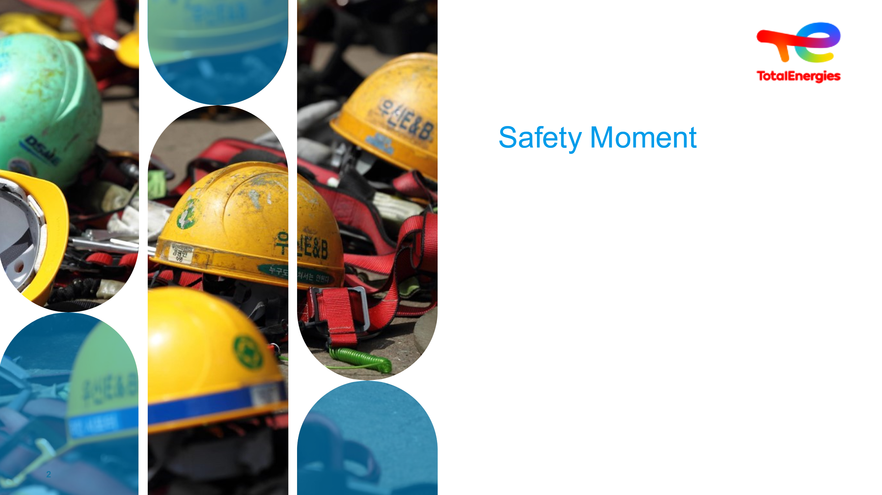  1 min | Illustrate this TotalEnergies rule | Illustrate this first safety moment with the safety moment of your choice |  | “Family Safety Belt” video
 |   5 min  5 min. chat | Illustrate this TotalEnergies rule | Illustrate this first safety moment with the safety moment of your choice | 5 min  In addition to opening the session by explaining the chosen sequence of events  The safety moment is left to the initiative of the moderator. Following the safety moment, open the discussion on the theme. | “Family Safety Belt” video
 |   5 min | Training course program |  | Agenda to be developed by the local coordinator | Slide +Oral
 | 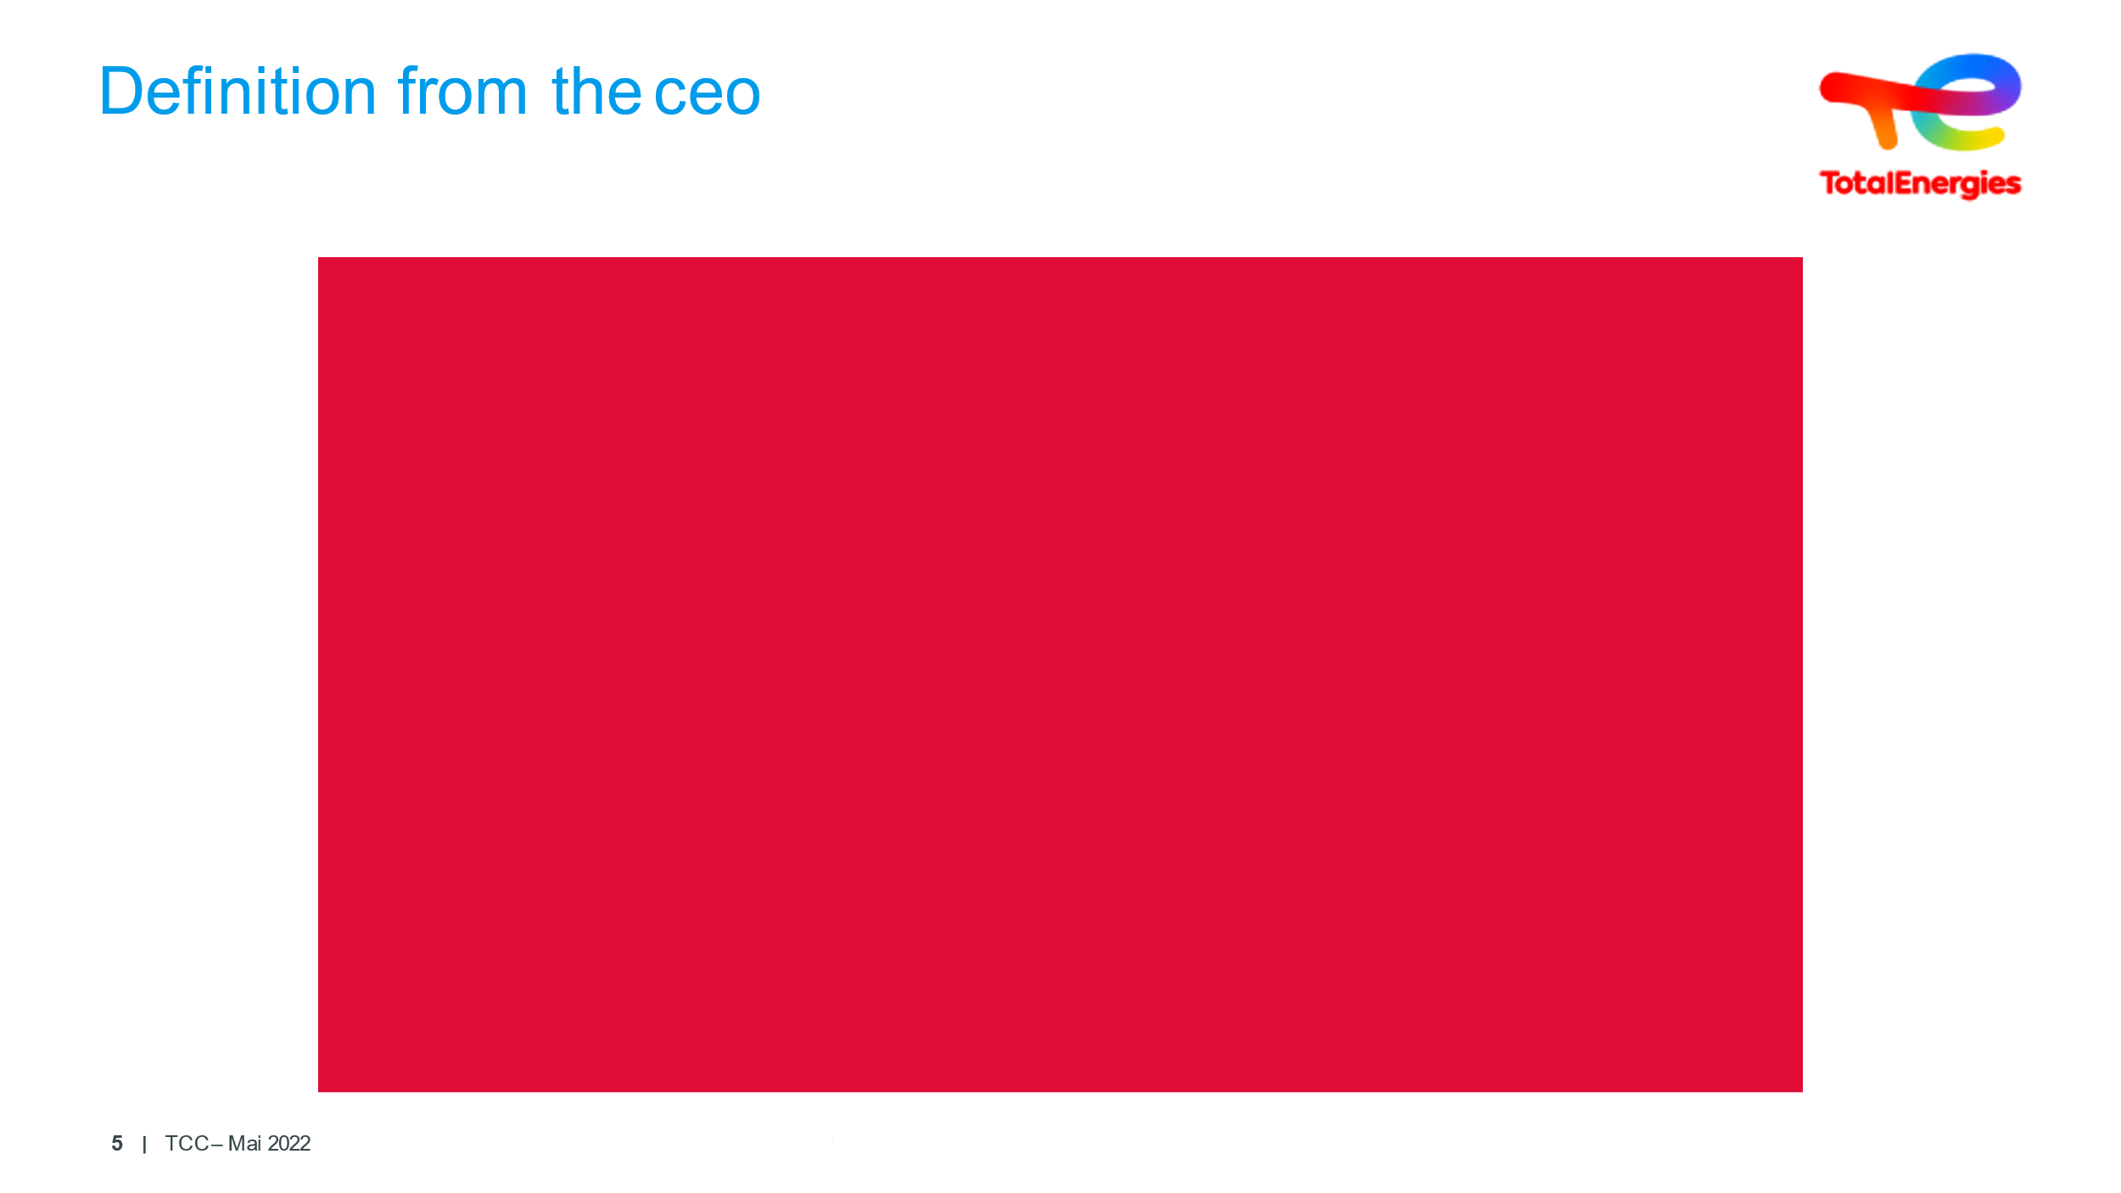  3 min | Introduce the Safety Pass | Introduction P.Pouyanné | Note that the initiative started before Total changed its name to TotalEnergies, but still valid.
 | 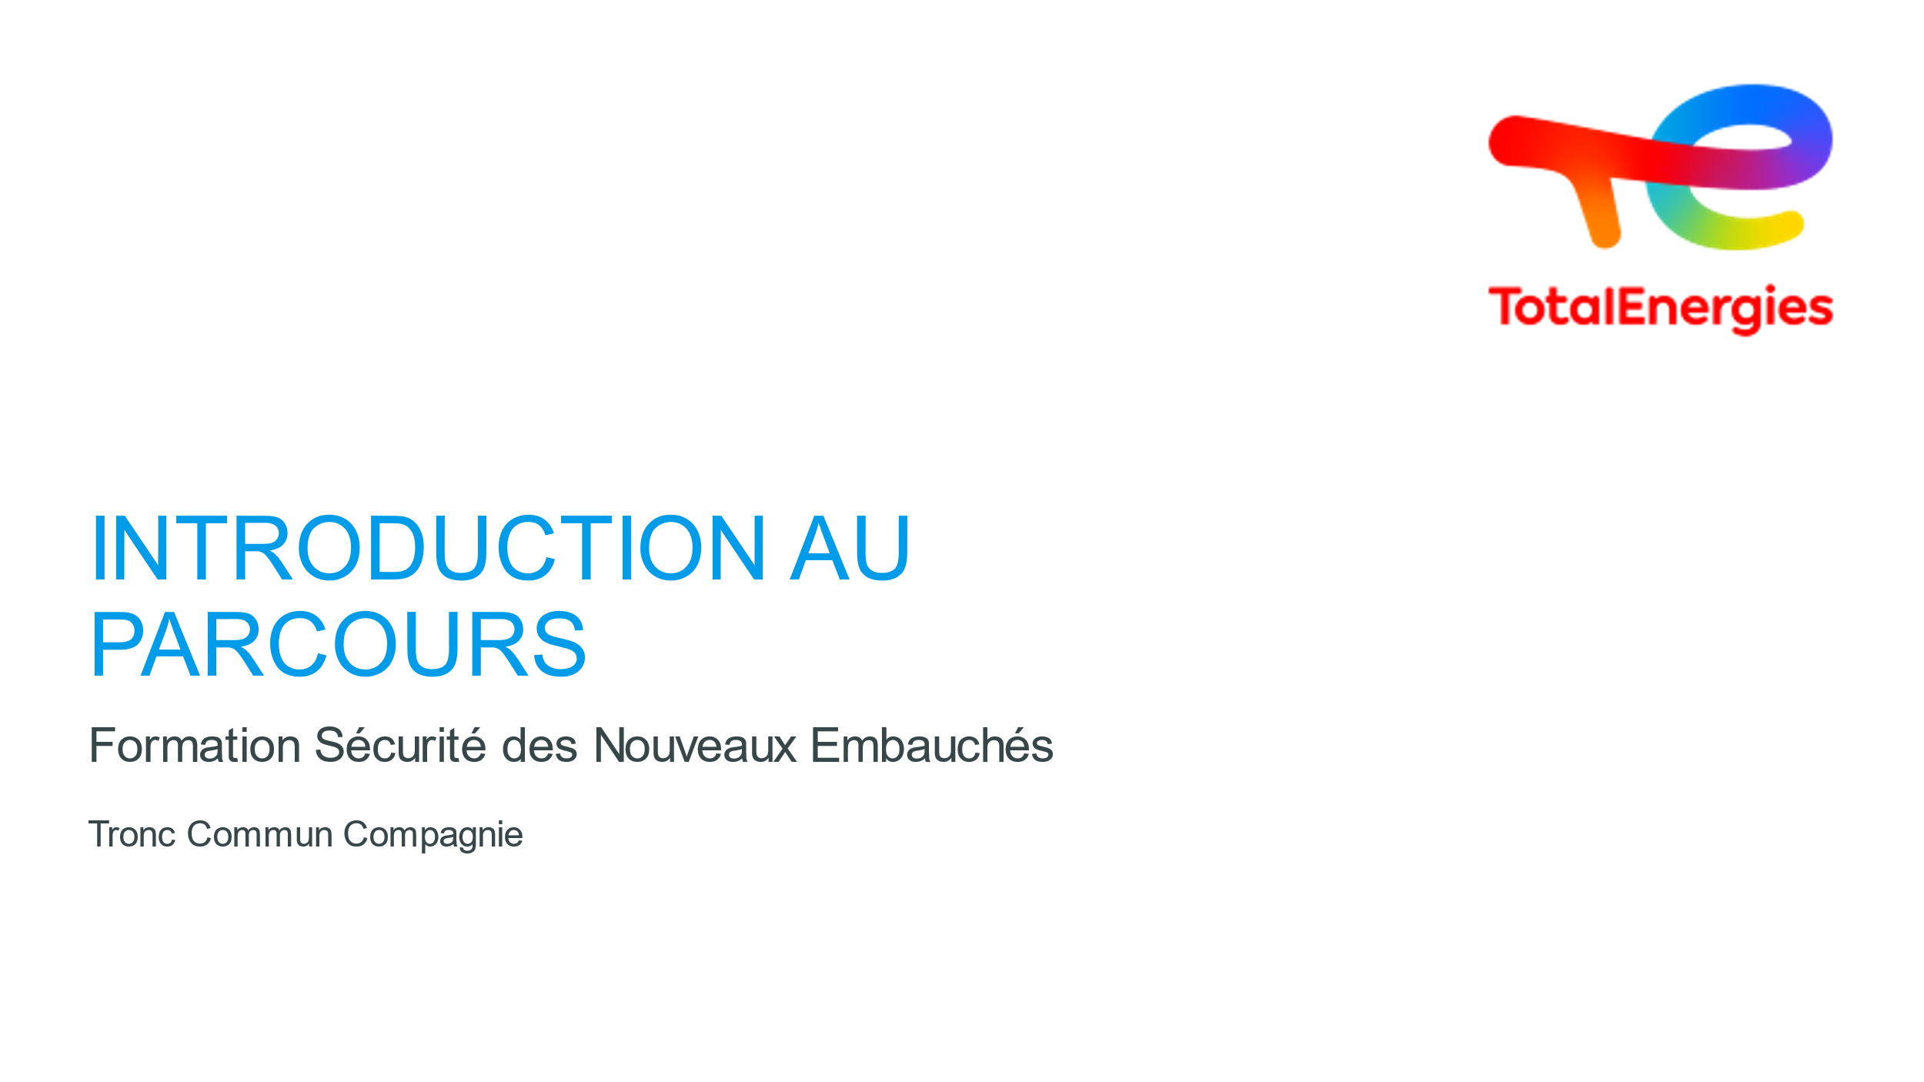  1 min | Introduction to the course | CCS : Company Core Stream | Explain CCS if required: Company Core Stream | Slide + Oral
 | 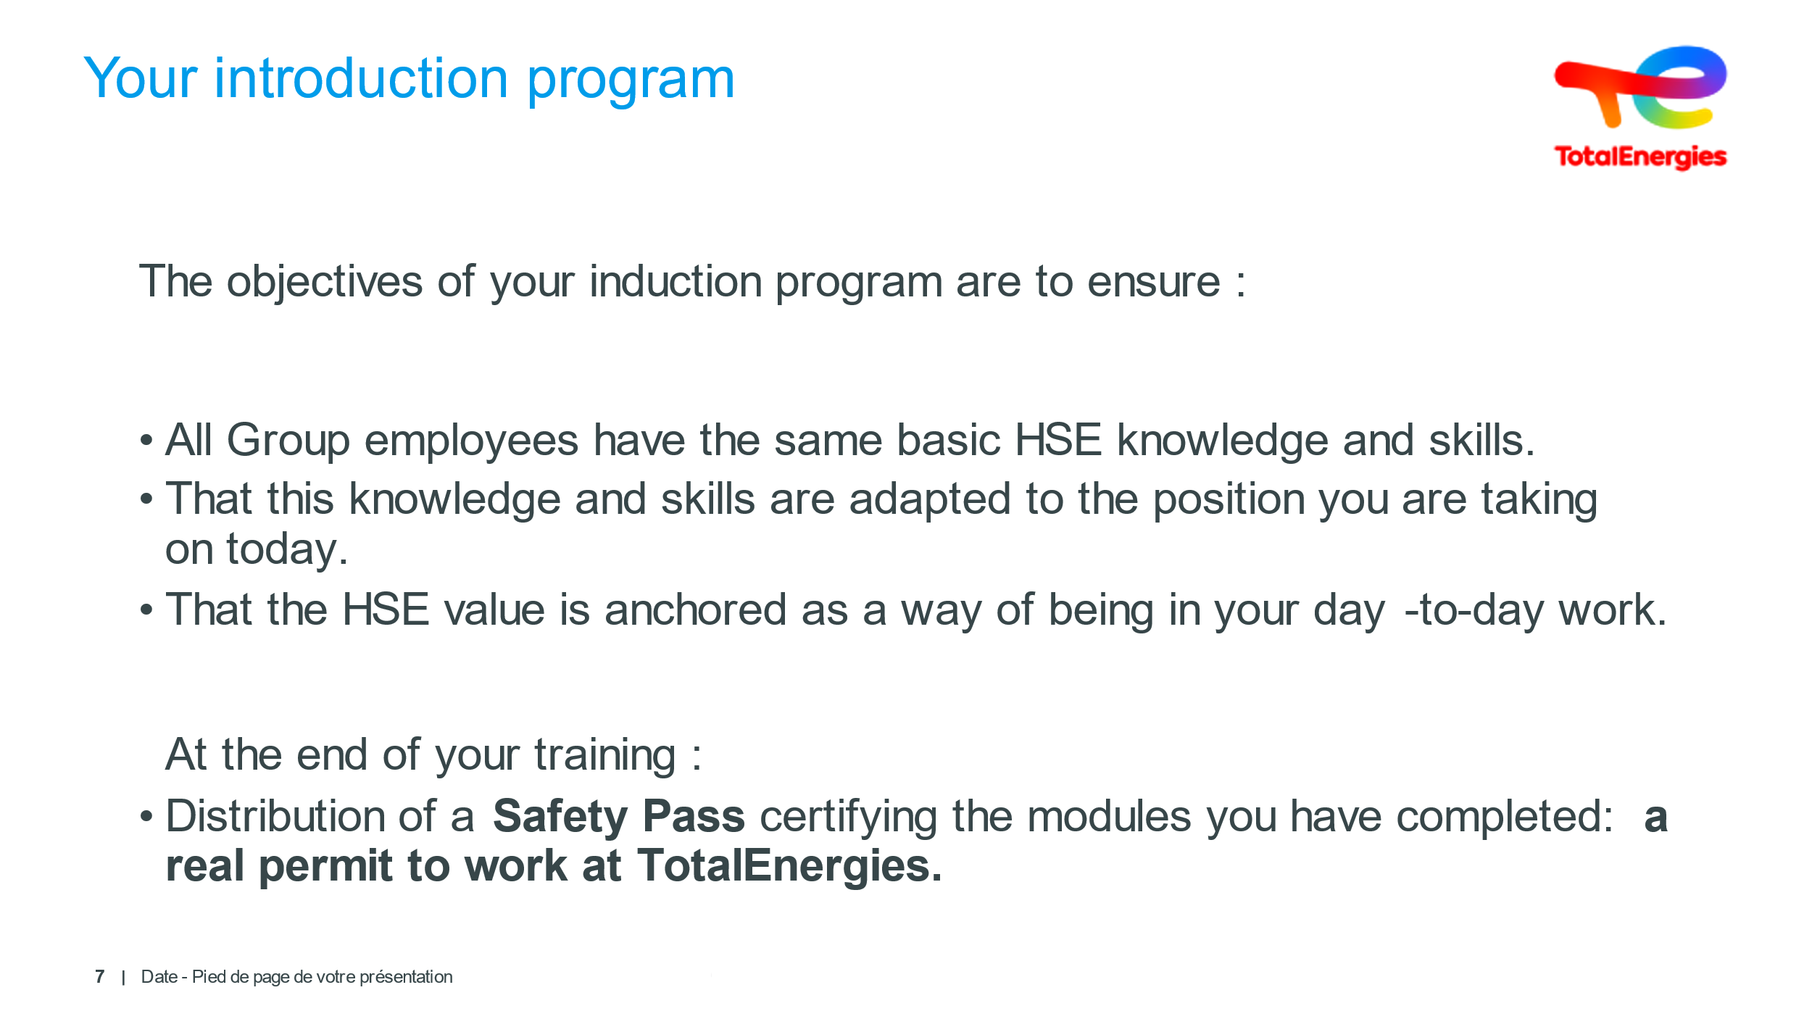 | Presenting the course program | Make sure that the course program is understood | Remind the goals | Slide + Oral
 | 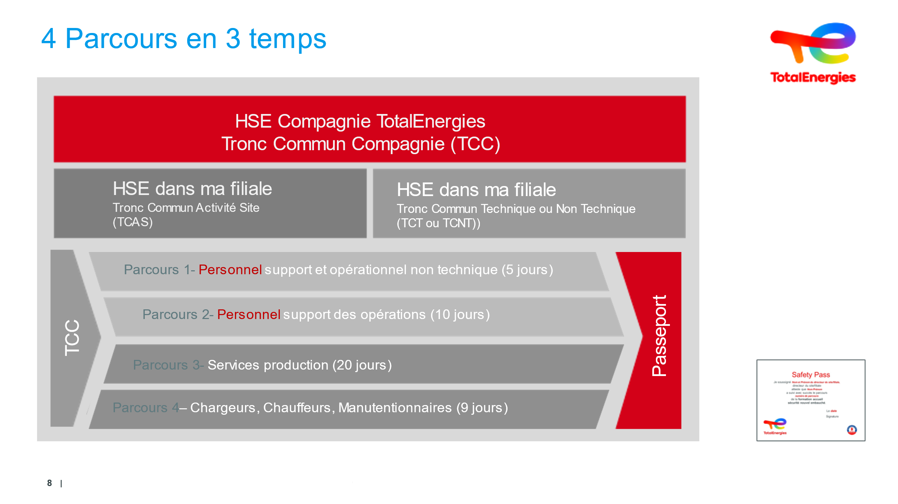  5 min | Understand why they need to complete the integration process and how it will take place | Ensuring the different pathways and phases are understood | The pathways begin upon hiring: you will have heard mention of safety in the very first few days.  New employees have three to six months to complete their pathway  Day 1: HSE with their direct manager, at a minimum Charter + HSE Commitment + Golden Rules online module + Frontline + other CCS topics  Pathway 1 + 2 + 3 + 4 = 54 days minimum!  Required: online Golden Rules module!  All new permanent contract entrants into the Company. Fixed-term employees; All new recruits complete the CCS (Company Core Stream) course  The objectives of your integration pathway are to ensure:  That all Company employees acquire the basic HSE knowledge and skills required.  That these skills and knowledge are appropriate to your current position  That HSE has been ABSORBED as a way of going about your everyday work.  At the end of your pathway:  You’ll receive a Safety Passport testifying to the modules you will have completed: akin to a TotalEnergies internal work permit.  Answer any questions. | Slide + Oral
 | 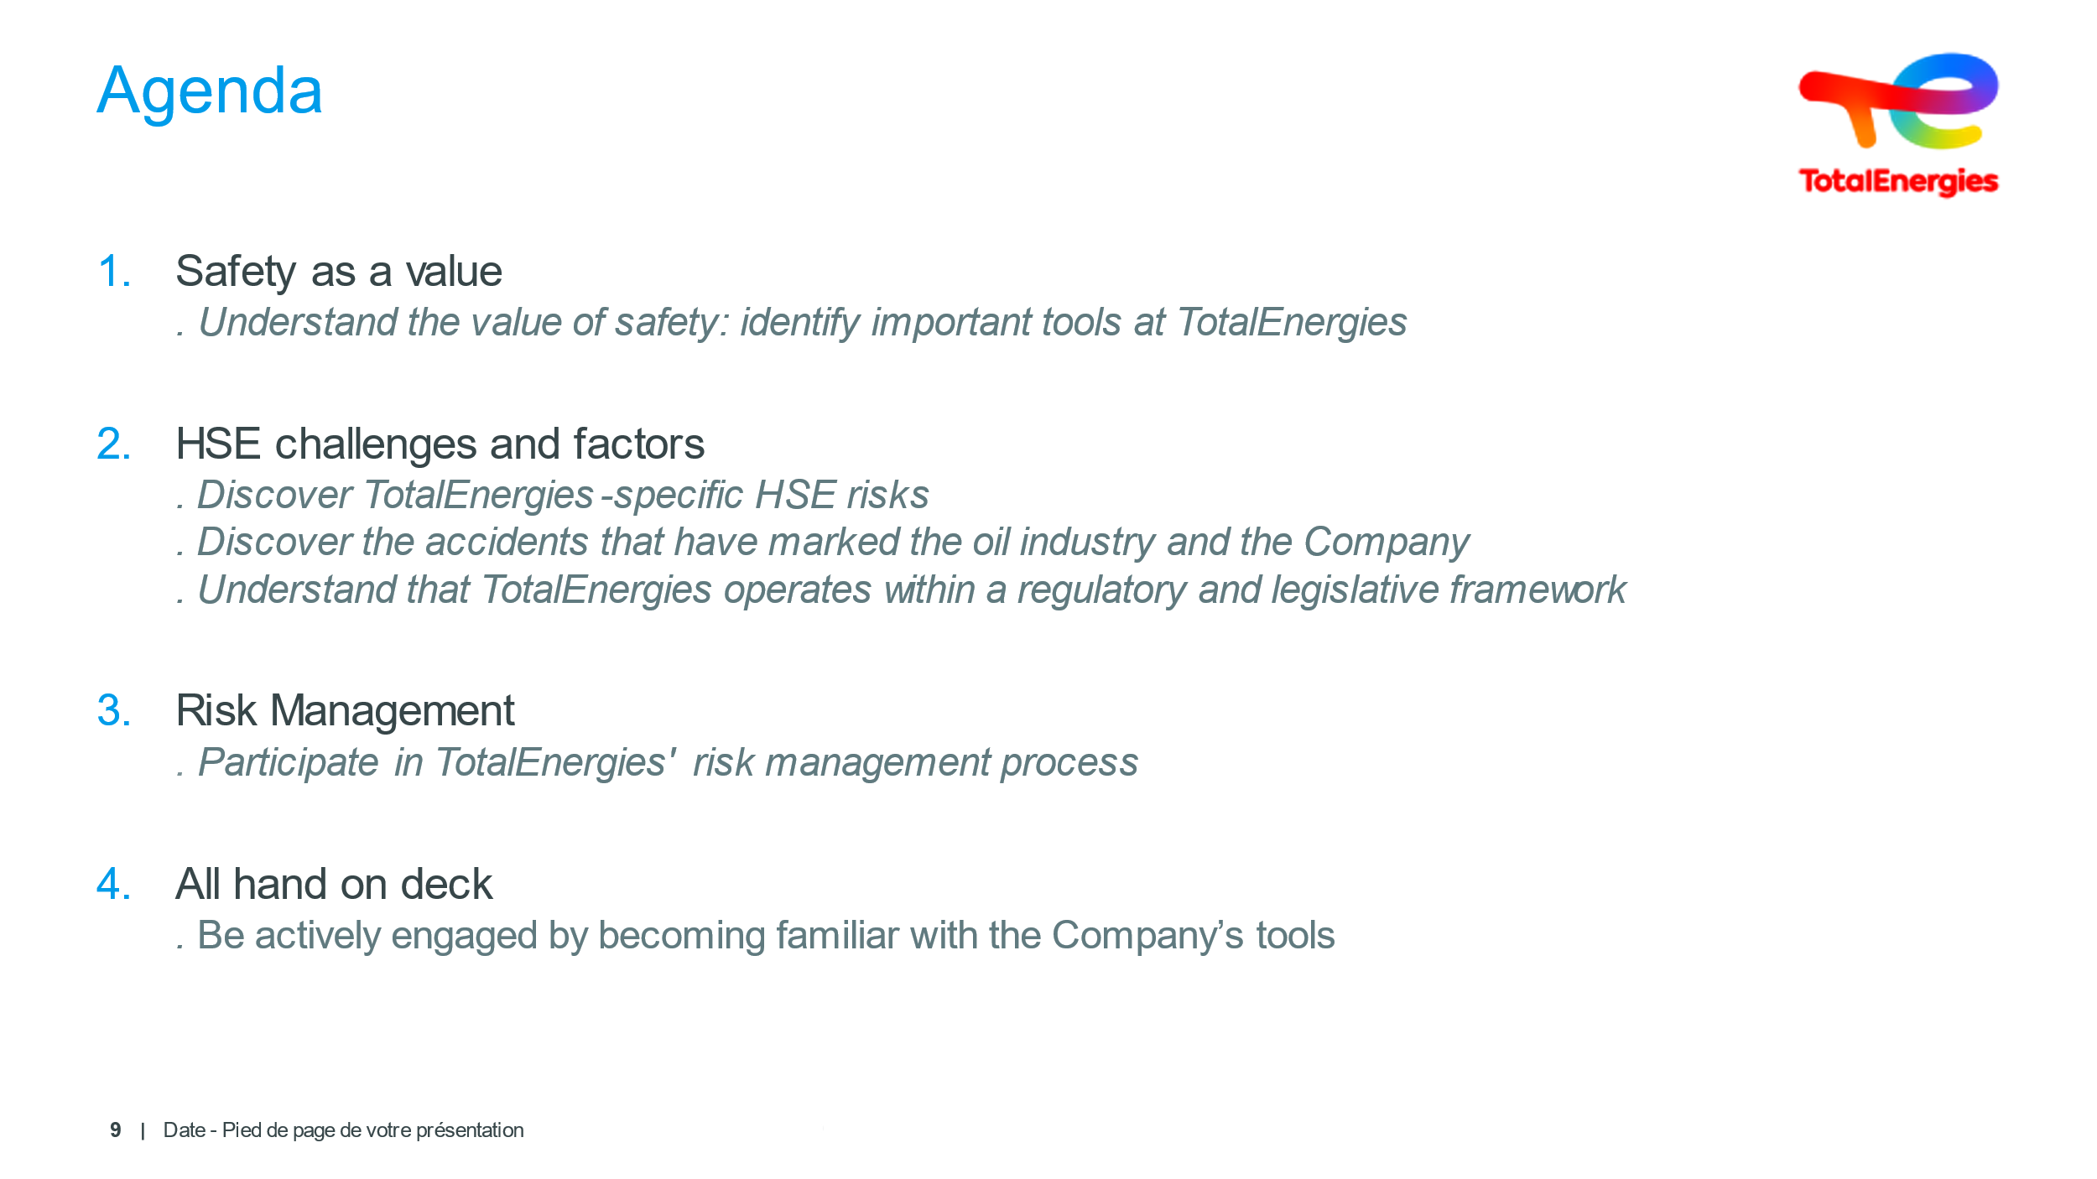  5 min | Agenda |  | Present the program without going into detail.  Do not cover HSE at this stage! | Slide + Oral
 | 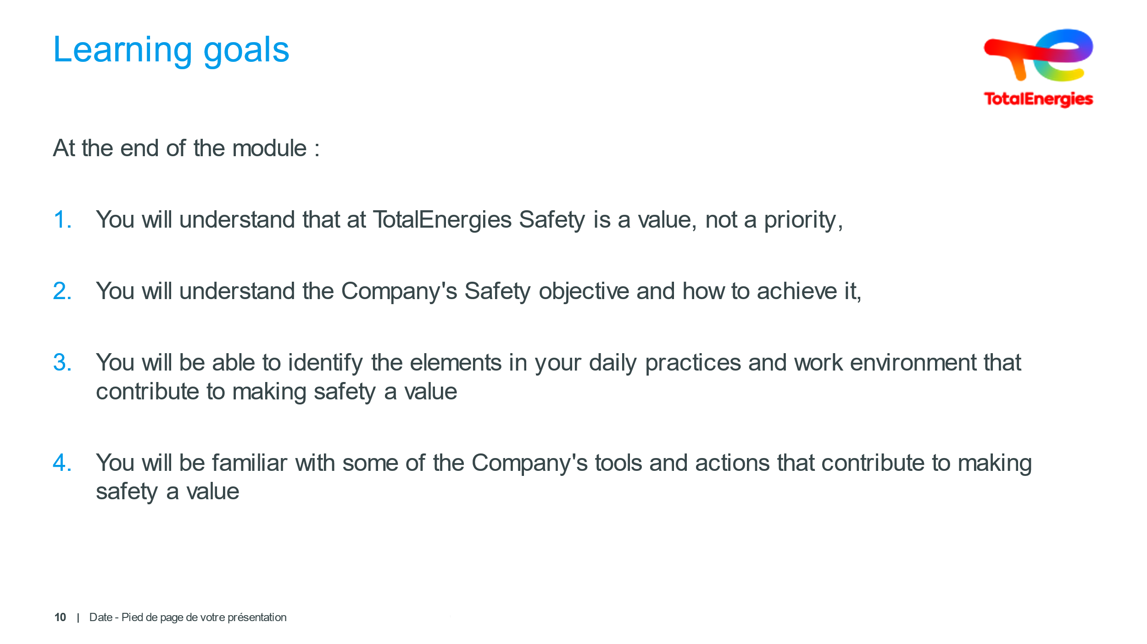  3 min | Learning goals |  | Present the training learning goals | Slide + Oral

