Safety as a value – 2 h 03
 |   1 min | Understand the value of safety, realize that our activities are high-risk and identify important tools at TotalEnergies | Understand and are able to demonstrate how Safety at TotalEnergies is a value, not just a priority  Are capable of identifying elements (decisions, habits, ways of doing things) in their daily practices and environment that personify/reflect the Company’s Safety value | Project slide and read title alone | Slide + Oral
 | 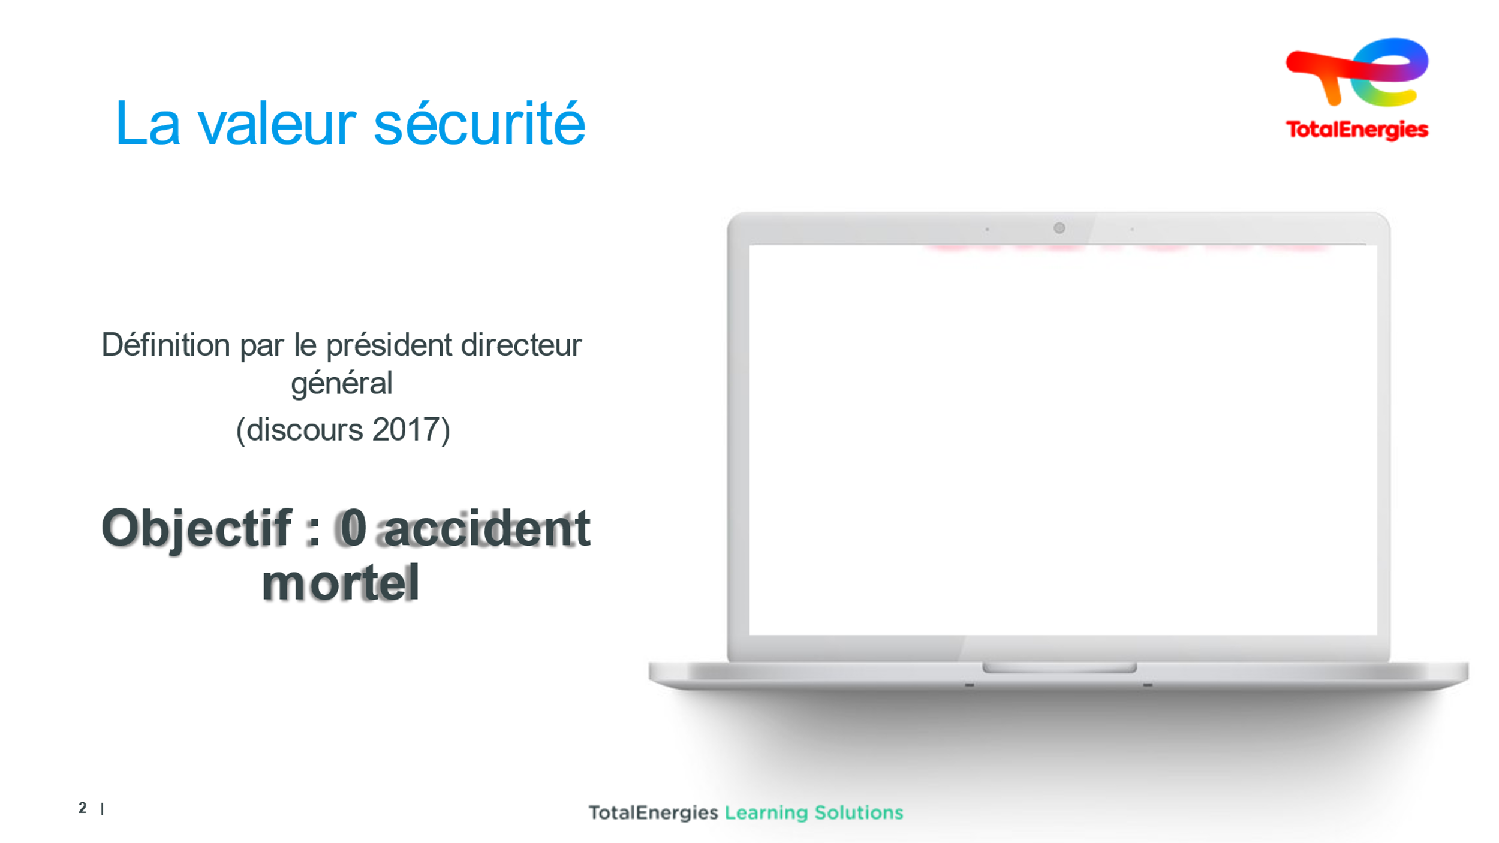  2 min | Detect keywords in the CEO’s speech in order to understand the values of the Company | Keep an eye on sound levels and on-screen visibility.  Video  Questions  Questions | Screening and check text can be heard  - Ambition: we aim to be the number-one responsible energy company, which means being a world leader in safety and the environment  - The conditions for this ambition to be successful are for everyone in all countries to make sure that all the decisions and action they take keep safety (our value) in mind. We can only achieve this if everyone is on board and exemplary in these areas  - As CEO, my job is to protect you, your safety matters to me  - Welcome to the family TotalEnergies, a sense of us being a family = solidarity between members  Then ask trainees for key takeaway words: SAFETY/VALUE/TRAINING/COST/ETHICS  Then ask what the difference between VALUE & PRIORITY is  A “value” is ethically and related to corporate culture, it is fully absorbed (a culture is a set of values).  The idea that “safety is priceless”, but still comes at a cost...  The idea that “nothing is without risk”, but that we can try to get as close as possible.  Accidents happen when alertness drops. | Movie  Slide + Oral
 | 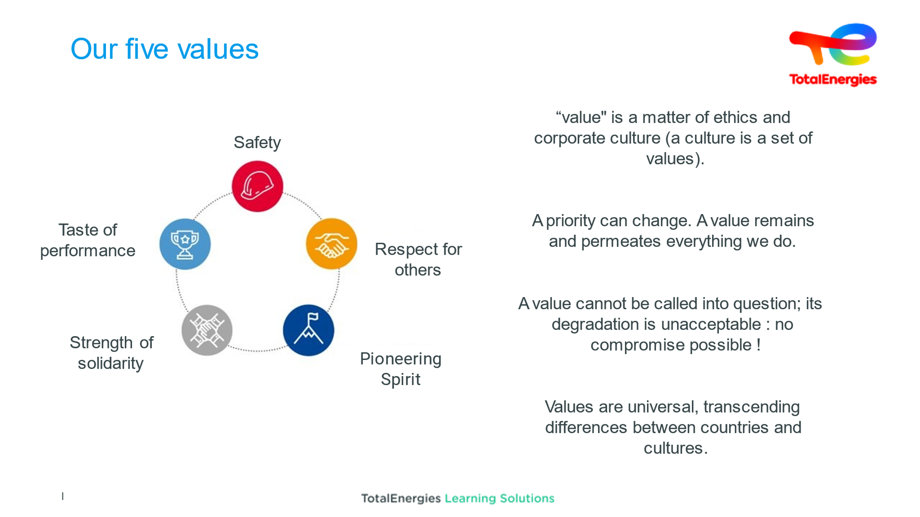  5 min | Learn about the values | Ensuring trainees understand and adhere to these values. | Read these five values while reminding participants that SAFETY is number one. Make it clear that these values cannot be opposed.  A priority can change. A value remains and permeates everything we do  A value cannot be questioned, it is not up for discussion: no compromise possible  (A value cannot be changed, although a priority can change)  Values are universal and transcend countries and cultures | Slide + Oral
 | 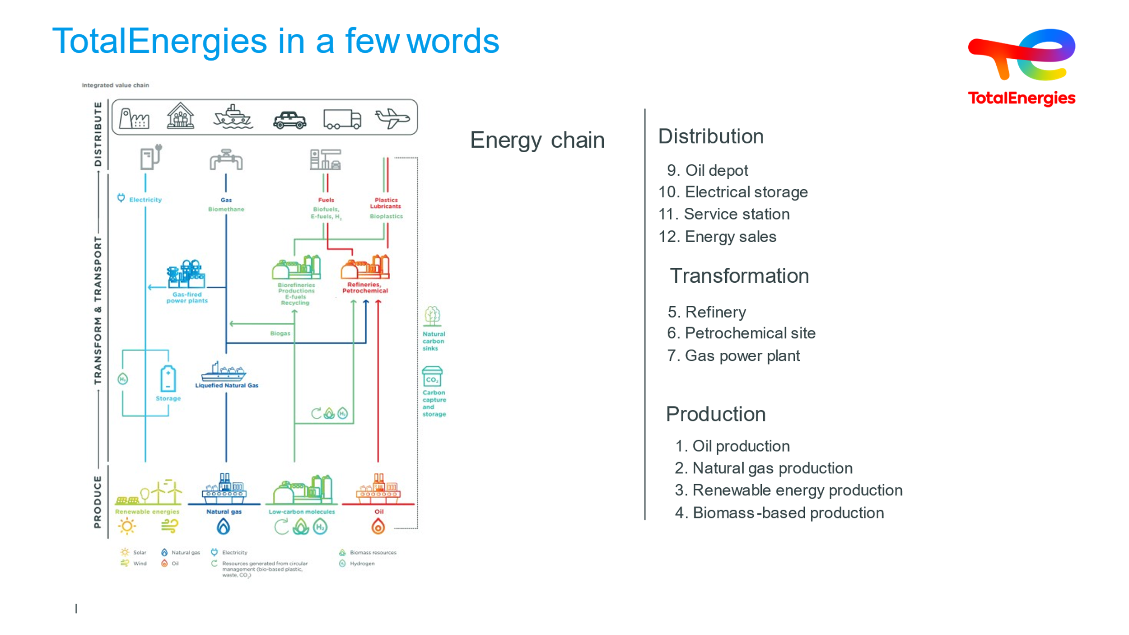  8 min | Get to know the Company's branches & key risks | Introduce the size of the company | Extract of TotalEnergies 2023 URD (Universal Registration Document)  TotalEnergies is a multi-energy company committed to providing ever more affordable, clean, reliable and accessible energy to as many people as possible.  We intervene across the channel:  - from energy production (EP Branch)  - to processing this energy into intermediate or finished products (RC Branch)  - and storage and distribution for these products to meet the needs of our professional clients and private individuals. MS1 Branch  1. List the Company's main activities  2. Ask trainees to explain the Company's energy chain  CLICK on ENERGY CHAIN (New company slogan)  We intervene across the channel:  - from energy production (natural gas, solar, wind, oil, biomass),  - to transport and conversion of these energies into intermediate or finished products  - and storage and distribution for these products to meet the needs of our professional clients and private individuals.  The Exploration and Production branch is responsible for our oil and natural gas exploration, development and production activities in more than 50 countries.  CLICK on UPSTREAM to view the corresponding video.  The Refining-Chemical branch encompasses our industrial activities and know-how in refining, petrochemicals and specialty chemicals.  CLICK on RC to view the corresponding video.  Marketing & Services designs and markets specialty fuels and products (lubricants, special fluids, LPG, fuel oil, bitumens, additives and special fuels, etc.), as well as services for individuals and professionals in the mobility, housing and industry sectors. We are one of Western Europe’s leading distributors and the biggest distributor on the African continent  The facilitator introduces the idea that our activities are high-risk (don’t go as far as to specify the degree of risk related to each activity)  3. Invite trainees to imagine the major risks associated with our activities, and share these over-arching categories of accidents with them:  IND: Fire/Pollution/Explosion/BLEVE/BOIL OVER  DOMESTIC: Occupational stress/Fall/Elec/  You can broaden the idea of IND & DOMESTIC risks so that every trainee (including administrative trainees) are able to connect. A few annex photos and/or videos  Added extra: More energy, less emission: that’s the double-sided challenge we aim to fulfil together with our clients, stakeholders and society as a whole to contribute to sustainable development across the planet and to tackle climate challenge. We promote renewable and decarbonized energy, produce and market fuels, natural gas and electricity. We are investing heavily in solar energy and wind power in a bid to be one of the top five renewable energy producers on the market by 2030. | Slide + Oral
 | 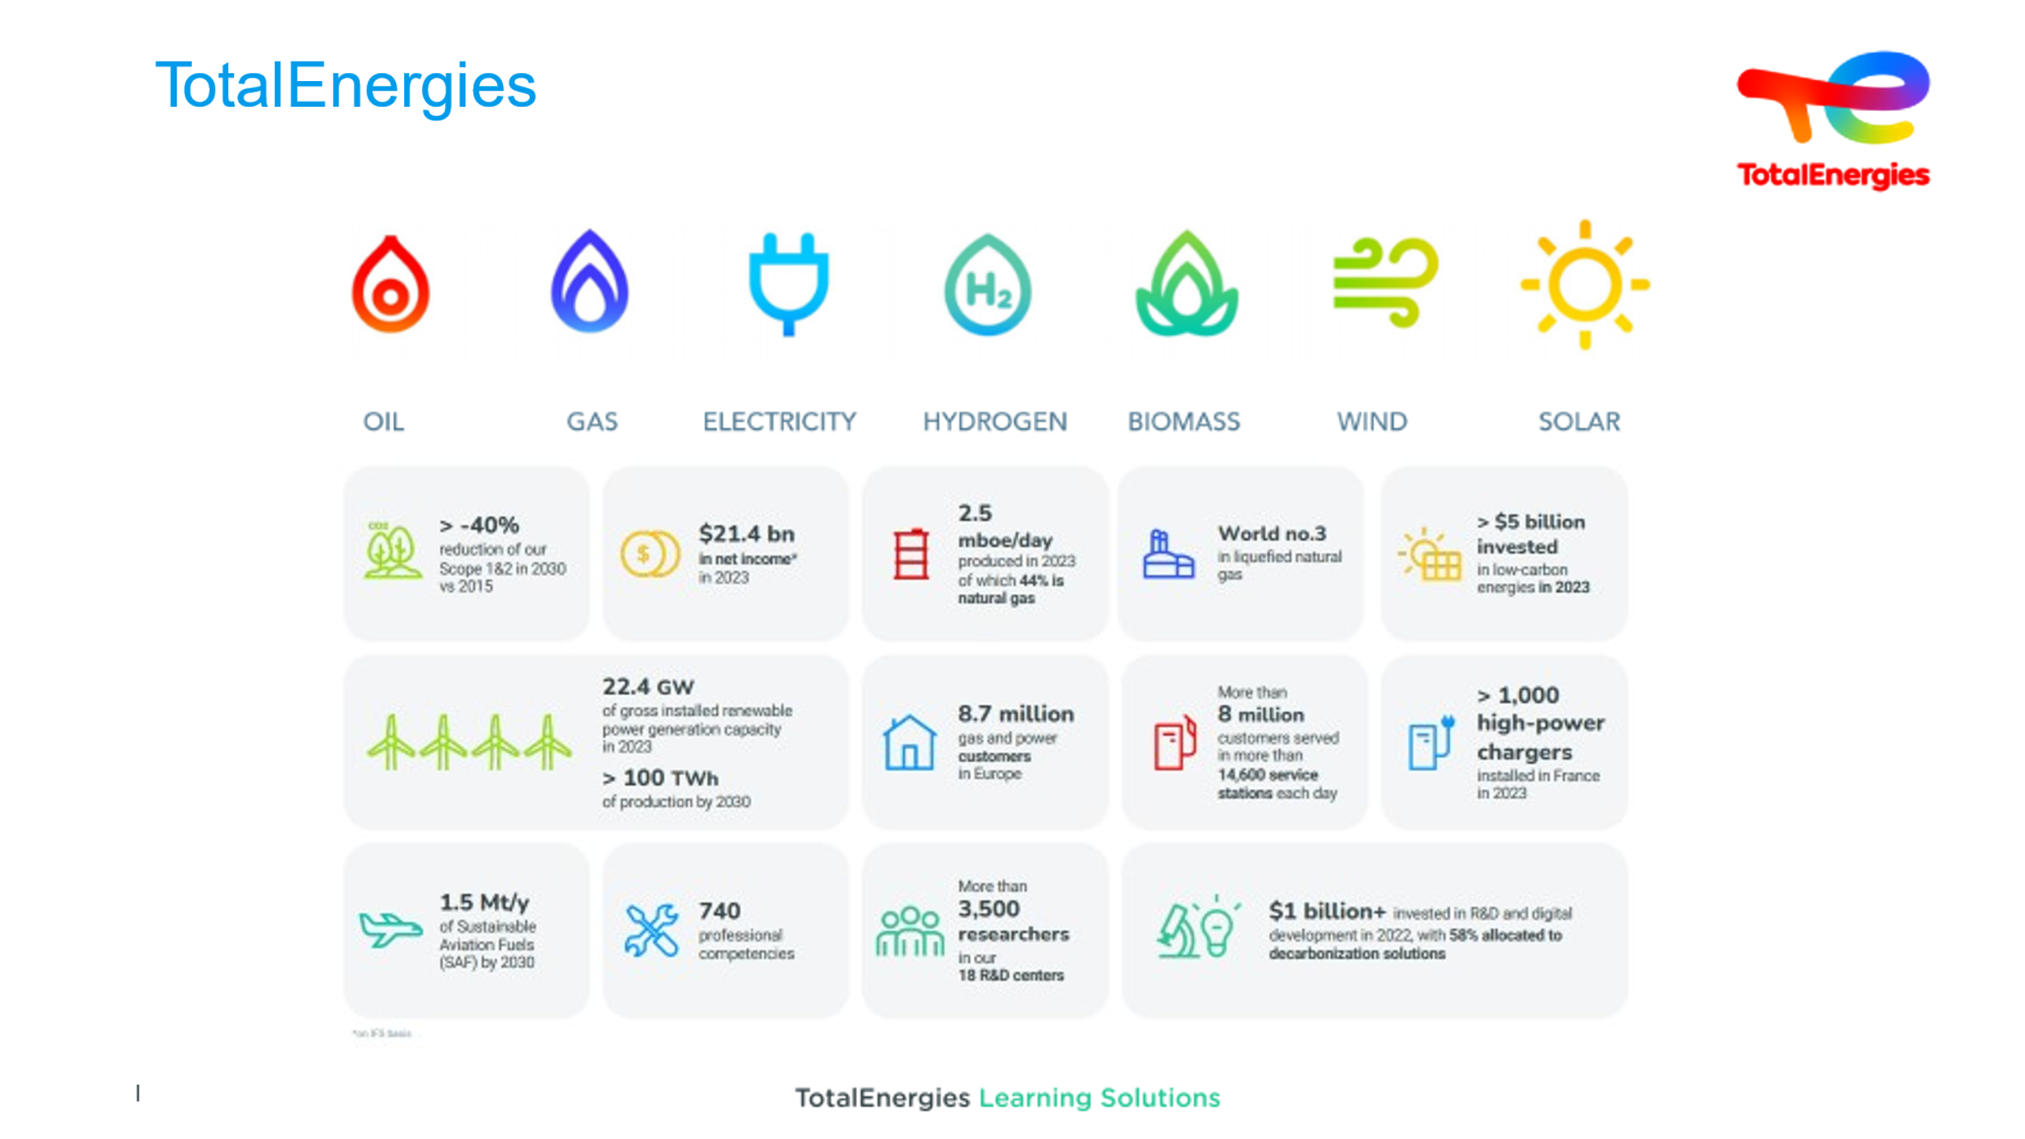  2 min | Get to know the Company's branches & key risks | Introduce the size of the company | TotalEnergies Brief Excerpt 2024  Remind trainees that the company is:  - 105,000 people  - Nearly 160 nationalities  - 730 business skills.  - Present in 130 countries and counting  - 800 industrial sites worldwide.
 | 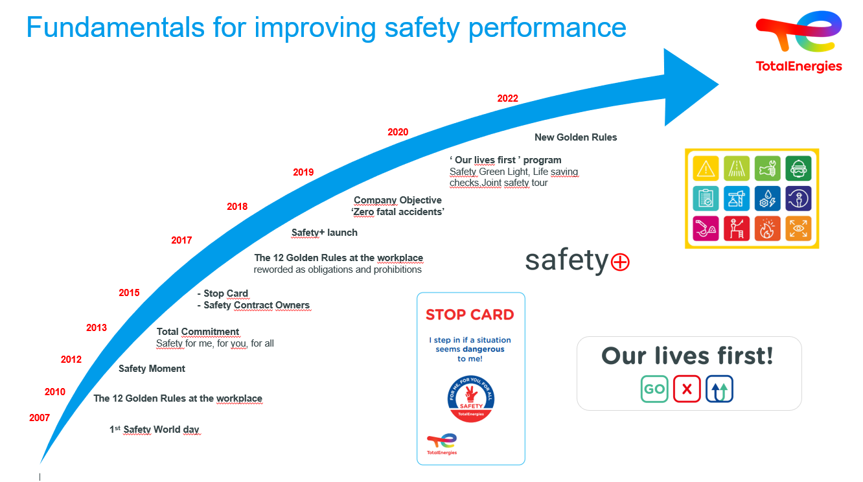  3 min approx. per theme |  |  | Ask trainees what tools are important for safety?  After gathering a few ideas (to jot down if needed, to rephrase if needed)  - SAFETY WORLD DAY  - SAFETY PLUS  - COMMITMENT TO SAFETY  We can go back over what the CEO said in his speech...  We can highlight the photo campaigns supporting this message  - THE STOP CARD  - ANOMALIES REPORTING  Don't go into too much detail, as we'll be coming back to this later.  - INITIATIVES…
 | 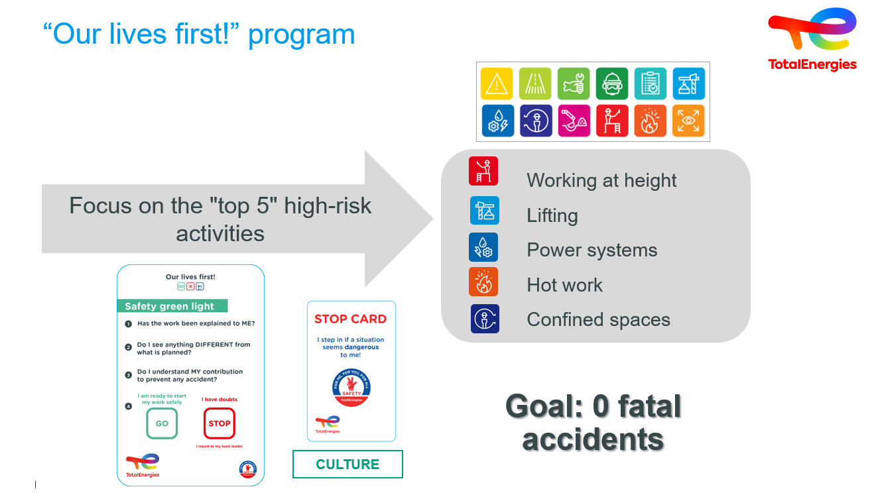2 min | Understanding “Our lives first!” initiatives | Debriefing if needed | Our lives first means focusing on the TOP 5 high-risk activities.... Not to mention what we call HIPO....  1.Working at heights  2.Lifting  3.Energy systems  4.Hot work - direct link with technological risk, which we'll discuss later  5.Confined spaces  All this goes back to the Golden Rules issued by TotalEnergies in 2010... revised in 2022 at the JMS.  But it also relies on other tools that we'll be talking about, such as the STOP CARD / SAFETY GREEN LIGHT.  For TotalEnergies, all this is the foundation of our Safety Culture. | Slide + Oral
 | 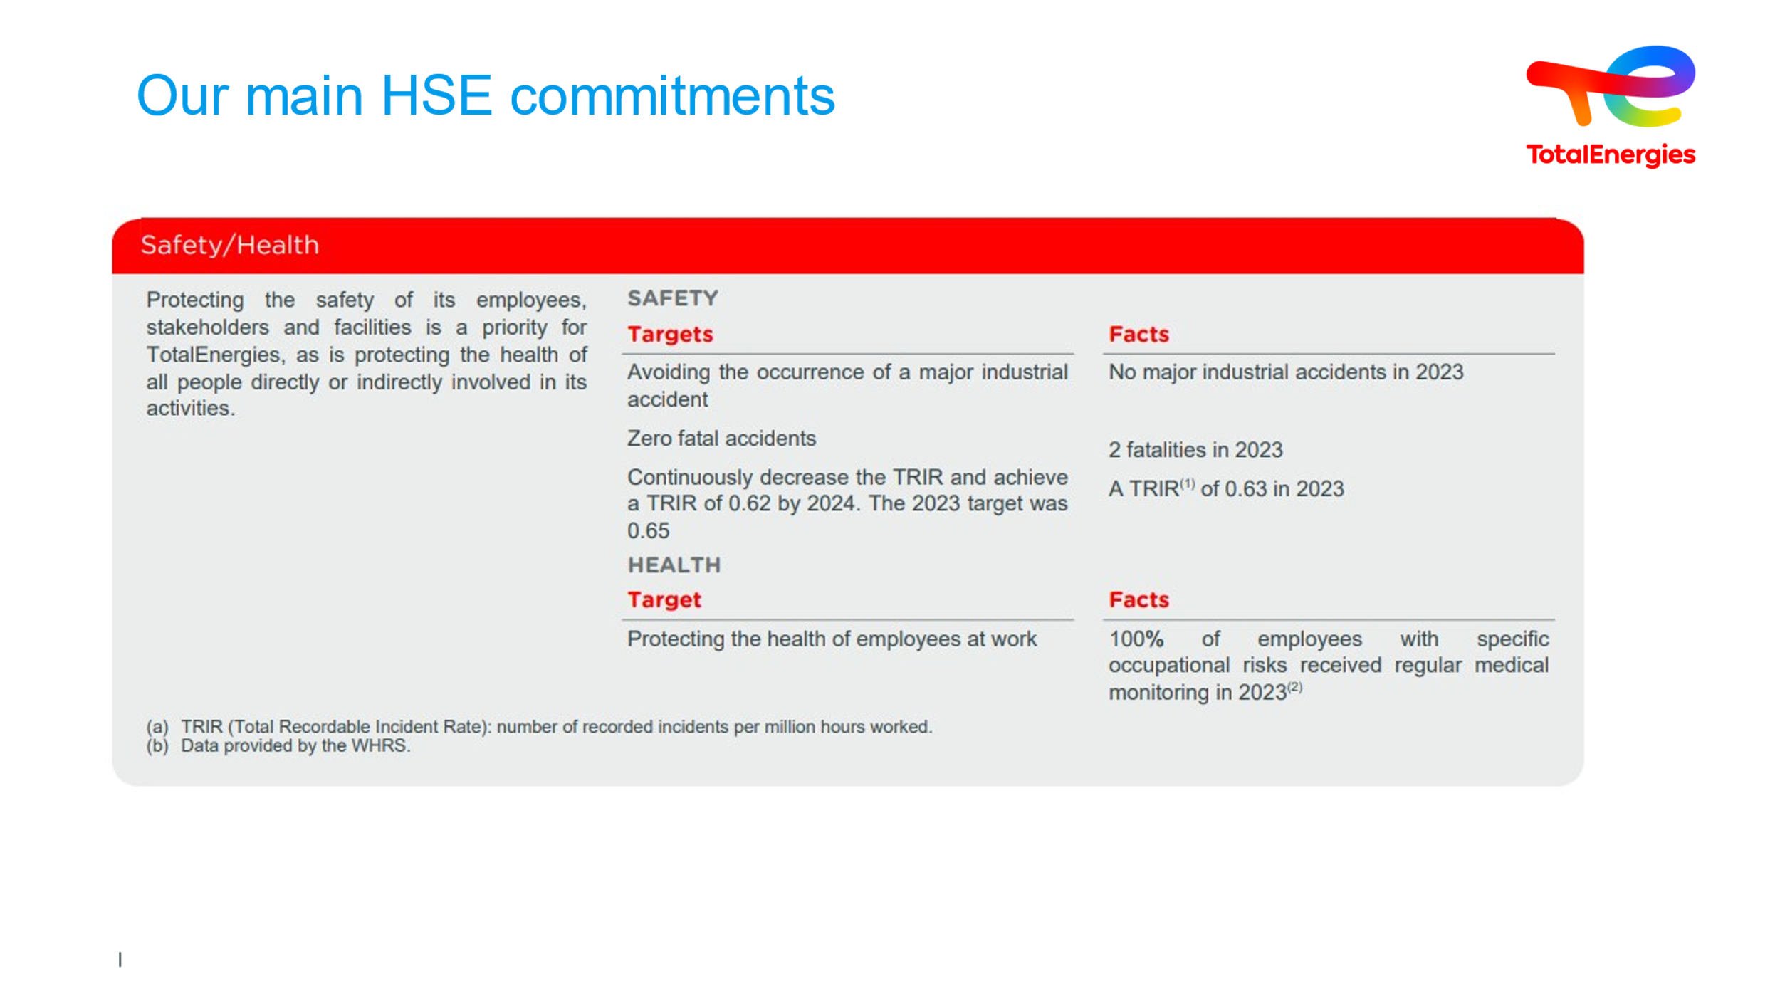 | Discover TotalEnergies’ commitments | In addition to safety, make it clear that the commitments are to be applied by each of the trainees, individually and as a group | Play each item live via WAT or through each slide.  Do not go into detail
 | 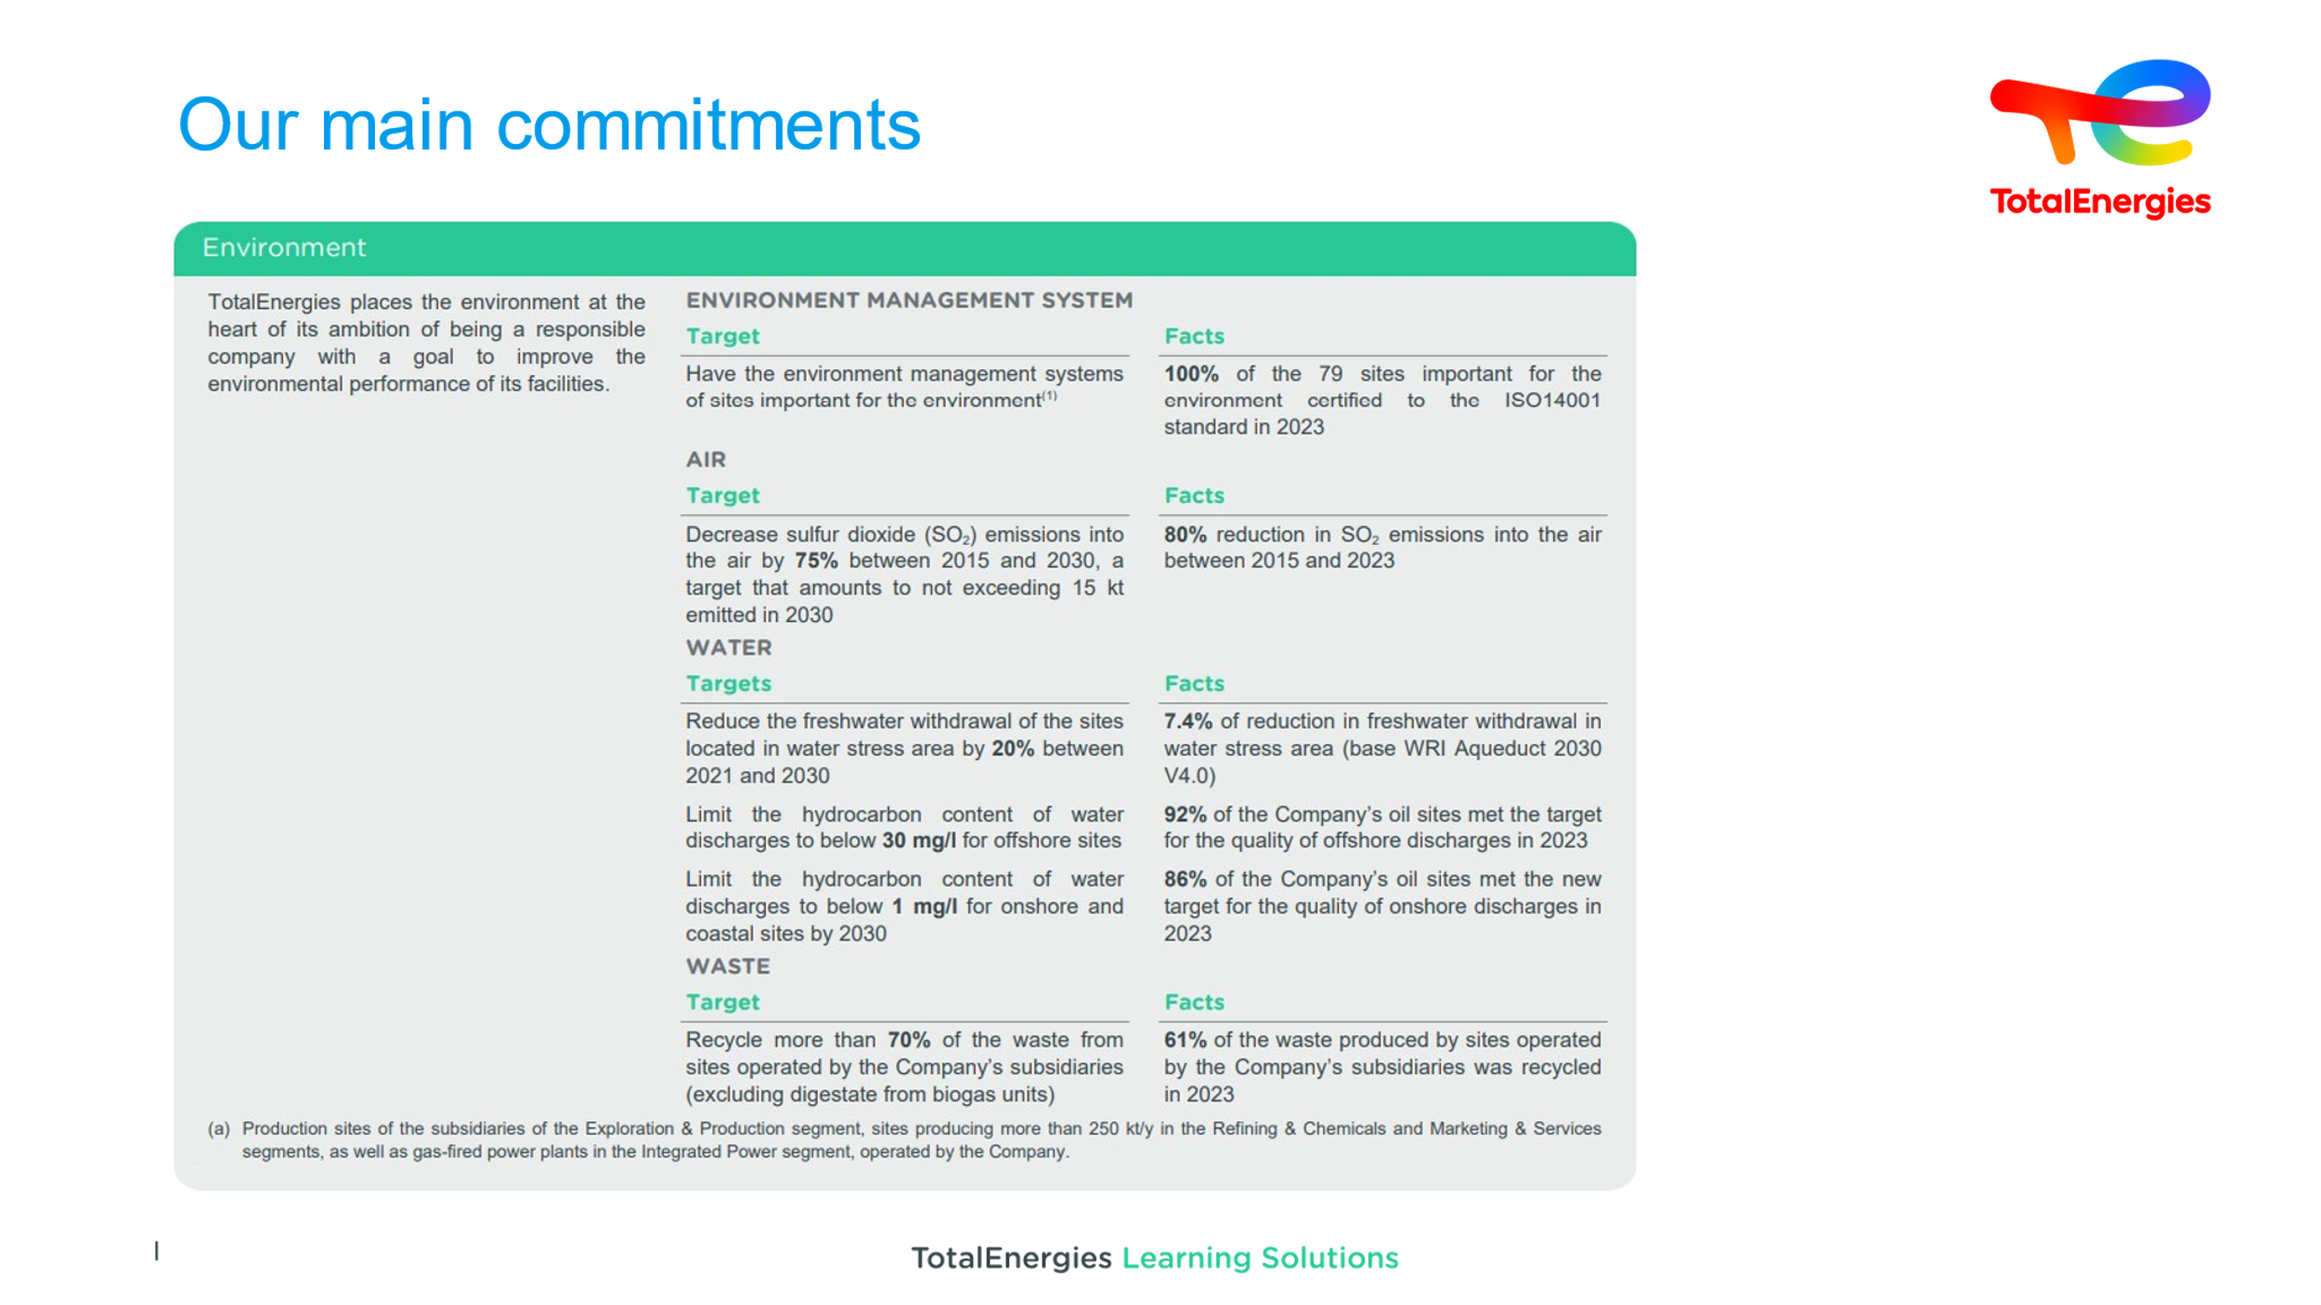
 | 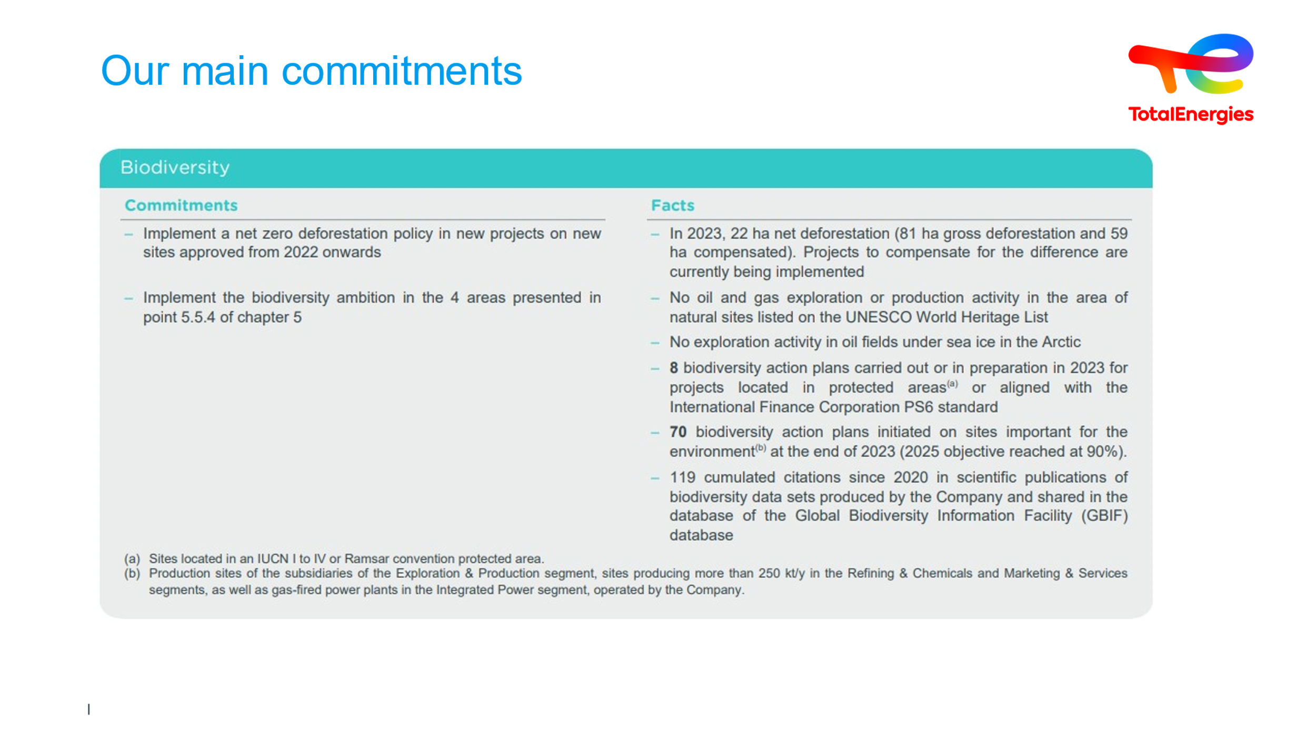
 | 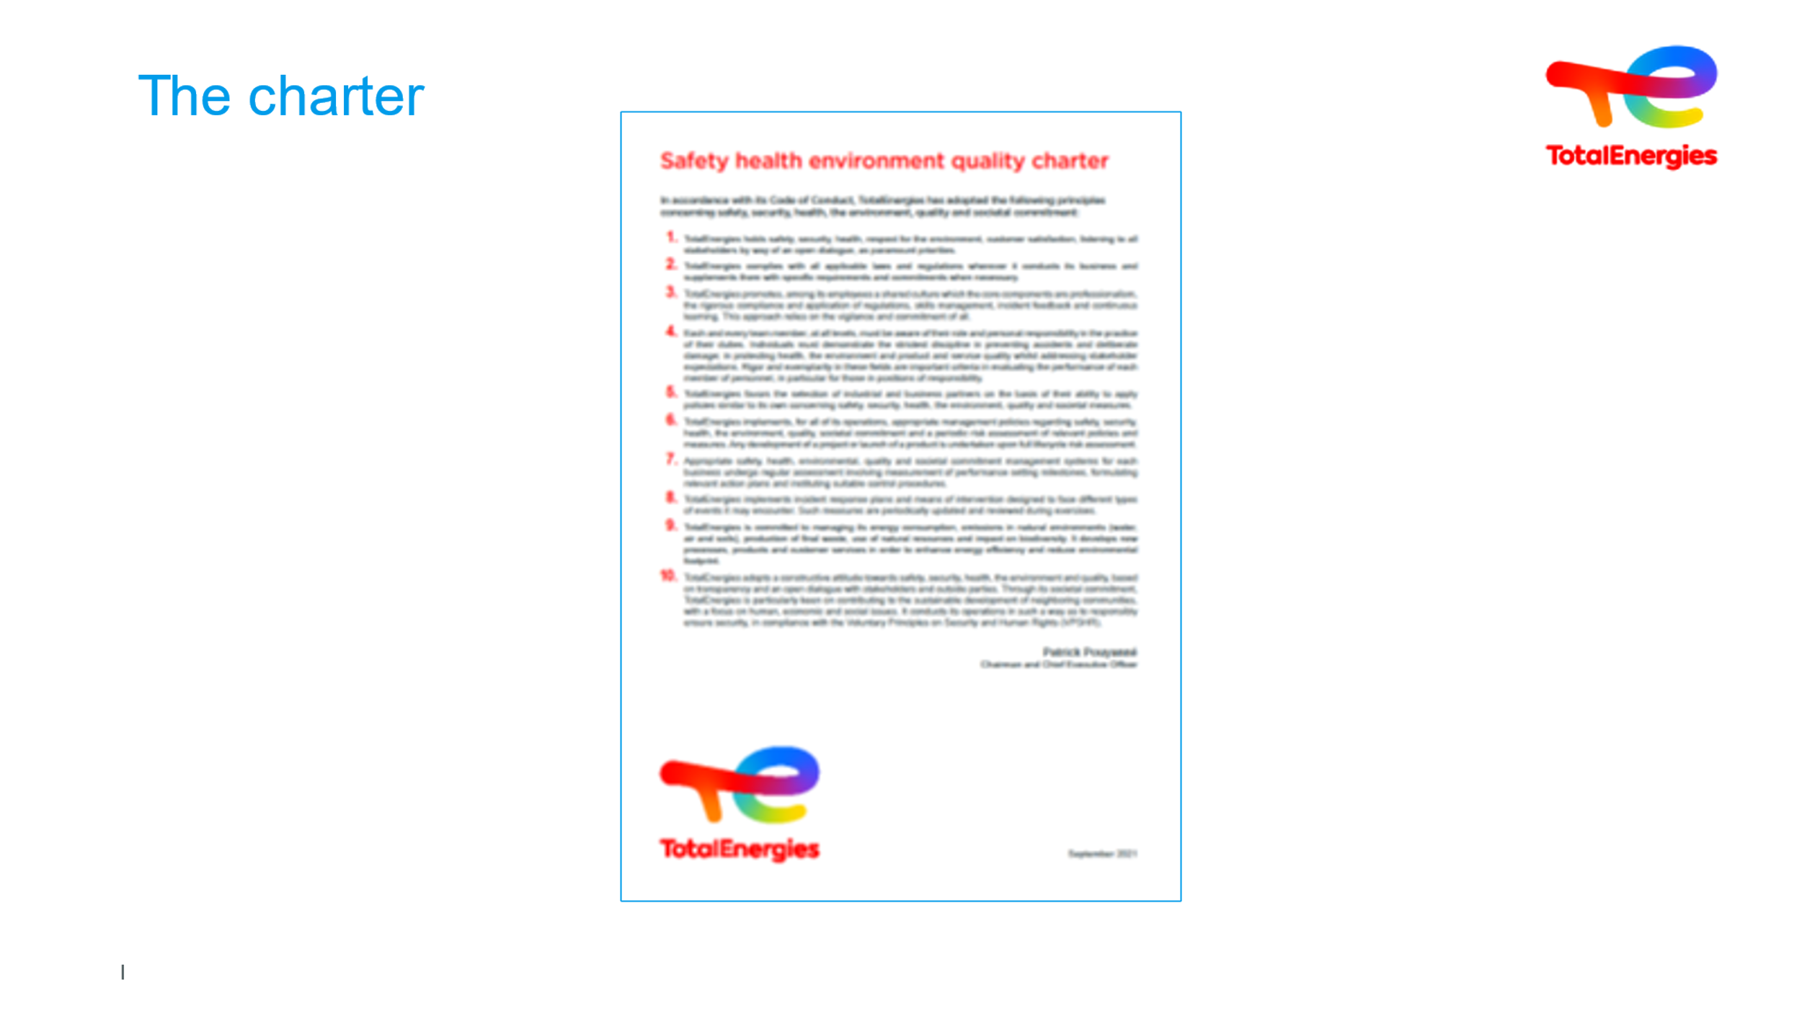  5 min | Discover the TotalEnergies charter | In the charter, “safety is a priority” because this is a 2014 edition: safety not seen as in 2020 as a VALUE | Paragraphs can be read one by one on the WAT.  The facilitator will point out that:  ● "Most often, the charter sets out the fundamental values and mission of all employees. Each employee is called upon to think and act according to these guidelines in his or her professional activity, and thus contribute to the company's success.  ● It enables each employee to carry out his or her job with full knowledge of his or her rights and duties. It applies to all activities controlled by the company, and in all countries where they are carried out. It applies to all managers and employees.  The facilitator concluded by pointing out that "we are all committed to the Charter", which is a public document available on the TotalEnergies.com website.  And that the charter is complemented by other TotalEnergies public commitments seen earlier, which are:  ● Health and safety  ● Progress commitments and indicators  ● Environment  ● Biodiversity | Slide + Oral

