Our HSE challenges 115 minutes (1:15pm/3:10pm)

 | 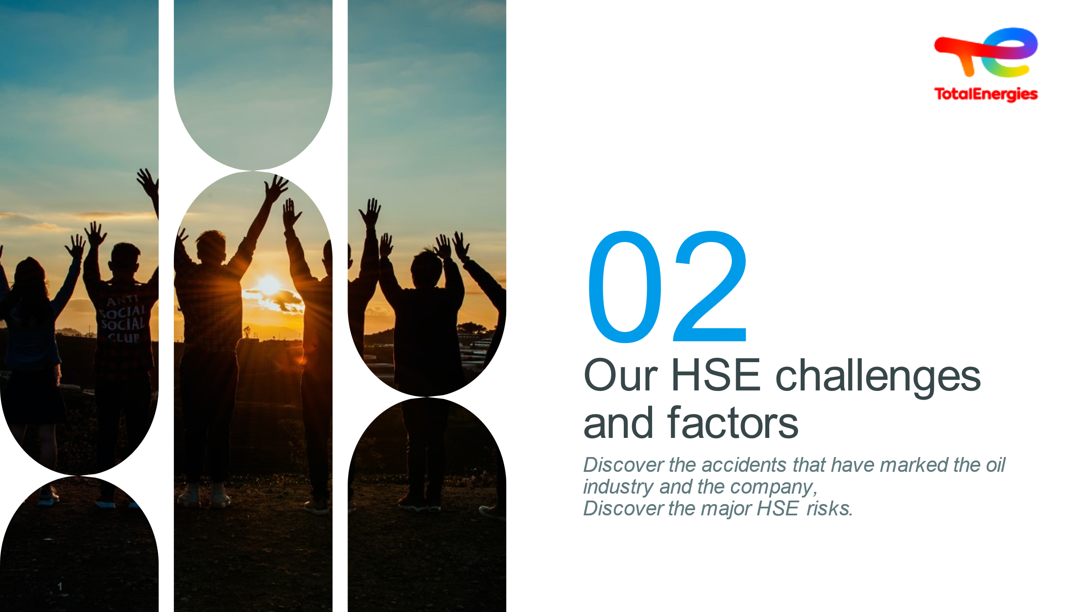 1 min | Title | Reading  Question | SEQUENCE OBJECTIVES:  - Discover the major HSE risks specific to TotalEnergies  - Discover the accidents that have marked the Group and the oil industry  - Understand that TotalEnergies operates within a regulatory and legislative framework  Before clicking, ask what HSE means  - Hygiene & Health  - Society  - Safety  - Environment | Slide + Oral
 | 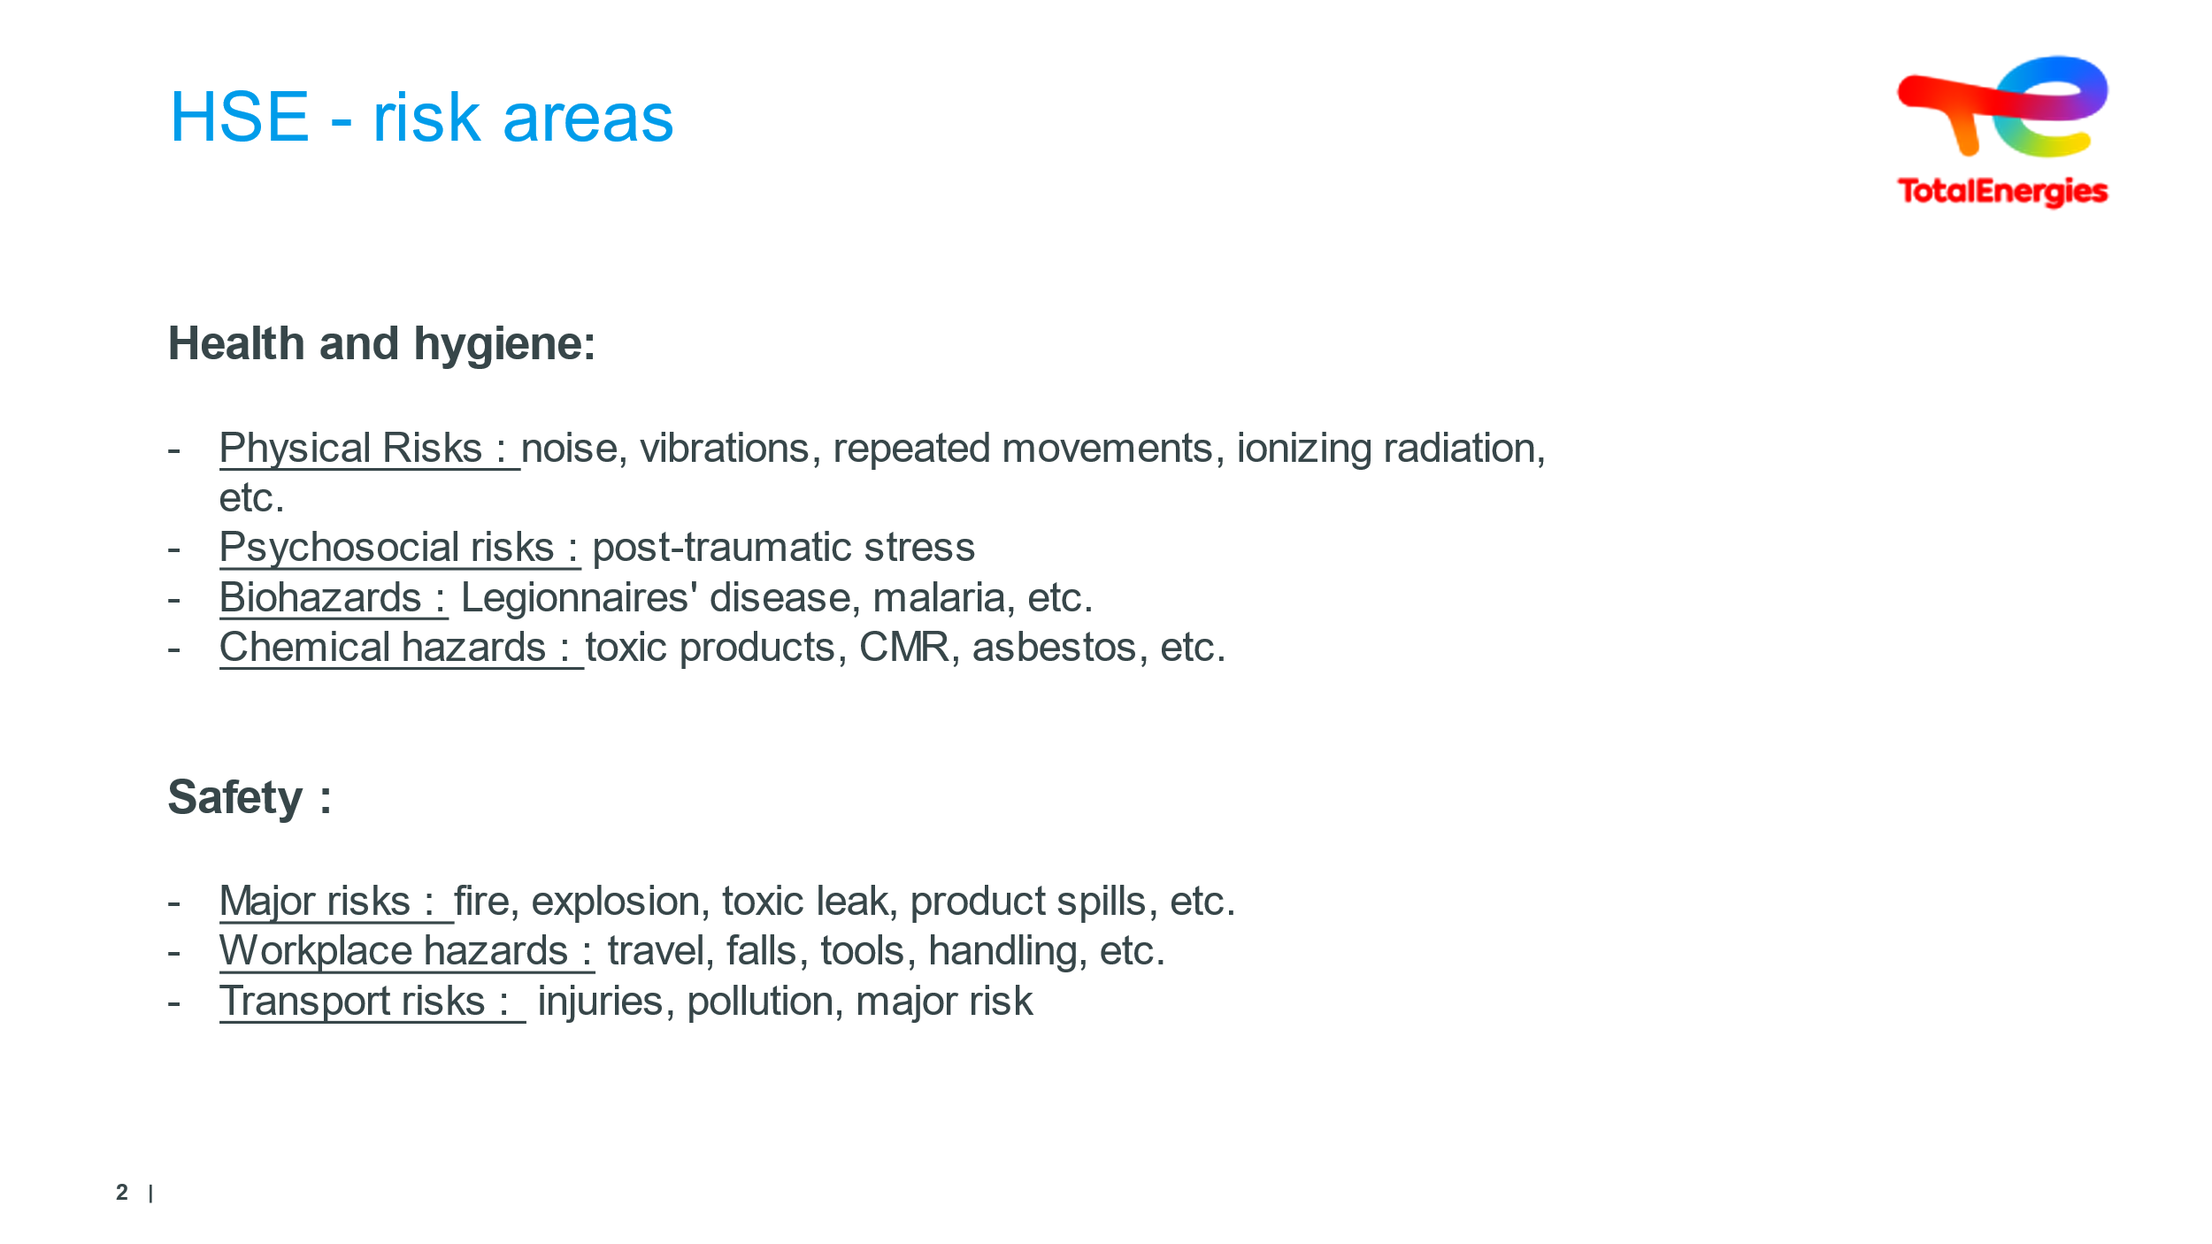  3 min | Discover the five risk areas covered in HSE | Synthesis | Read without going into detail  It is necessary to make it clear that through the phenomena listed (noise, vibration, etc.)  each of them will cause damage to people, property or the environment.  This damage can be immediate (nausea, cuts, etc.)  Or accumulate over the long term and then lead to illness (hearing loss, etc.)  Questions can be asked about the various terms, such as CMR. | Slide + Oral
 | 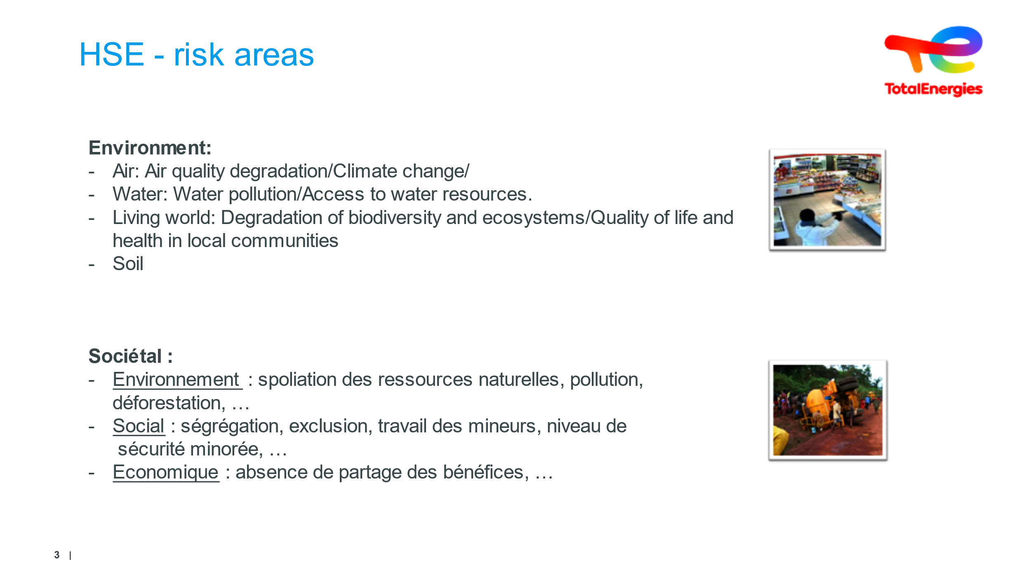  3 min | Clarify these risks by various area |  | Read without going into detail  Societal: Bachelot law post AZF, and PPRT(mitigating the risk of impact of the activity)  We will point out that there are other risks: legal, financial, media, etc.  Positive social actions to be implemented  -Identify and mitigate the risk of impact on local communities.  -Engage and build a relationship of trust with the stakeholders concerned  -Create a positive impact and shared value | Slide + Oral
 | 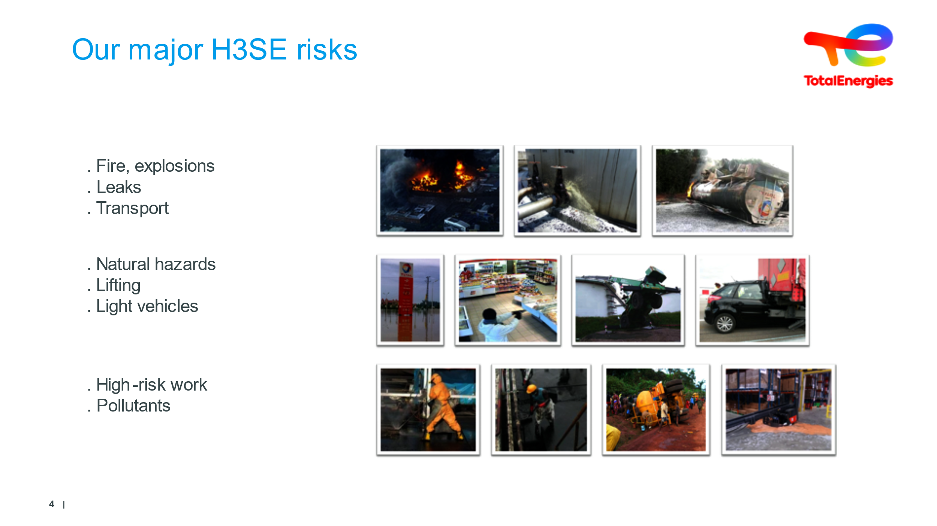  5 min | Clarify these risks by various area |  | The facilitator will further clarify the different HSE areas. | Slide + Oral
 | 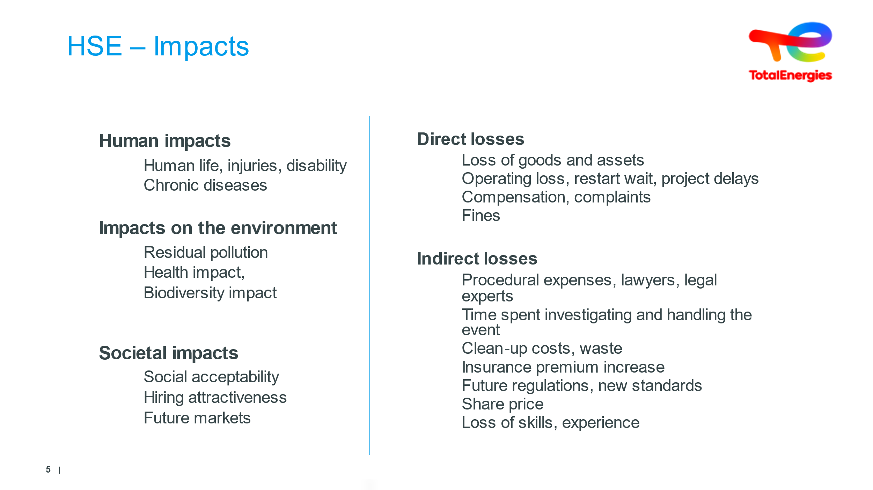  5 min | Clarify impacts |  | The trainer asks the trainees to think about the various types of impact... for each of the following areas : Human/Environment/Societal/Direct & Indirect Losses  The facilitator will emphasize the importance of preserving human life | Slide + Oral
 | 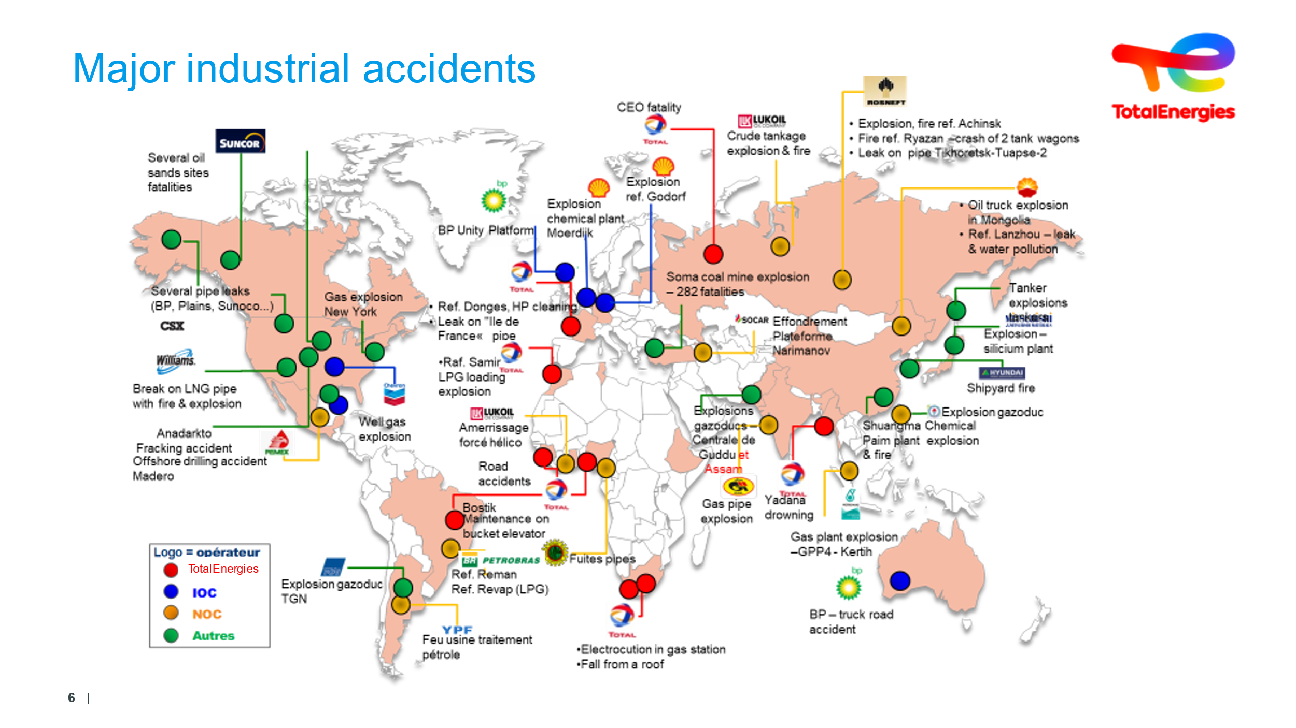  10 min | Discover the extent of industrial accidents worldwide |  | The facilitator will present the slide on industrial accidents worldwide to which oil companies are exposed. They will point out that many accidents that place all over the world  Industrial accidents: the global oil industry is exposed to them  Exposure of all oil groups:  Many accidents all over the world.  The ARIA database (Analysis, Research and Information on Accidents) at BARPI (Bureau of Risk Analysis and Industrial Pollution) | Slide + Oral
 | 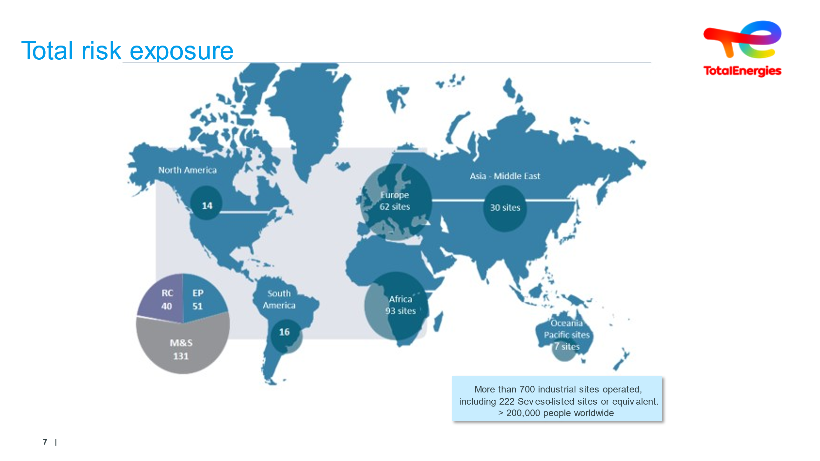  10 min | Spotlight on TotalEnergies accidents | Reading  Question | The facilitator will use Slide 35 to focus on TotalEnergies. They will present the figures.  “TotalEnergies is highly exposed to industrial risks.”  For each incident, ask learners to guess, or talk them through the human, ecological, and social impacts as well as direct and indirect losses. | Slide + Oral
 | 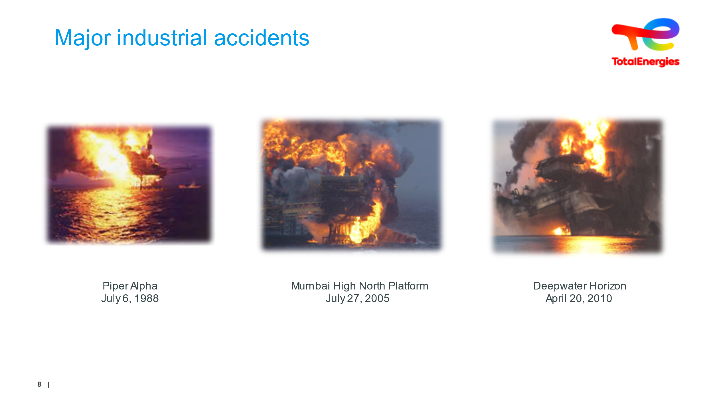  2 min par accident |  |  | In addition to major technological accidents at industrial sites, there are also events in the upstream EP branch.  Do not go into detail about these accidents.  But to reinforce the point that distances lengthen the arrival times of external reinforcements and that, as a result, everything has to be organized on site...  The site manager is trained and authorized by the employer before taking up his post, and is also retrained...  But the drills must keep all personnel on constant standby and in a state of readiness to react, as planned.  The + :  Piper Alpha:  Piper Alpha is the name of a former oil platform located in the North Sea near the Piper field. It was first operated by Occidental Petroleum in1976. Originally intended for oil extraction, it was later converted into a gas platform. Work began on one of the compressors and was expected to be limited to the day. At the end of the day, the work had not been completed, but no further action had been taken (no information to the upstream crew, no entry in the watch book, etc.). On the night of July 6, 1988, when the second compressor was vibrating, the shift supervisor decided to switch operations to the compressor returning from work. This changeover was carried out from the control room, without visiting the site. This changeover led to a gas leak, the loss of the platform and 167 fatalities.  Deepwater:  The Deepwater Horizon explosion refers to an explosion and extensive fire that occurred on April20, 2010, on theTransOcean Deepwater Horizon drilling rig, whichwas working on behalf ofBP.  The rig sank two days later, and now lies at a depth of 1,500 m. Prior to these events, 126 people were present on the platform. Of these, eleven people were initially reported missing, then officially declared dead. A further 17 people were injured among those repatriated to the mainland.  Mumbai :  ONGC's unfortunate accident in Mumbai (India) caused a devastating fire that resulted in complete damage to the MHN platform (a 30-year-old, 7-storey platform). with a helicopter positioned on it and is ranked as the seventh most expensive accident in the oil and gas industry costing around $195,000,000.
 | 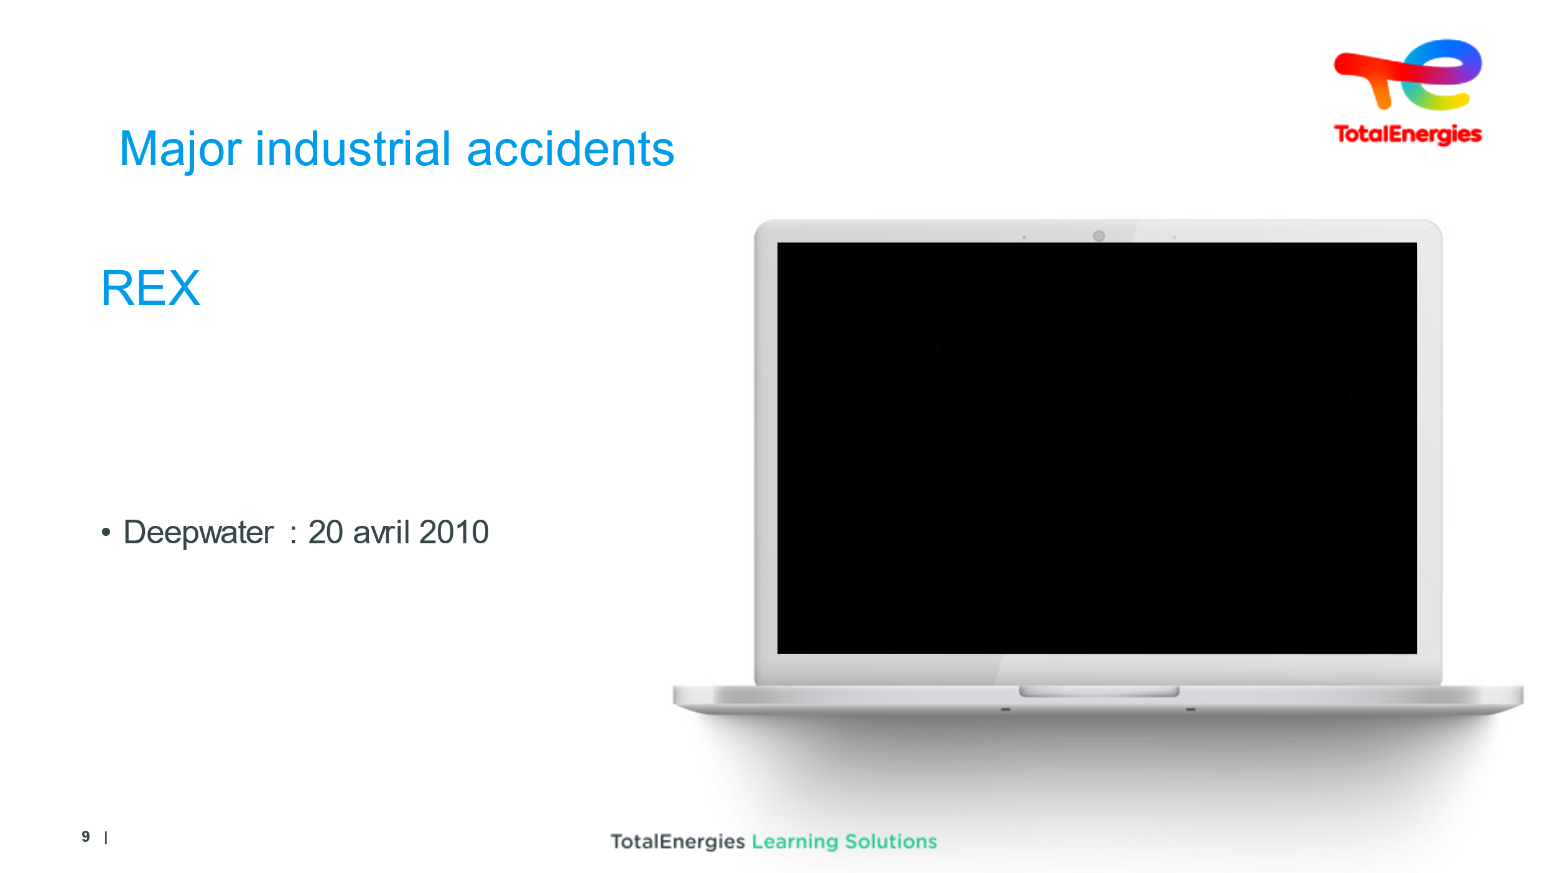  1 min | See the phenomenon of a major industrial accident | Deepwater | Refer to the terms used by the journalist.... | TF1 Video
 | 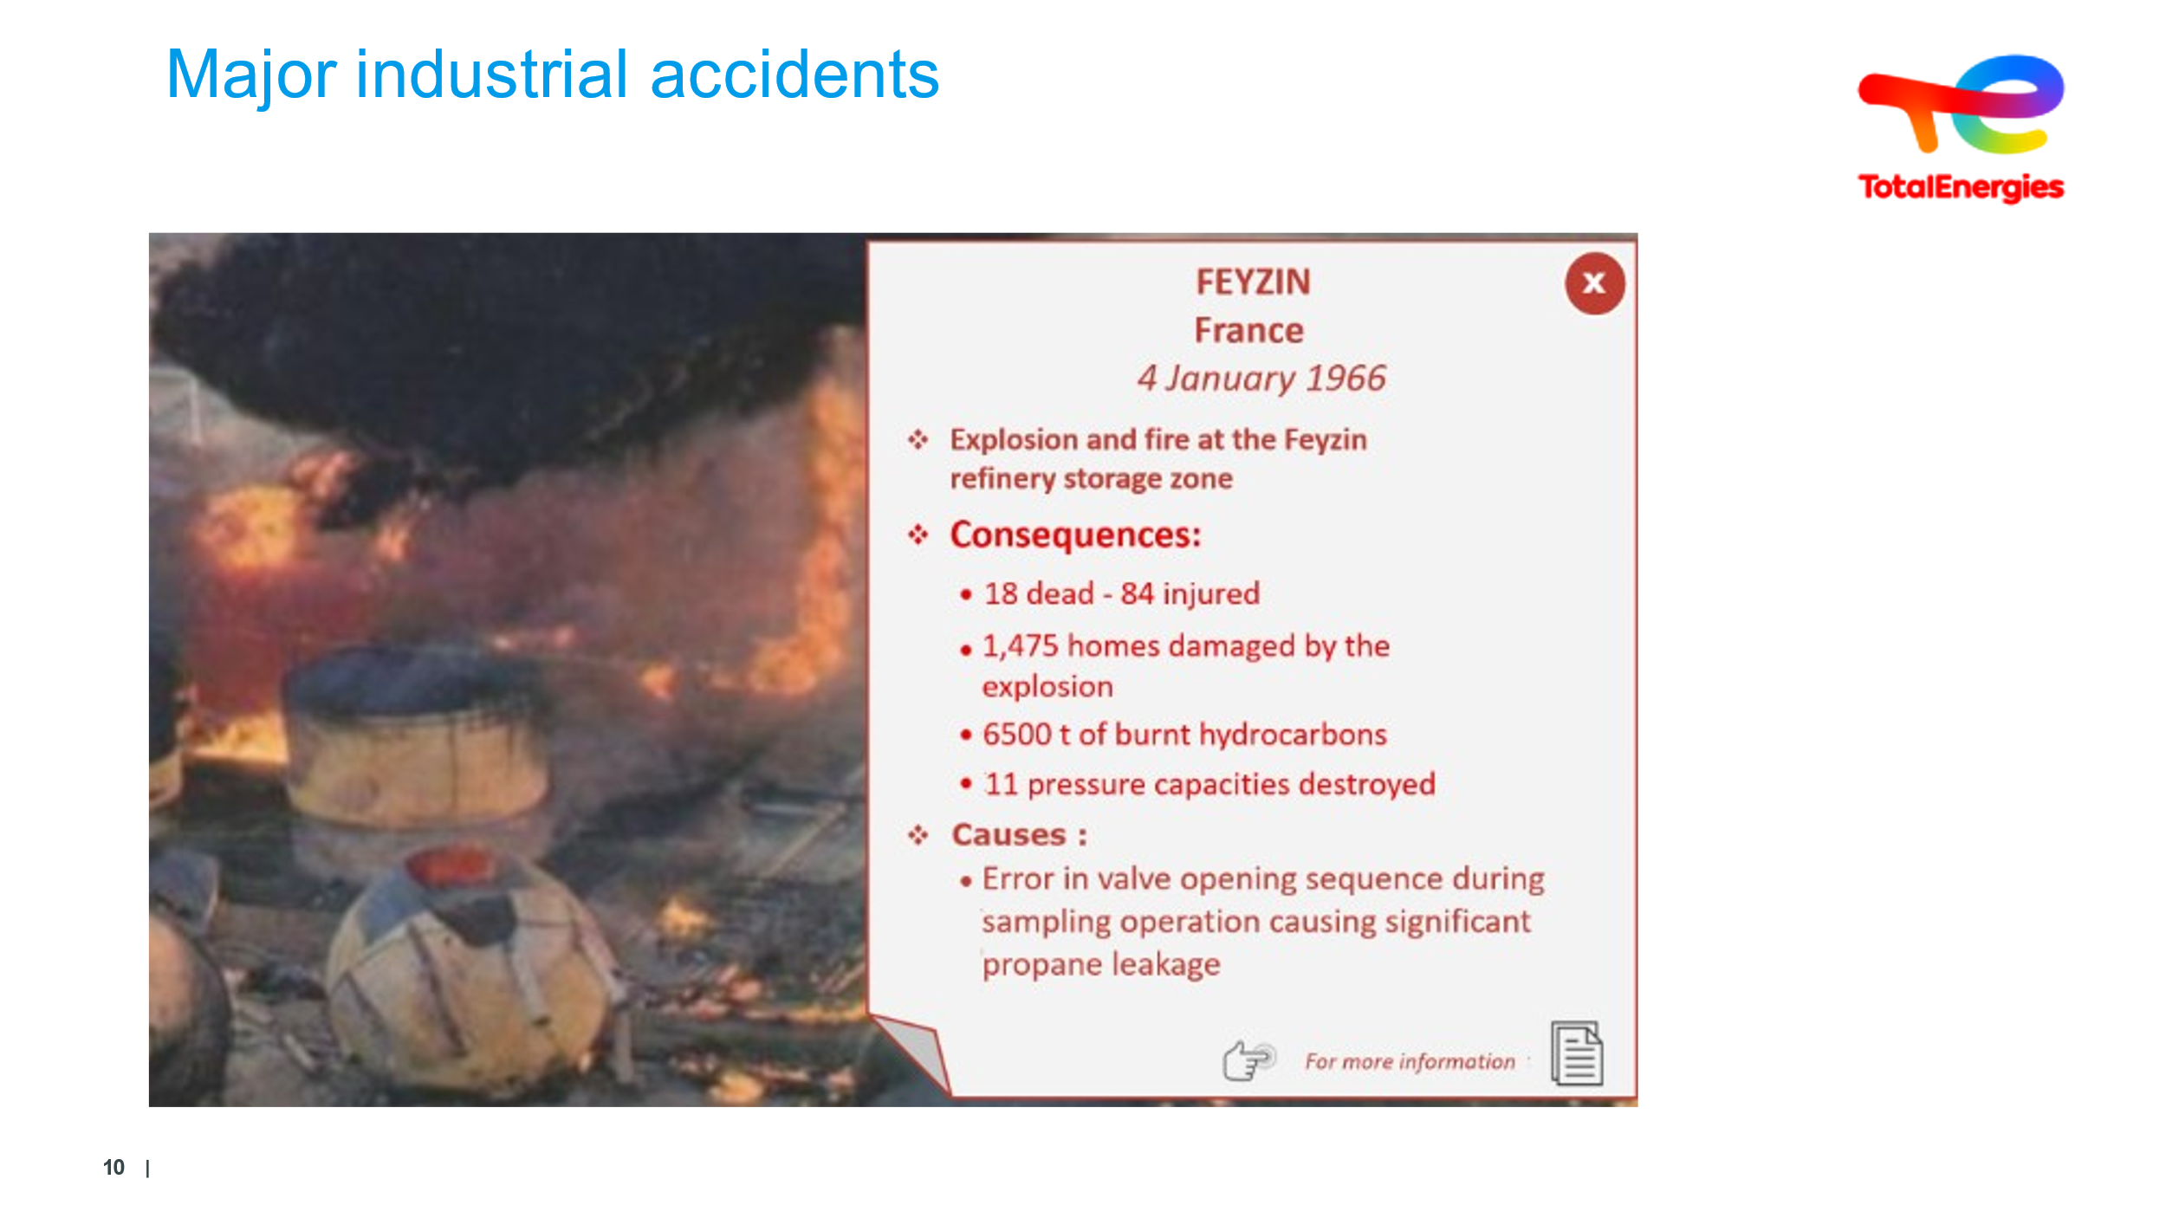  5 min  including  30s of video | See the phenomenon of a major RC industrial accident | FEYZIN | FEYZIN : January 4, 1966  Following sampling, a propane and then butane leak occurs. A vehicle serves as the ignition point. (18 dead including 11 firefighters)  This accident was the accident that marked the oil industry in France. It results in improved emergency management, with standards for the construction and operation of oil sites ushered in.  Order of September 4, 1967/the forerunner to the POI (internal operation plan, Plan d'Opération Interne), internal relief organization & work authorization.  Added extras:  The trainer can explain BLEVE.  BLEVE: Boiling Liquid Expanding Vapor Explosion | Slide + Oral  +  VIDEO Info 1966 + BLEVE
 | 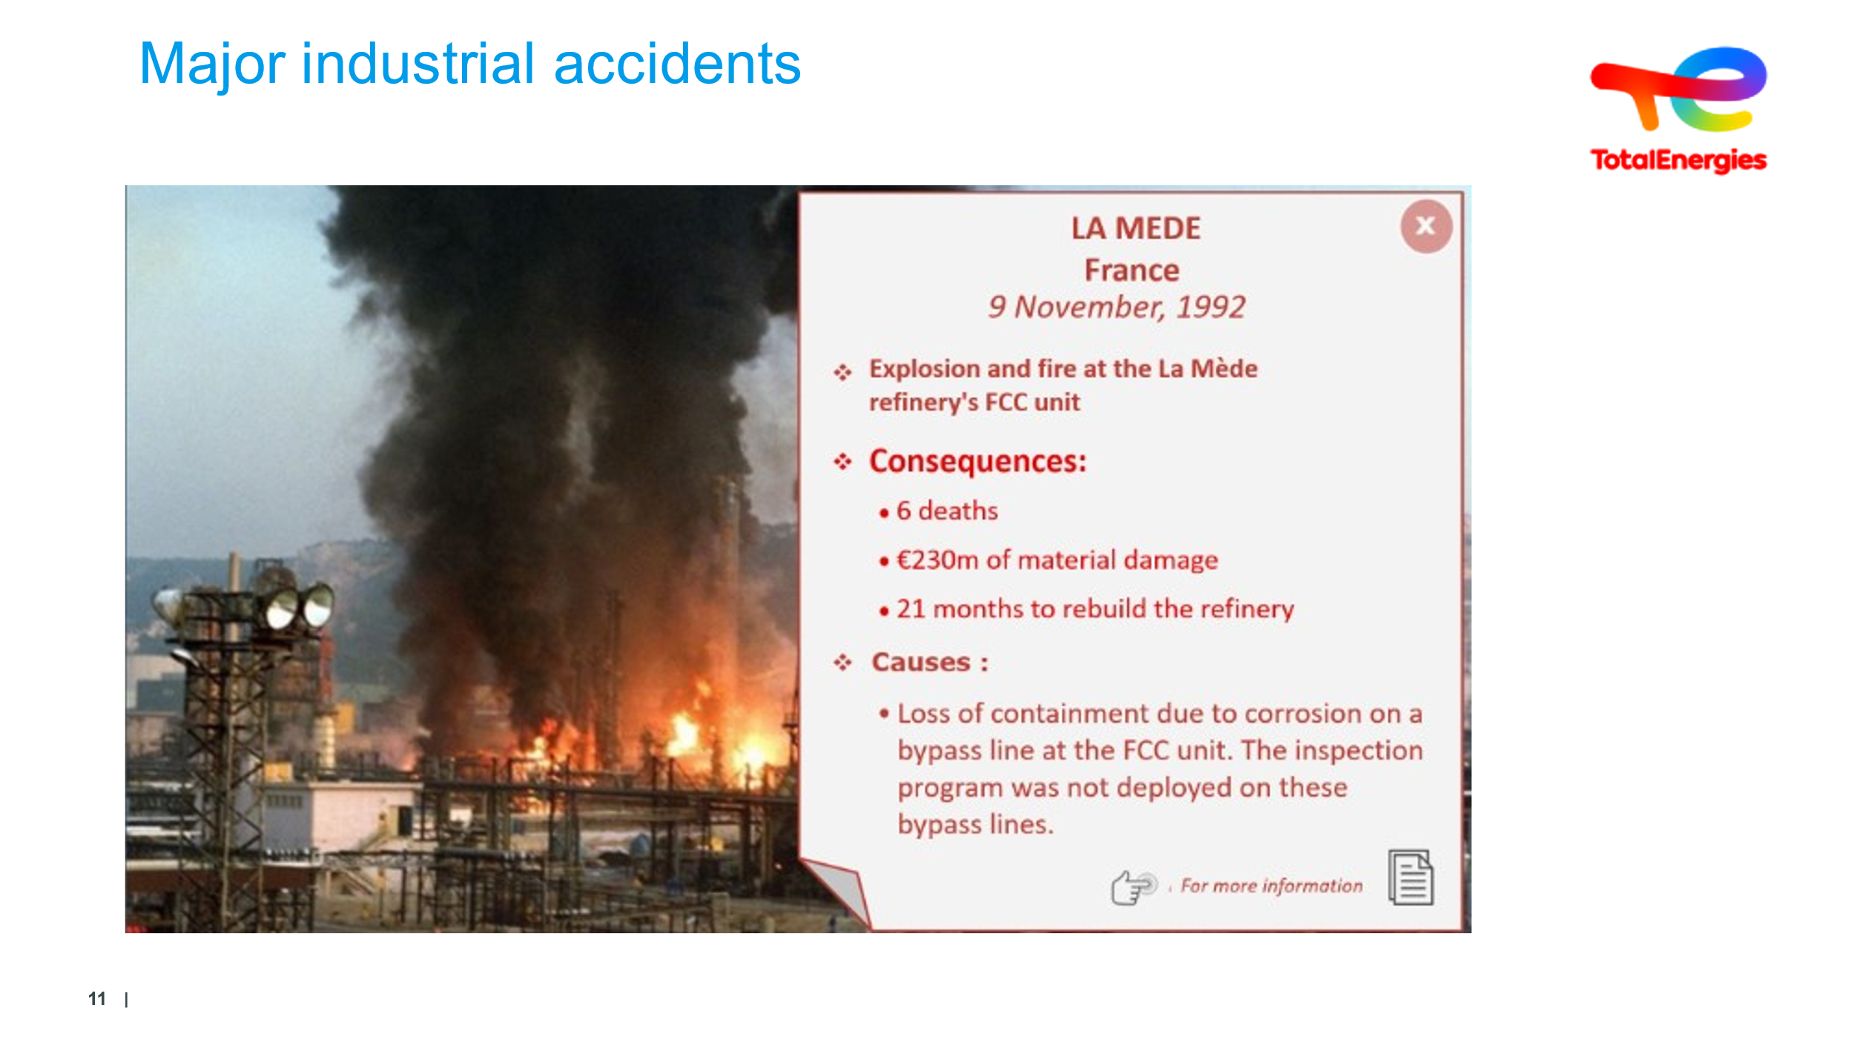  5 min | See the phenomenon of a major RC industrial accident | MEDE | La Mède November 9, 1992: 6 dead  Cause: rupture of a corroded pipeline that was not included in the inspection plan.  Added extras : line was not inspected as it was a bypass line/  Consumption 150 m³ foaming agent/  (equivalent to 5 tons of TNT)/  Cost of 3 million Francs - €250m | Slide + Oral
 | 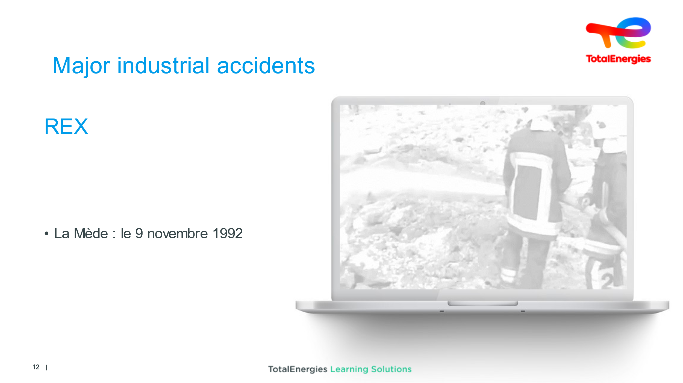  1 min |  |  | Launch video
 | 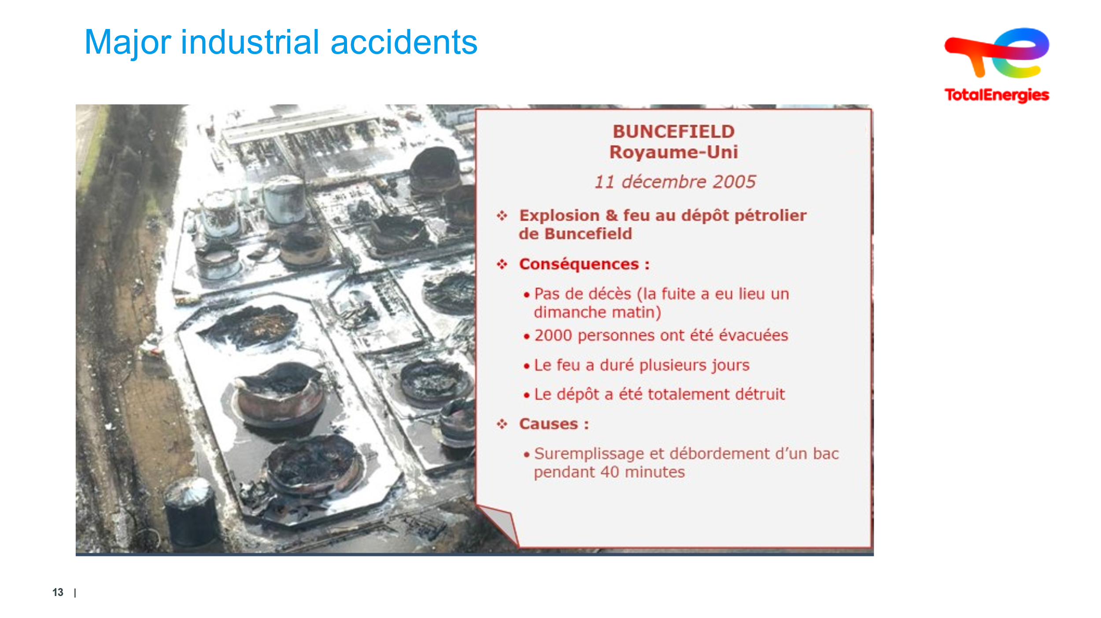  5 min | See the phenomenon of a major industrial accident | BUNCEFIELD: a storage facility wiped out/Water consumption & foaming agent | This is a typical demonstration of the domino effect...  This was a 40-minute gas tank overfill that triggered a series of explosions and fires, completely destroying the depot. No deaths because nobody was on site.  The damage shows just how difficult rescue efforts were...  Added extras:  UVCE: Accidental open-air gas explosions or UVCE (Unconfined Vapor Cloud Explosion)  Buncefield: December 11, 2005, but depot totally destroyed (273,000m³).  Smoke visible from London (40 km)/  Water consumption 68,000 m³ & Foaming agent 786 m³/  30km of piping used/  These figures demonstrate how difficult it was to contain.  Cause: tank overflow during overfilling for 40 min, vapor cloud and multiple explosions  The trainer can explain via the associated BOIL OVER video and extension of gas following leakage via UVCE. | Slide + Oral
 | 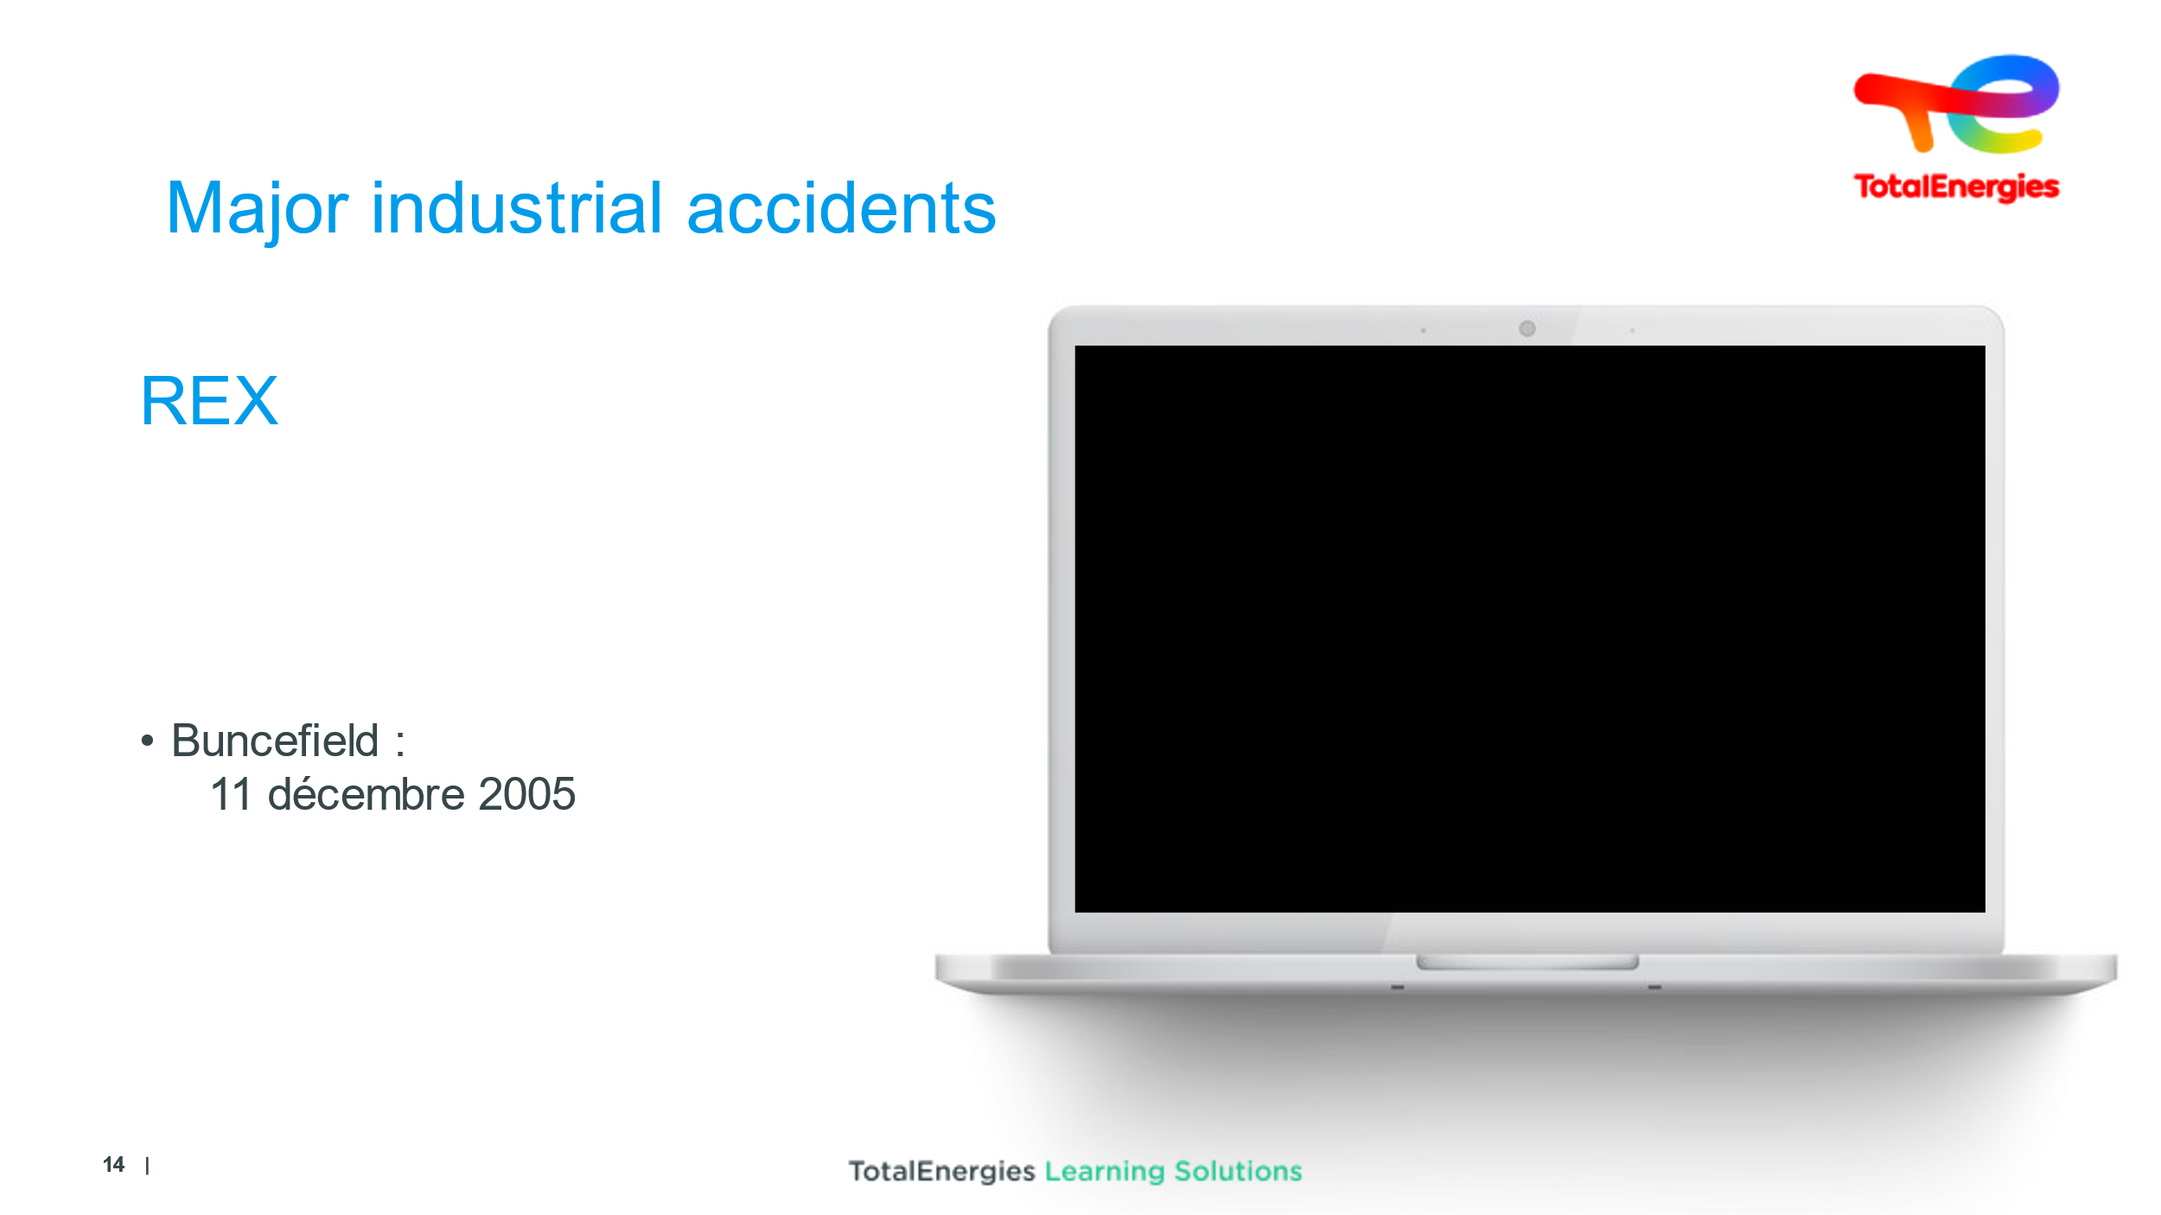  1 min | See the phenomenon of a major RC industrial accident | BUNCEFIELD | [Sound deliberately muted]  Smoke / London 40 km under the smoke....…. | Video
 | 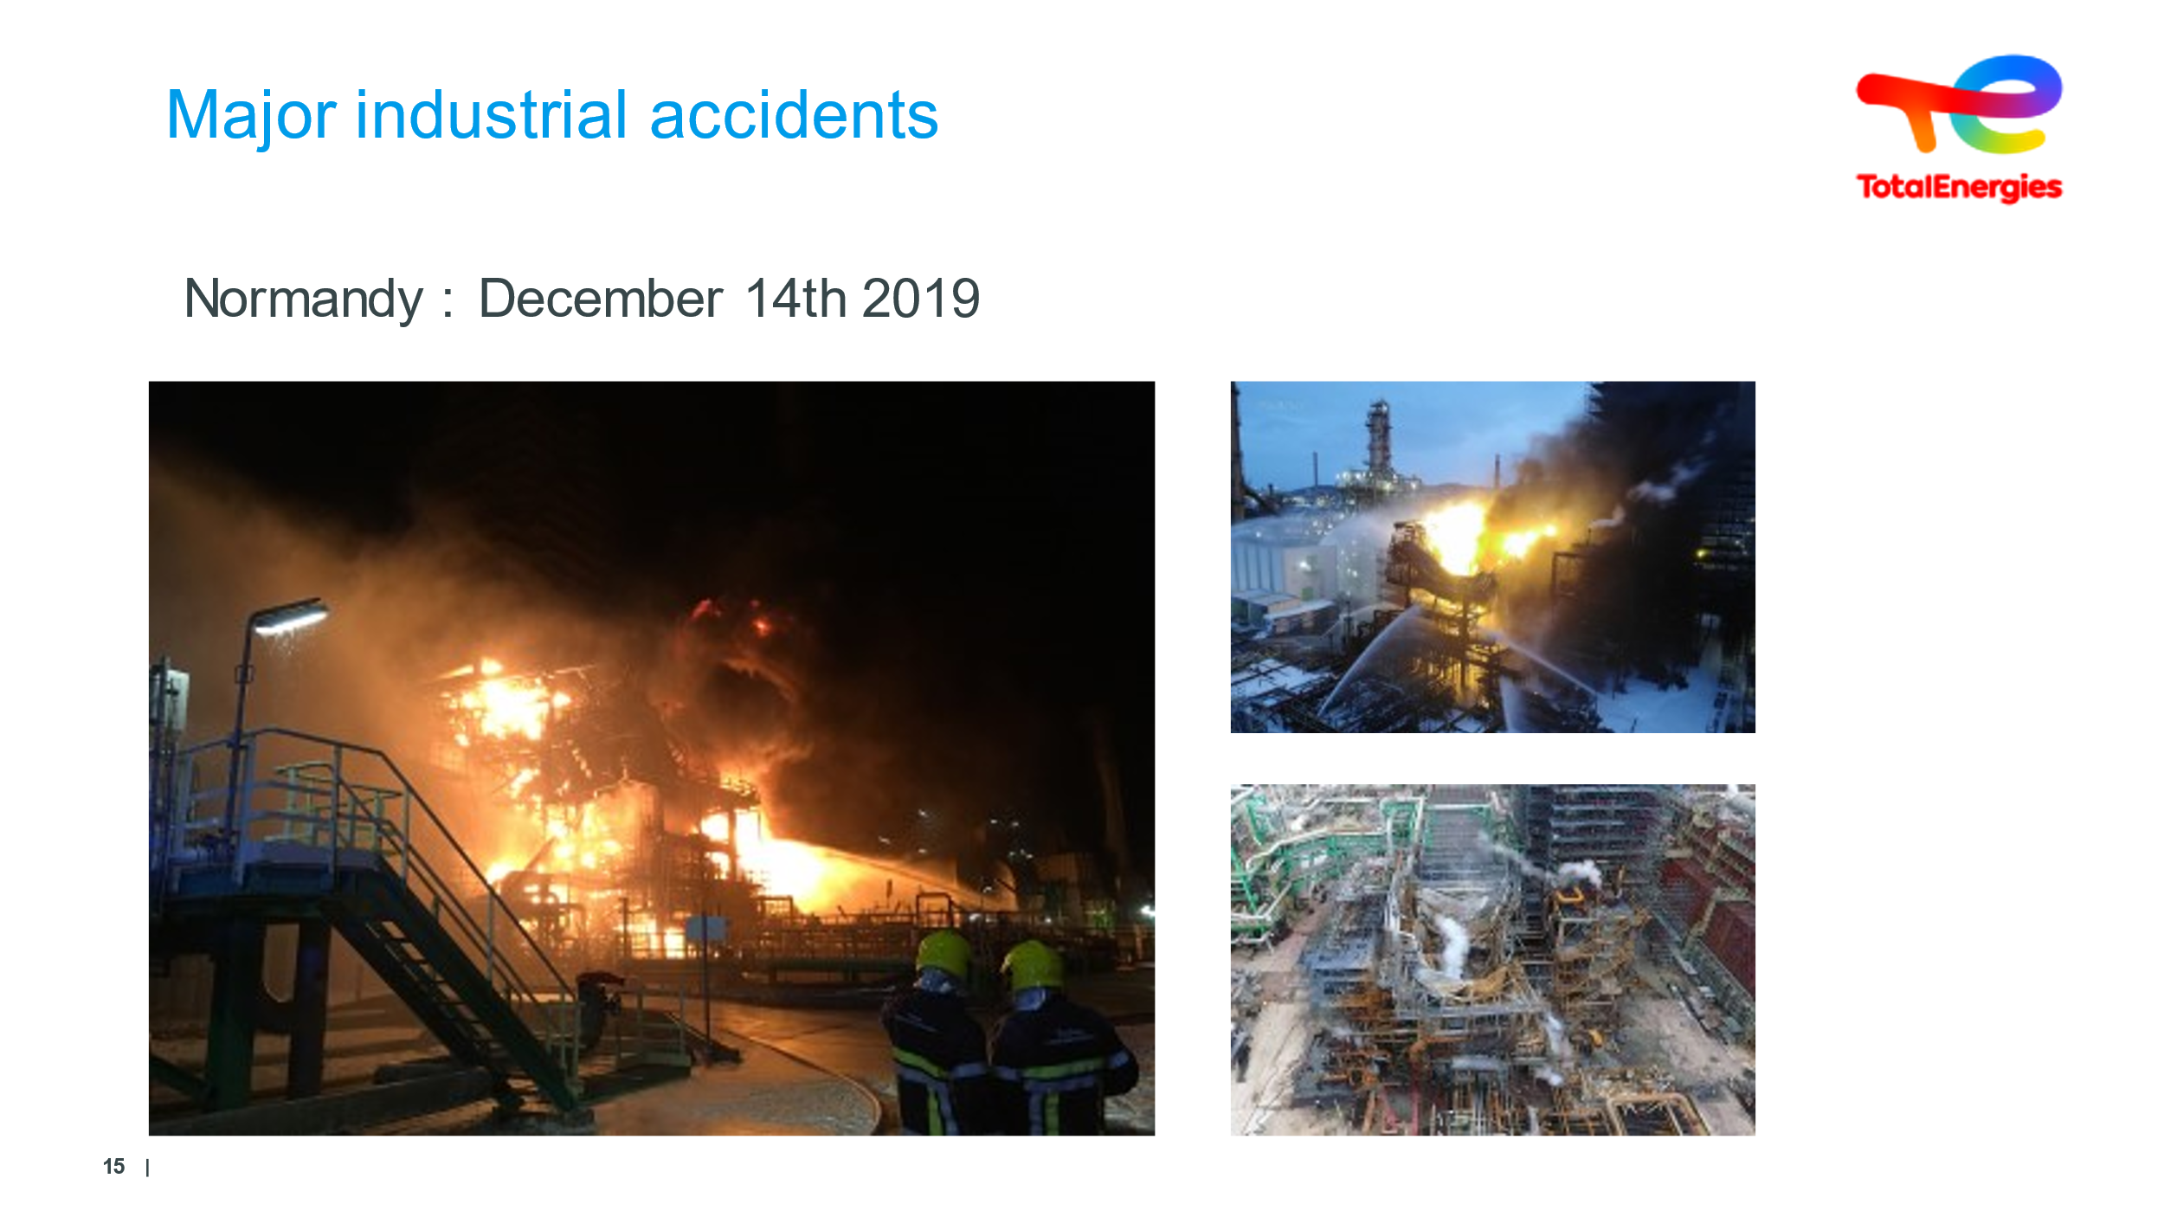  5 min | See the phenomenon of a major industrial accident |  | REX Normandie 14/12/2019 (during COVID crisis)  On December 14, 2019, at 3:15 a.m., a leak of approximately 3^{m3/h} occurred on a gasoline line near the pumping area of distillation unit D11 at the Normandy refinery.  A leak is detected by the instrumentation, but not immediately by the control room operator, and a quantity of gasoline develops in a piece of equipment.  At 3:37 a.m., the gasoline tank ignited and the fire spread to part of the distillation unit.  The fire was extinguished around 2 p.m. on December 15.  Consequences: No injuries / 12-month shutdown due to refusal by DREAL, then approximately 6 months for repairs.  Causes : - Leak in fuel line  - Leak under trugnion - external corrosion  Added extra :  - No inspection of this singular point  - Delay in leak detection  - First-level alarm not detected (6 times), flashlight confused with process alarm  - Unintentional masking of alarms  - Lack of knowledge of ECL (control system)  - Effectiveness of fire-fighting response (no over-accidents linked to gasoline reflux balloon)  - Lack of water for the first 30 minutes for the emergency service  - Fixed fire-fighting equipment not taken into account in emergency plan (unknown flow rates)  - Lack of communication in the field and inadequate management of the fire-fighting water network. | Slide + Oral
 | 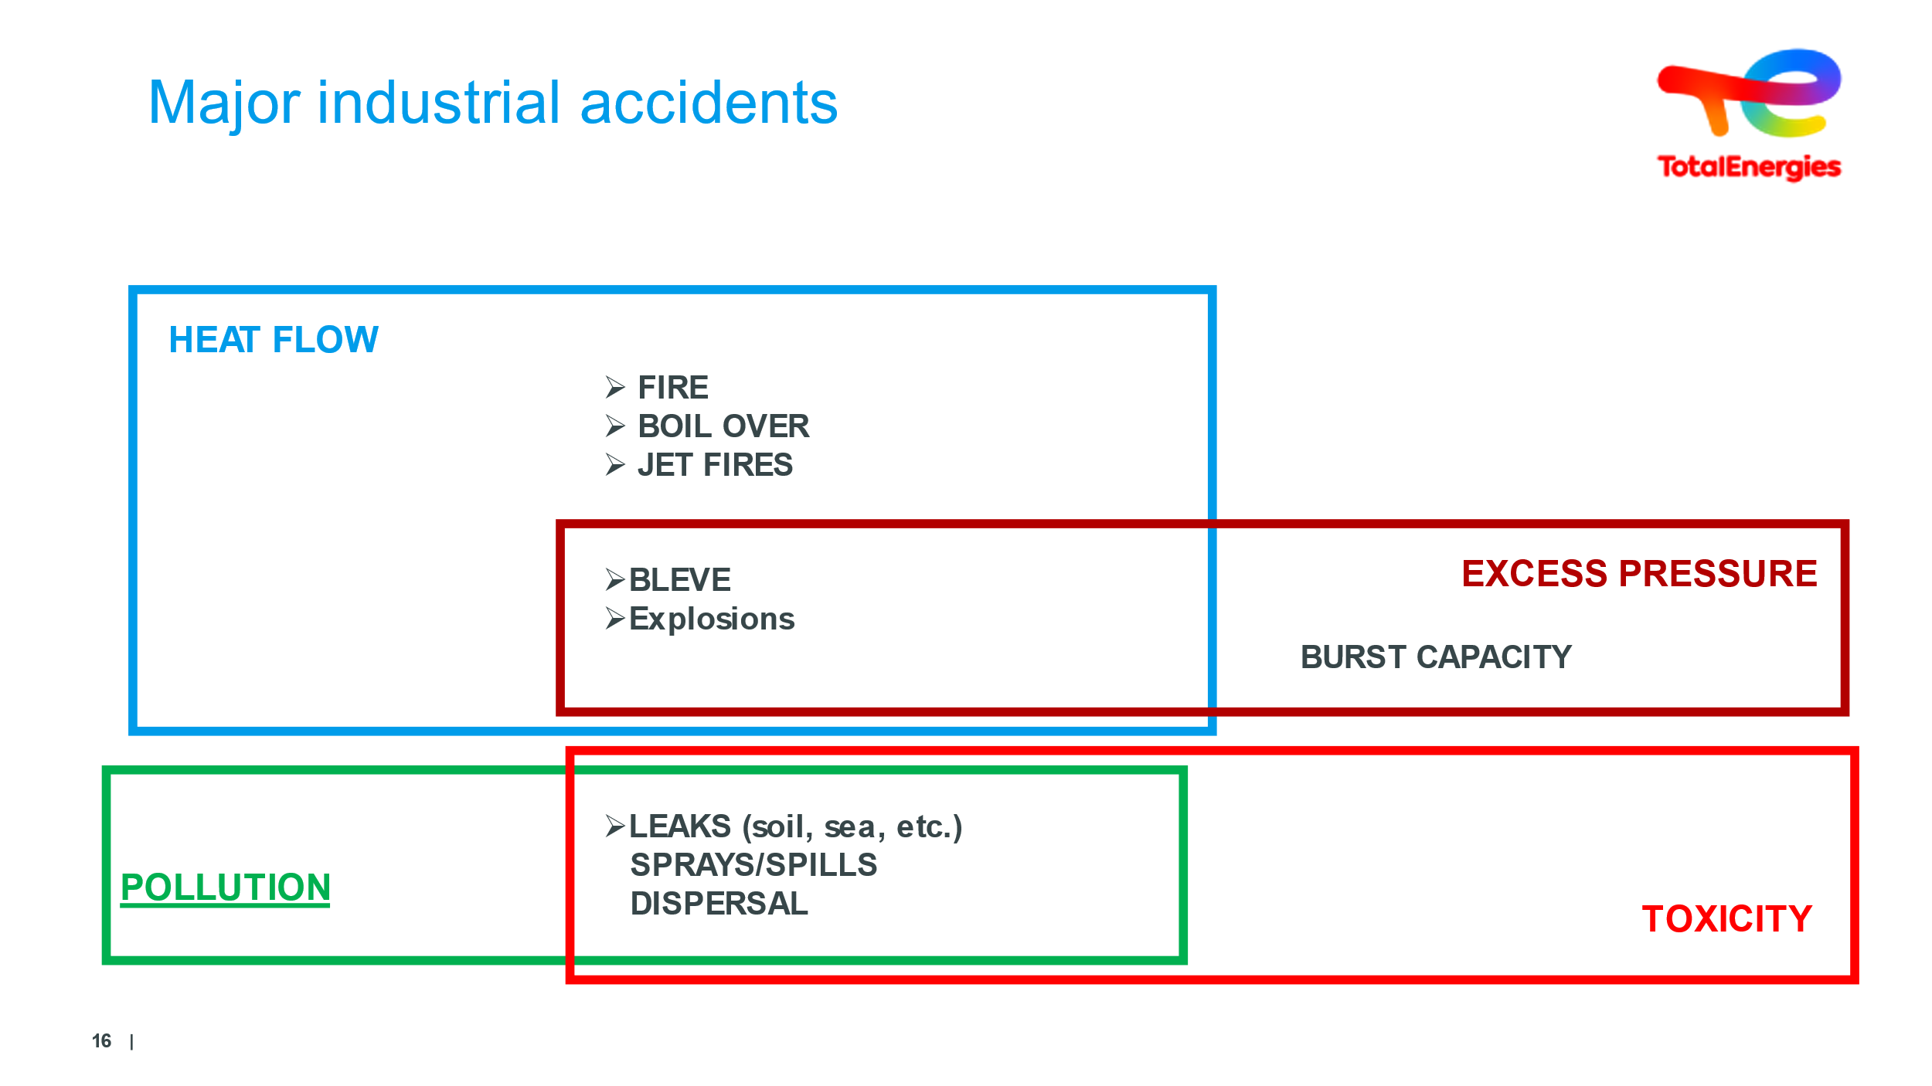  4 min | Discover the domino effect | If the starting point is absent, nothing happens | What types of consequences and effects can you define in our sites?  Heat flow/Pollution/Toxicity/Excess pressure  What types of events can occur on our sites?  Each event taken in isolation can thus be the starting point of each phenomenon. Continue by specifying that each can give rise to another and so on. Escalation has been triggered, but how far will it go?  The domino effect is to be studied as part of reflection into dangers.  Their effects and consequences should be studied. Some catastrophes are sparked by domino effect.  Make people aware that without loss of containment or product leakage, there are no dangerous phenomena.... Excluding thermal runaway linked to batteries | Slide + Oral
 | 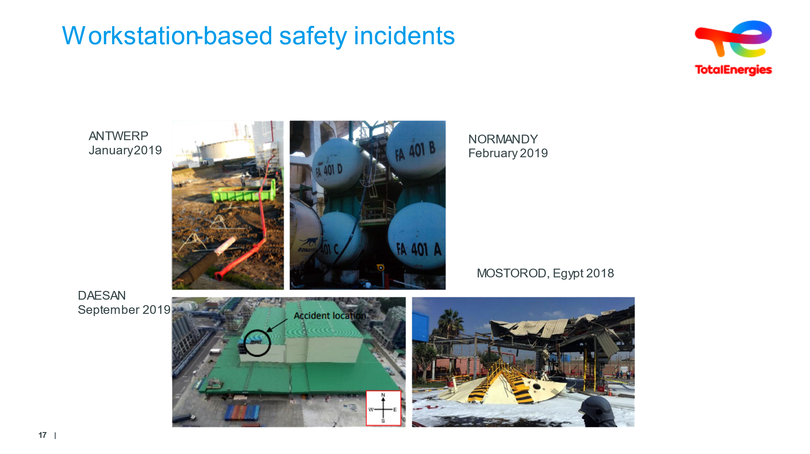  4 minutes | Present the most recent safety incidents at TotalEnergies |  | - Earlier, we took a look at industrial accidents (Technological Accidents), but accidents can also occur at workstations.  - These events only impact those located at the workstations, and can be just as deadly.  - In these cases, the events are caused by a lack of preparation, coordination, change in conditions. They affect all EC staff, but we’ll get to that later.  - Added extras:  - Antwerp, January 2019:  Replacement of fire system piping, working at 1.5m underground. After removing 7/8 bolts, the line (450kg) supported by a hoist & telescopic machine fell from its support structure and caused a worker to fall down a 1.6m drop! Skull fracture!  ALERT-RC-RBE-2019-005.pdf  - Normandy February 2019:  A person fell from 10m high when sand-filling by hose. This hose was fixed to the railing and caused both the railing and the victim to fall  ALERT-RC-RBE-2019-006.pdf  - DAESAN September 2019: Korean refinery,  - The explosion occurred on a steam pipe in a petrol production unit during maintenance operations.  ALERT-RC-RPO-2019-081.pdf  - MOSTOROD Egypt February 2018: very little product (under 15L) with huge consequences: two dead/roof of the tank blown 40m high! VIDEO to show  REX-MS-AFR-2019-024.pdf | Slide + Oral  + VIDEO to be inserted
 | 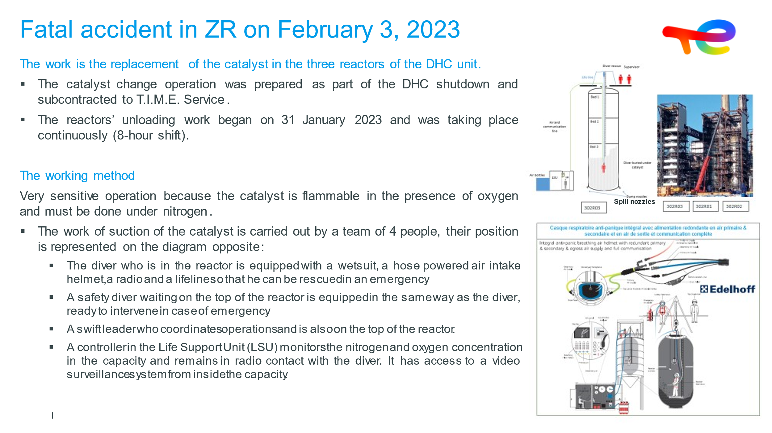  2 min | Present the latest fatal events at TotalEnergies | Present the latest fatal accidents at TotalEnergies involving our sites |  | Slide + Oral
 | 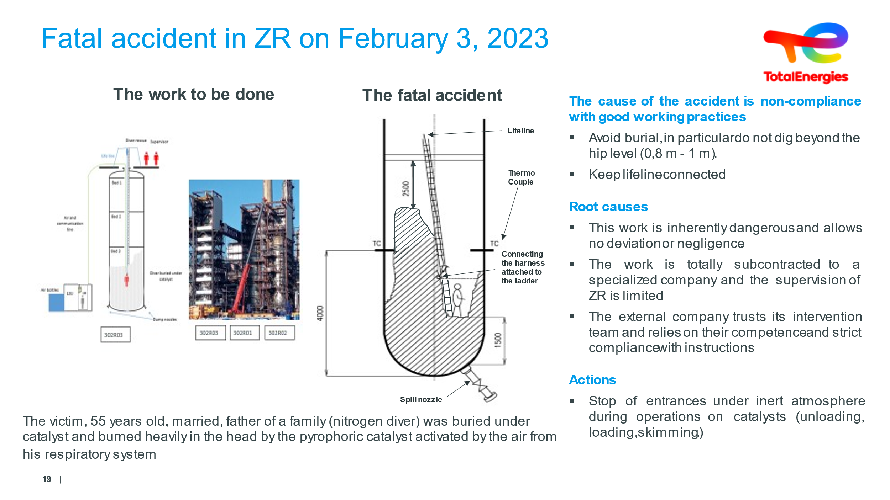  2 min | Present the latest fatal events at TotalEnergies | Present the latest fatal accidents at TotalEnergies involving our sites |  | Slide + Oral
 | 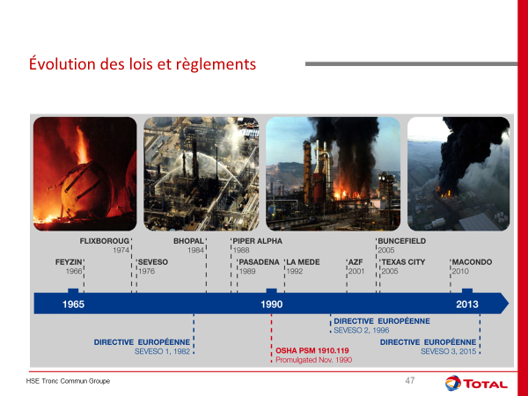10 minutes | Changes to texts | Make it clear that previous incidents paved the way for key regulatory texts | DON'T GO BACK OVER THE ACCIDENTS...  The law and regulations exist to ensure the safety of the surrounding populations.  In particular by means of checks, safety and environmental studies (authorization before plant/factory openings), constraints  To ensure that manufacturers are in control of their risks.  Our facilities are listed environmentally-sensitive facilities due to the risk they pose.  The Seveso directives allow for several risk levels - Unclassified/Declared/Authorized/Authorized with Restrictions.  What is a European directive? The laws made are Europe-wide, and are intended to be applied within each country’s legislation, with the same constraints. Each country can harden the law, but cannot soften it.  Seveso European Directive: Land facilities.  European OFFSHORE Directive 2013 for Off-Shore installations!  US Directive: OSHA PSM (Occupational Safety and Health Administration – Process Safety Management)  Added extras: For TOTALENERGIES, the principle of applying the most binding laws is in force | Slide + Oral
 | 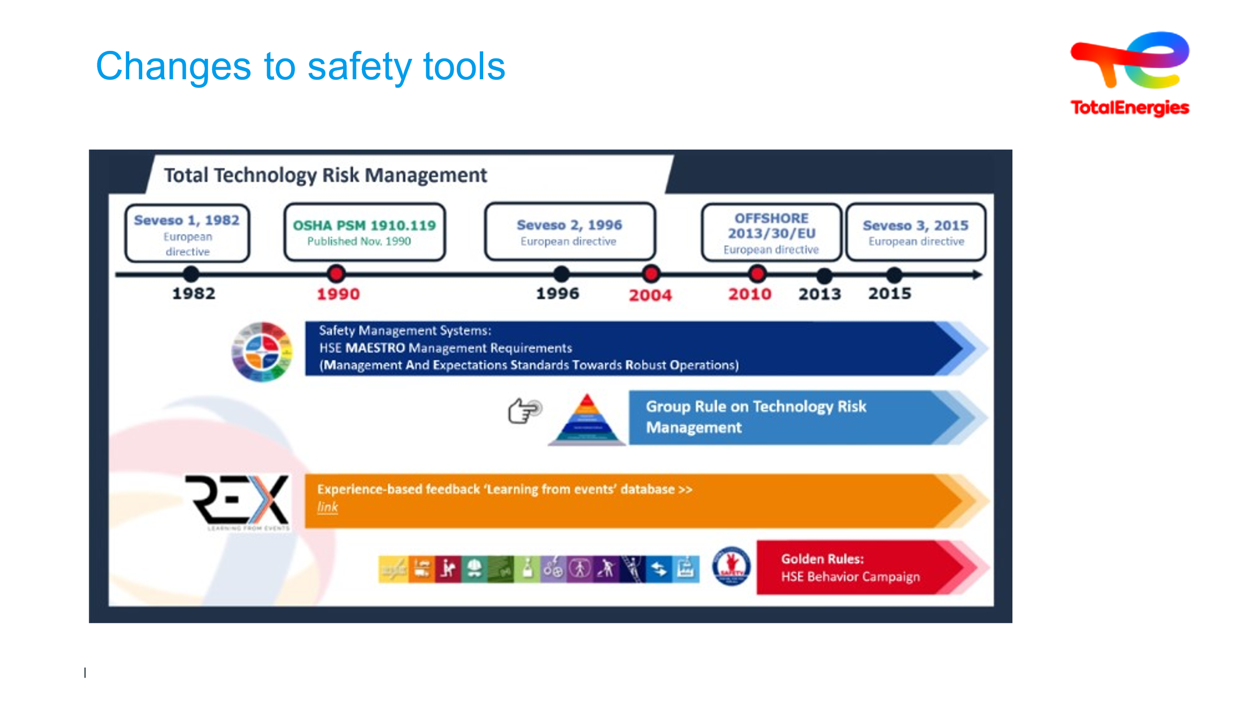  5 minutes | Changes to safety tools | Understand that events lead to major regulatory texts | We will look at these tools later on. At TotalEnergies, action has also been taken.  • TotalEnergies is highly exposed to all kinds of risks (HSE)  • Were they left uncontrolled, these risks would lead to HSE consequences (and material and immaterial damage) to local communities, our clients, our neighbors, our own staff, our facilities  • Losing your life or being injured while working at or for TotalEnergies is a failure for our entire Company  • One of the major risks is the Company's downfall  • We want our Company to be sustainable and exemplary in terms of HSE  As a result, the Company has put in place TOOLS and a SYSTEM that endures and is strengthened over time.  OFFSHORE 2013/30/EU: European directive similar to Seveso, with regard to offshore installations.  2010 : The Golden Rules  2015 : Transportation Management Stystem & associated inspections  2017 : Safety, a core value  2019 : « Zéro fatal accidents » goal  2020 : « Our lives first » program  NOTES:  Find the dates on which the various tools presented were implemented.  Indirect question: why are there red dots for 1990/2004/2010? | Slide + Oral

