Risk management, management framework & SMS - 52 min
 | 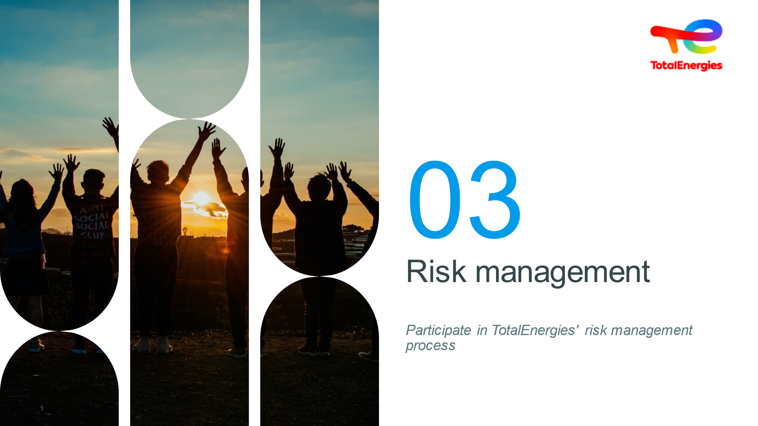  1 minute | Title: Risk management |  | At the end of this module:  You will be able to explain what risk management is | Slide + Oral
 | 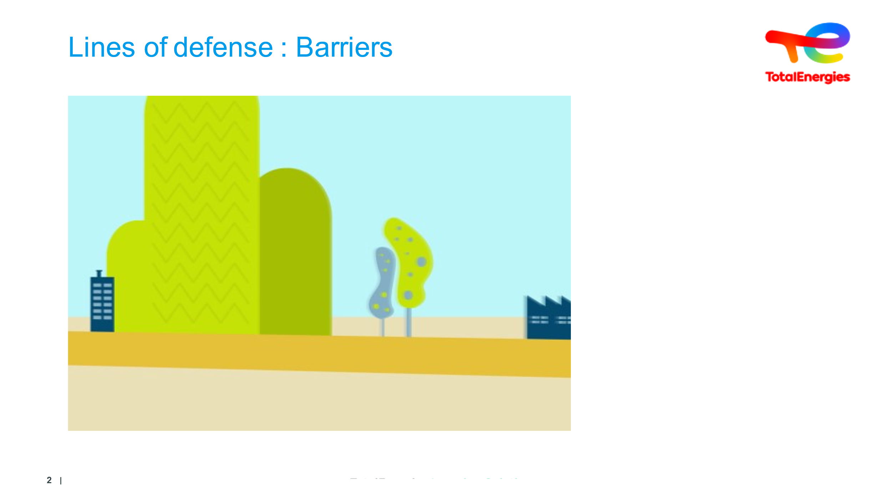  4 minutes | Understanding the concept of a barrier | Video | Play Video | Video
 | 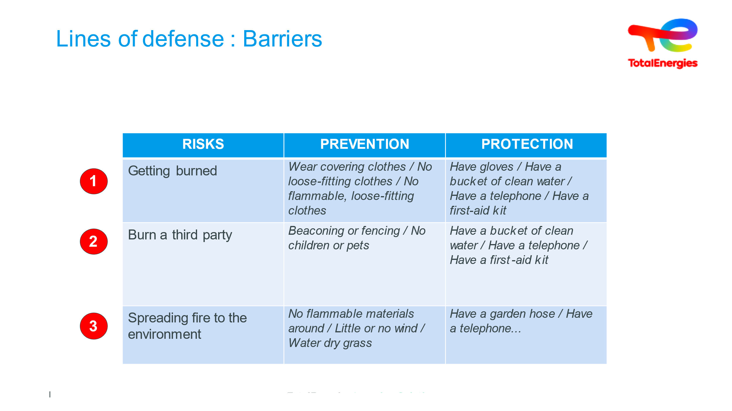  5 minutes of discussion | Question? | Let's talk safety.  Make learners aware that everyone is responsible for ensuring safety on a daily basis. | Example of a barbecue :  1 - Getting burnt  2 - Burning a third party  3 - Having the fire spread  Employees should define prevention barriers and protection barriers...  When employees share their thoughts, make it clear if there are errors linked to  - A PREVENTION barrier that acts so that the incident does not occur.  - A PROTECTION barrier that acts by reducing severity, but takes action after the incident occurs. This type of barrier is defined as a RECOVERY and ATTENUATION barrier in the ICSI movie.  The following may be added:  - Some barriers can take action in several scenarios.  - These actions are often carried out without being aware of the objective of the action.  - A telephone with no signal, no battery, no number to call, is an inefficient barrier...  - You can point out that the right way of doing things/best practices are often understood and shared without any additional comment... This is what some call ‘standard practice’. | Slide + Oral + Exercise
 | 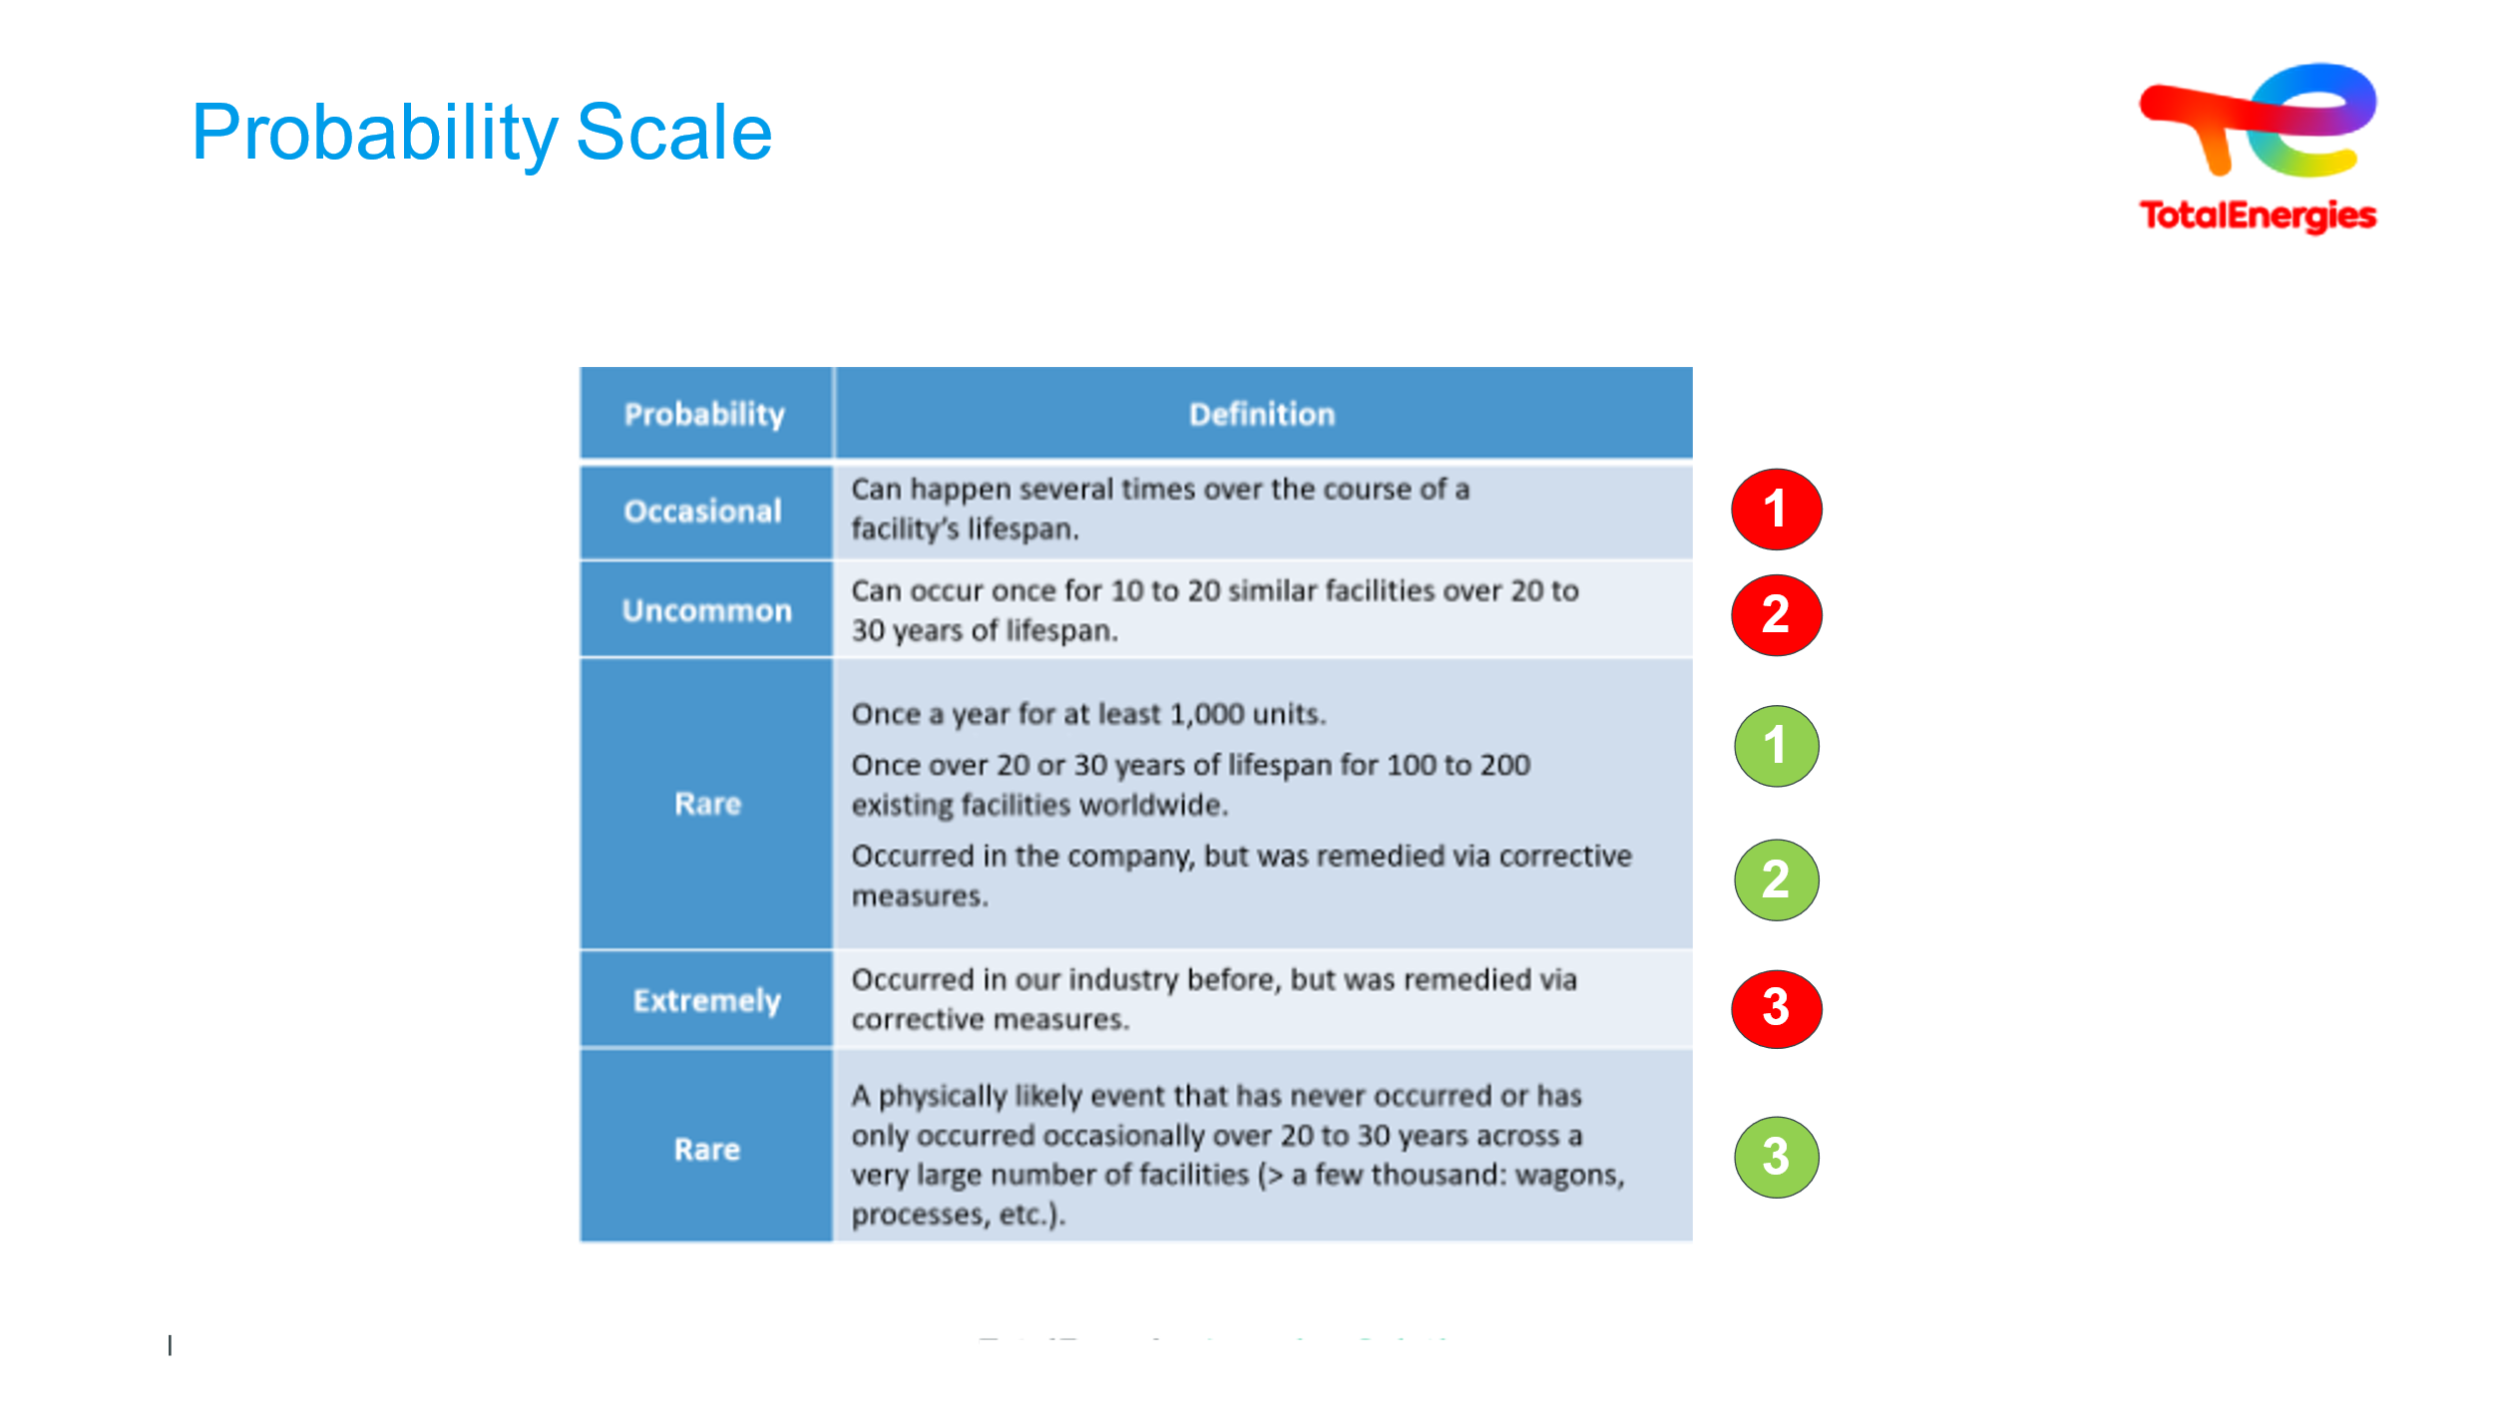  5 min explanation & discussion | Probability Scale | Understand the company framework rolled out in line with regulations | In order to understand what everyone is talking about, we need a single, common frame of reference.  We can read the probabilities that have been defined. It should be made clear that probabilities are linked to the recognition of a large number of events, without which, individually, there will always be a tendency to minimize the probability of occurrence.  The trainees are then asked to try to define the probability of each scenario WITHOUT & WITH the barriers defined together.  To facilitate responses, ask the question: "Who got burned while barbecuing?  1 red: Burn self  2 red : Burning a third party  3 red : Fire extension  1 green : Burning despite defined barriers  2 green : Burn a third despite the barriers  3 green : Fire extension in spite of defined barriers | Slide + Oral
 | 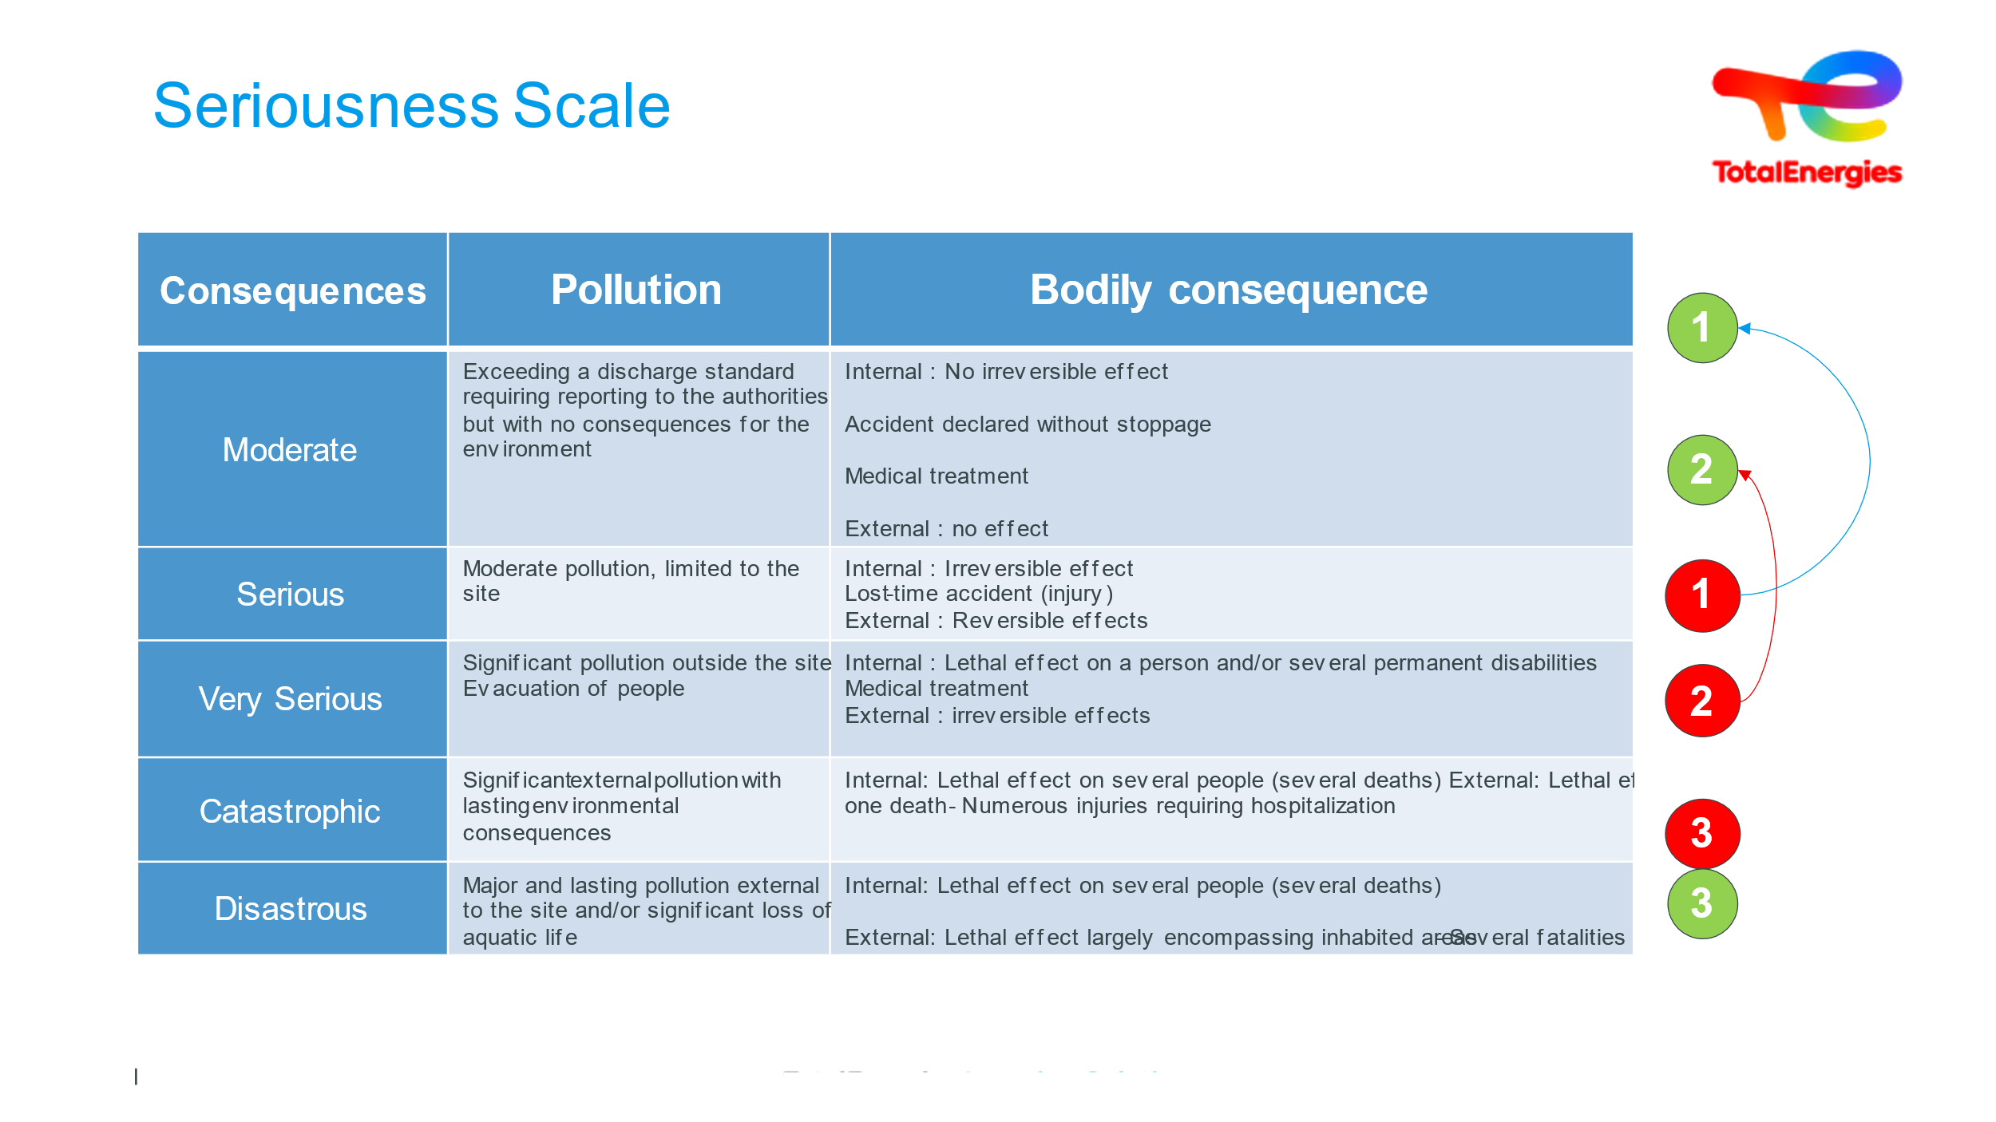  5 min explanation & discussion | Seriousness Scale | Understand the company framework rolled out in line with regulations | Here again, a common, shared frame of reference is needed.  The gravities defined in this way must be read and expressed in the same way.  The trainees are then asked to find the gravities of each scenario...  In order :  1 red: Burn yourself, without any barrier  2 red : Burn a third party, without any barrier.  3 red: Fire extension, without any barrier  1 green: Burning despite defined barriers  2 green: Burn a third despite the barriers  3 green: Fire extension despite defined barriers | Slide + Oral
 | 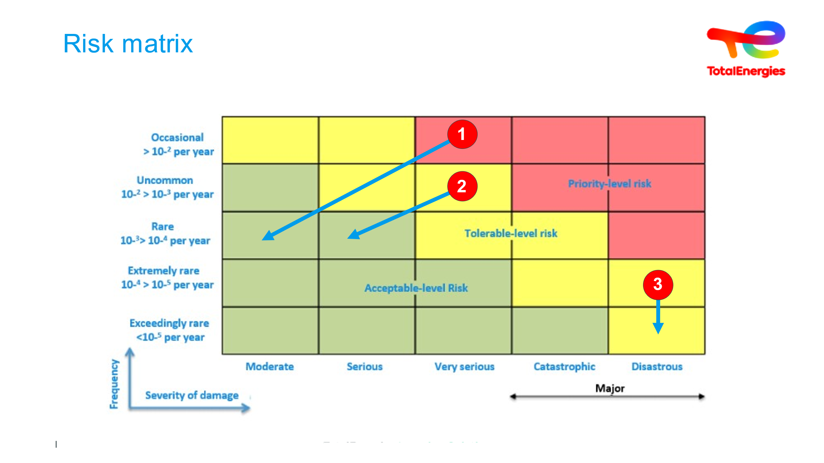  3 min. explanation +  1 min. summary | Understanding how a risk matrix works | Trainees must realize that they do not all have the same sense of risk or seriousness | Let's now place our 3 scenarios in the risk matrix, with the severity of potential damage on the abscissa and the frequency of occurrence on the ordinate. It's important to see the 3 different zones:  - RED : priority risk... Scenarios cannot be left in this zone. Something must be done.  - GREEN : acceptable risk zone. It may seem surprising, but we all do it: the car is the means of transport with the highest probability of occurrence, and the severity is not negligible, since there are still deaths on our French roads... We'll come back to this later.  - YELLOW : intermediate zone where it's time to ask questions and implement protection and/or prevention barriers. In the example of the barbecue, the same barrier can be used for several events. With the example of case N° 2, the implementation of barriers moves the risk into the green zone. | Slide + Oral
 | 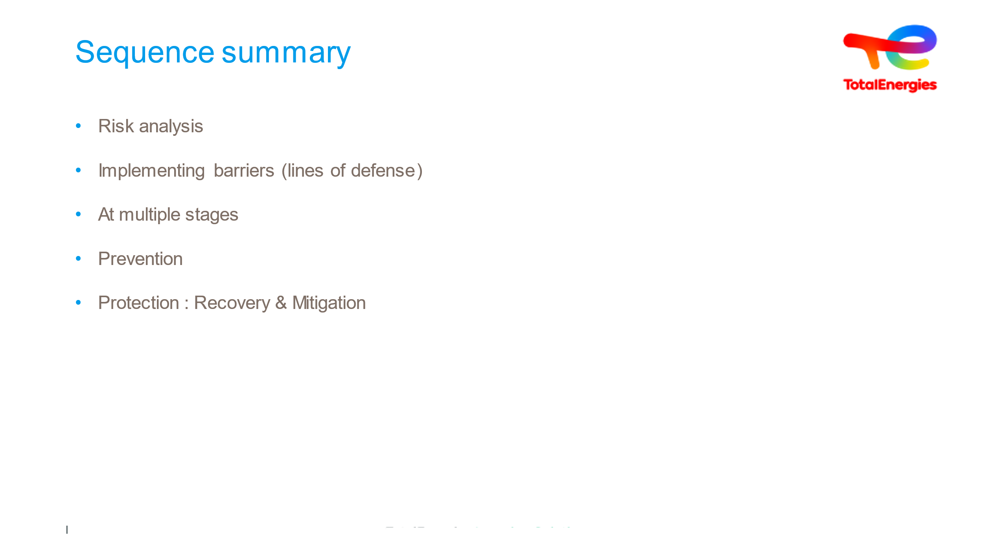  5 min | Sequence Summary |  | Risk analysis  Implementing barriers (lines of defense)  Organizational  Technical  Human  At multiple stages  Prevention => to prevent the dreaded incident: Taking action in terms of probability of occurrence  Protection  To keep the situation under control once the incident occurs (e.g., immediate use of a fire extinguisher, gas evacuation)  To mitigate the consequences of the incident (example water curtain, firewall)  To limit exposure to the incident (plant evacuation)  To limit the impact on people (relief and care) | Slide + Oral
 | 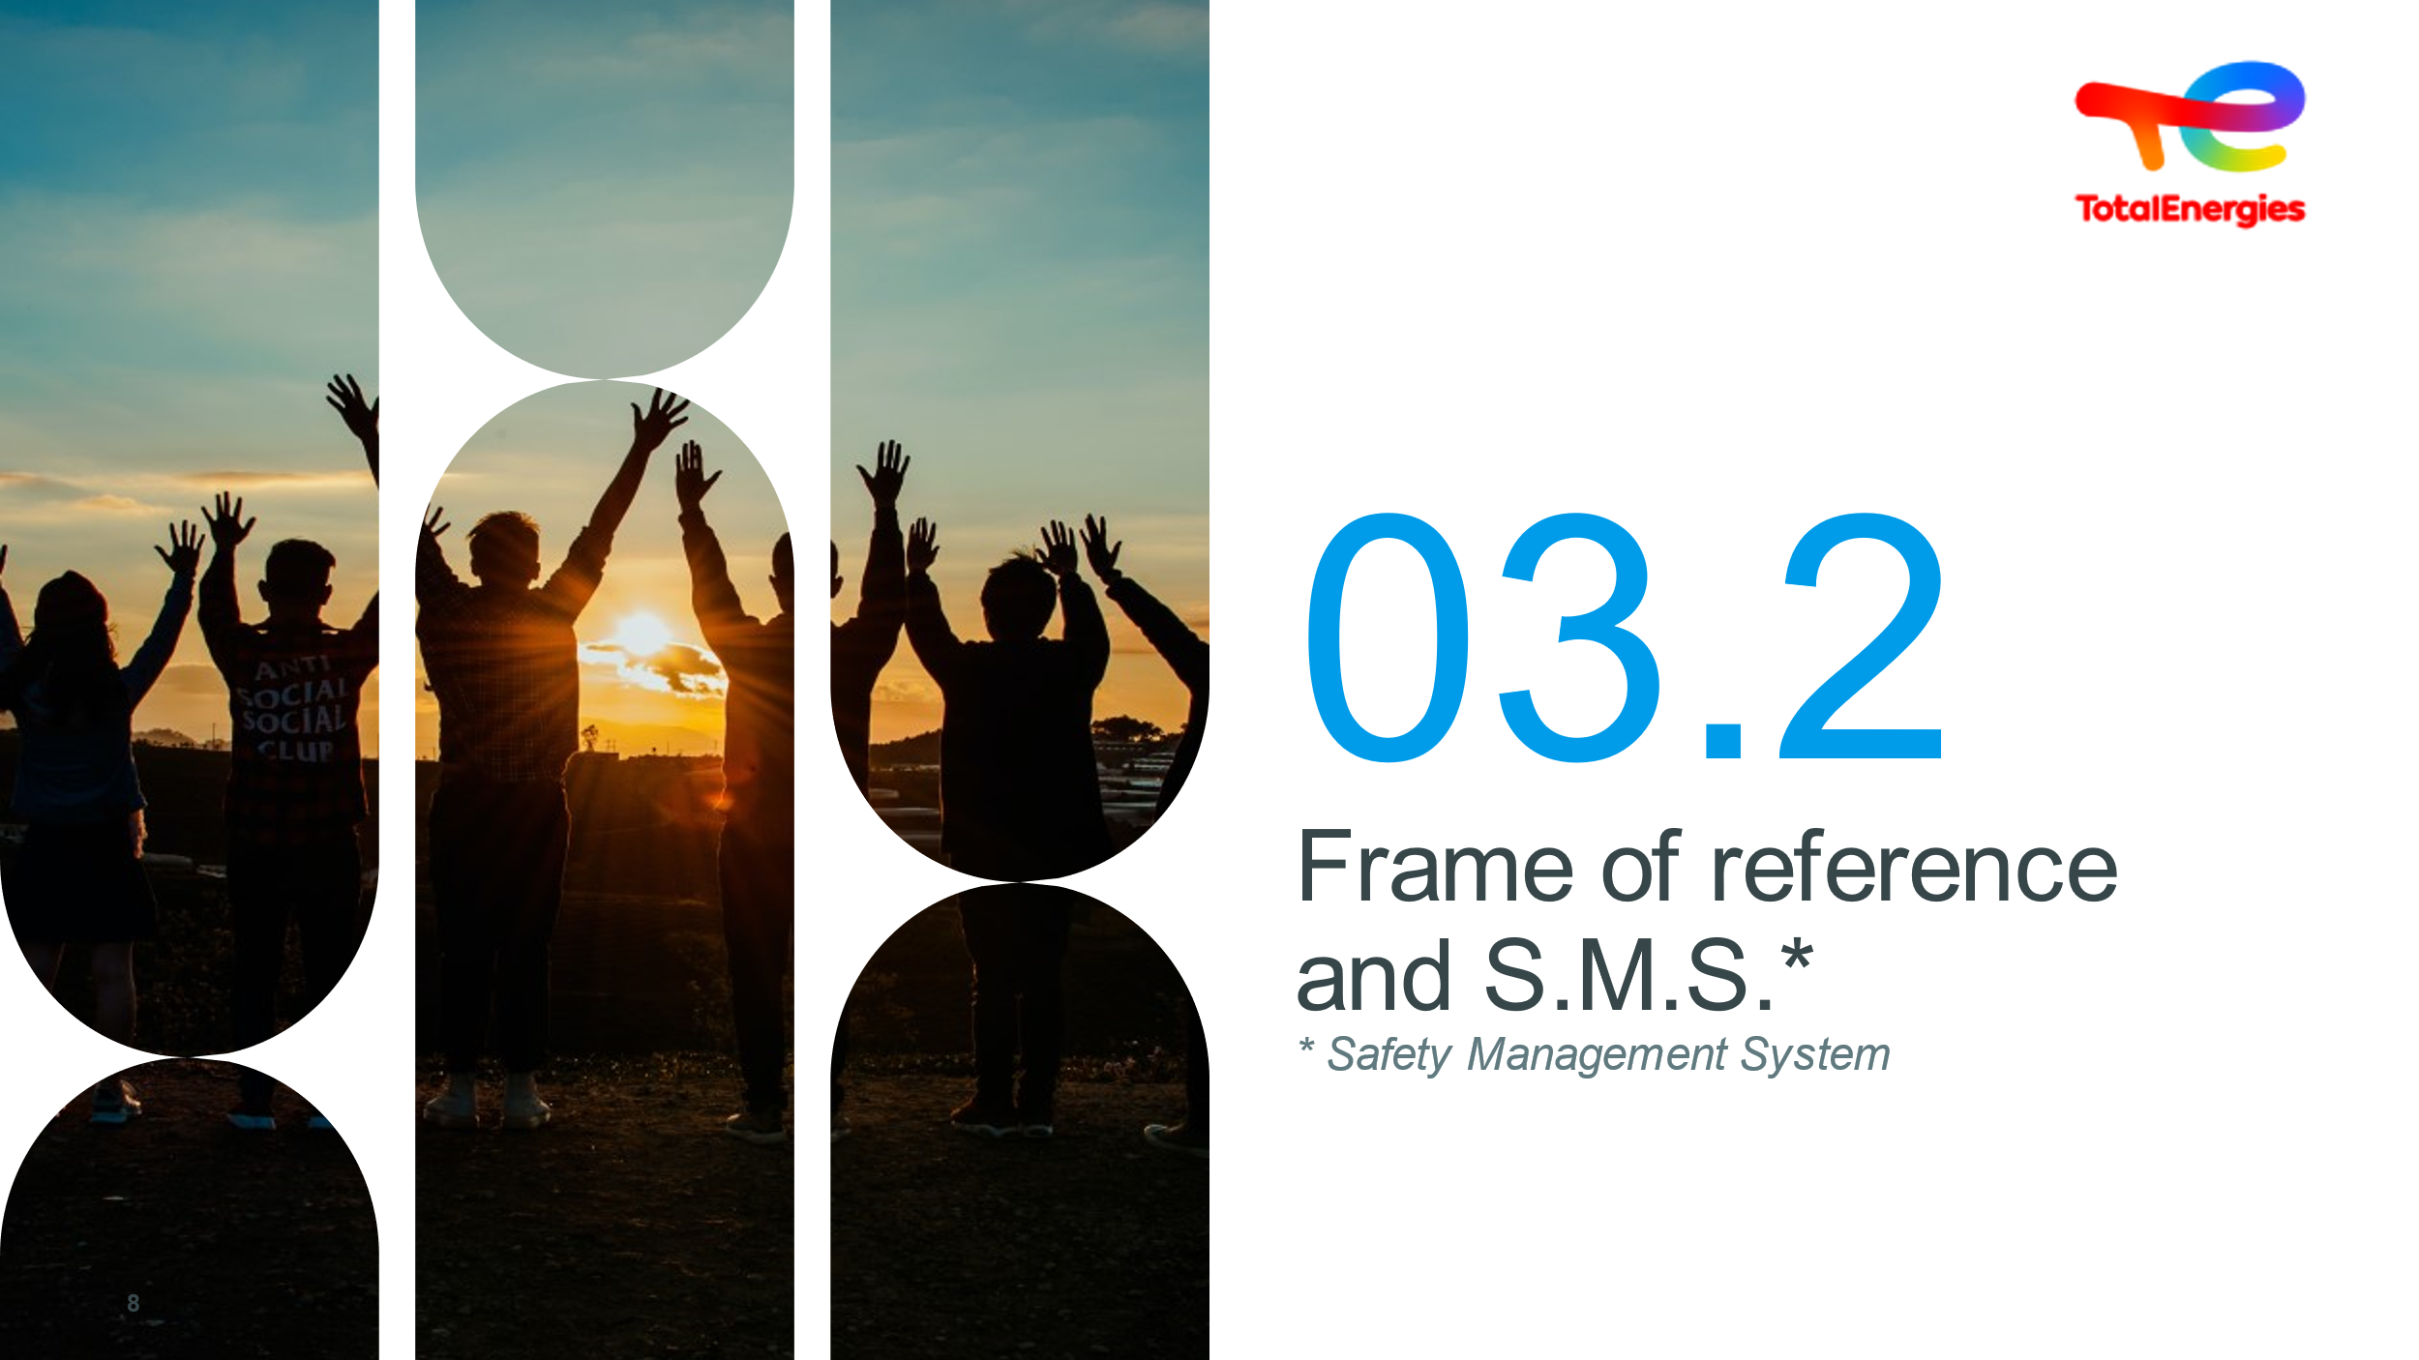  1 min | Frame of reference and S.M.S |  | Project the slide and read the title without further ado | Slide
 | 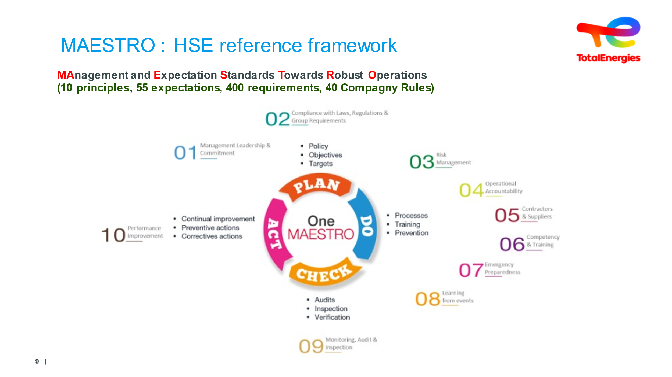  2 min | Understanding the MAESTRO reference framework |  | TotalEnergies has adopted the ONE MAESTRO framework. "Management And Expectaction Standards Towards Robust Operations“  10 principles / 55 objectives / 400 requirements....  This One Maestro reference framework is based on the Deming Wheel or PDCA method.  PLAN: Define policy and plan to effectively address hazards and risks, legal and other requirements, corporate objectives and targets, and management program requirements, within the context of operations.  DEPLOY: Execute the plan, taking action in an organized way to implement management programs in line with policy, objectives and targets.  CHECK : Monitor and measure, deal with non-conformities, implement preventive and corrective measures, audits and inspections.  ACT: Following a systematic review of performance, take action to harmonize or improve the process. | Slide + Oral
 | 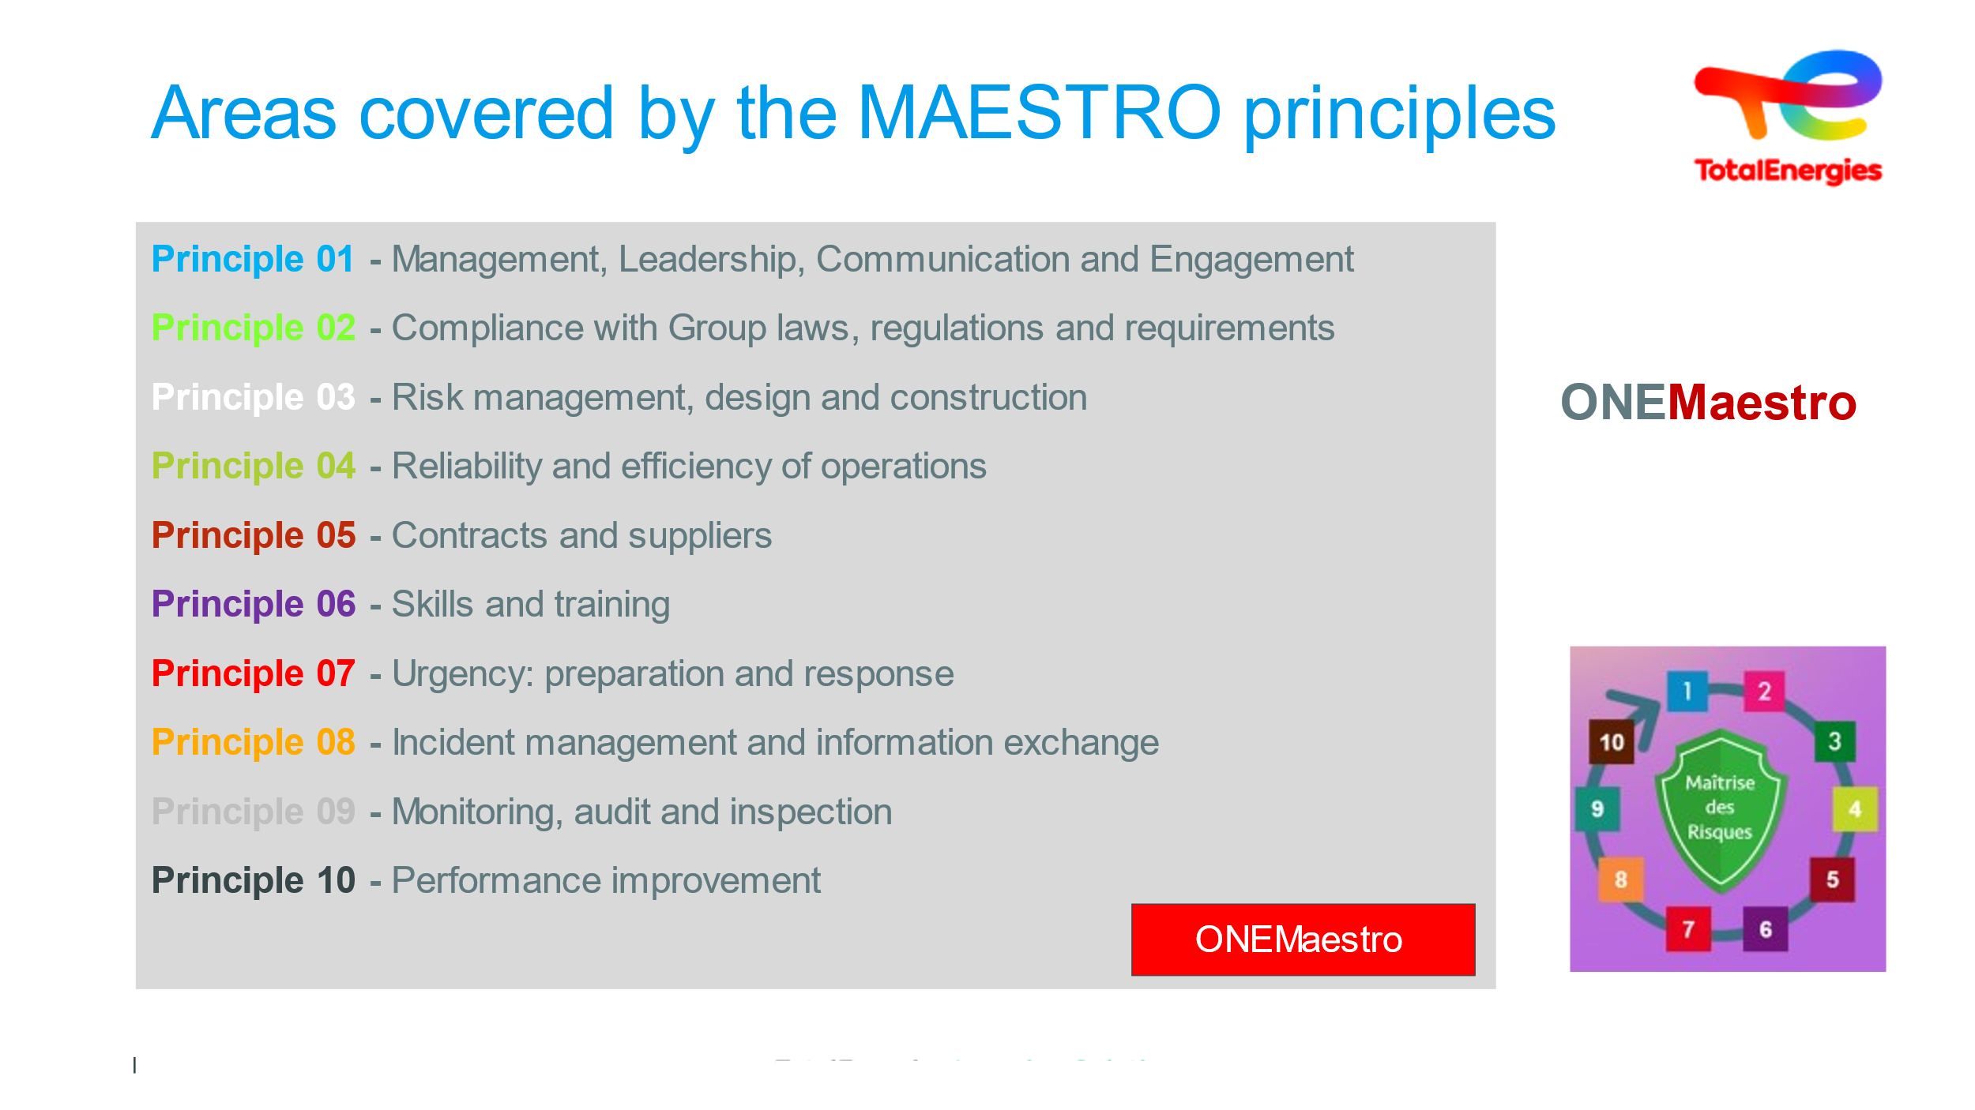  1 min per topic |  |  | TotalEnergies' SMS is handled by ONE MAESTRO.  There is a One Maestro online training module on Lizzy.  The 10 principles contained in the One Maestro Directive are based on the PDCA method.  These 10 principles make it possible to build an HSE management system based on a continuous improvement process, with a single objective in mind: risk management.  These 10 principles are transposed into 55 expectations.  - Management: Exemplarity, rigor, vigilance, professionalism. Visible commitment & assessed performance.  - Legislation: Compliance with laws & regulations, the company’s voluntary commitments & applying the most stringent or binding regulation/law that exists  - Risk management: Hazards/dangers systematically assessed, associated risks evaluated & measures defined, measures reassessed. EDD (hazard assessment study)/Prevention plan/AT (work permit)/One Maestro also applies to non-operating entities or subsidiaries.  - Reliability: Shared operational responsibility. Each person takes action at their own level, on behalf of themselves & their team. Inseparable from operational aspects.  - Contractors: Assessing external companies, Tech + HSE/In accordance with company requirements/Contract duration/SMS or manual for the improvement of company safety equivalent  - Skills: Required technological & HSE skills go hand in hand/Skills assessments/Training plans with recycling/Tasks and skills and training all aligned  - Urgency: AdR associated with emergency situations/Organization available with trained and experienced staff/These plans take into account stakeholders/POI/PSI/PPI/PUM/GUM/IMS (all French crisis management plans)  - Incidents: All incidents = report & analysis/experience feedback/HIPO = thorough analysis/We are all responsible for reporting any non-compliance!  - Audits: Management is responsible for ensuring HSE policy is applied/Evaluating, monitoring, auditing, inspecting/If discrepancies are picked up, corrective action to be taken, tracked until completion.  - Performance Improvement: Action plans are reviewed regularly/SMS effectiveness is analyzed & monitored complete with indicators/Action points ranked by priority/PDCA roll-out  Added extras :  These 10 principles are grouped together under the PDCA continuous improvement method.  1 / 2 / 3: Identify, Prepare & Plan  4 / 5 / 6 / 7 : Implement  8 / 9 / 10 : Manage & Improve
 | 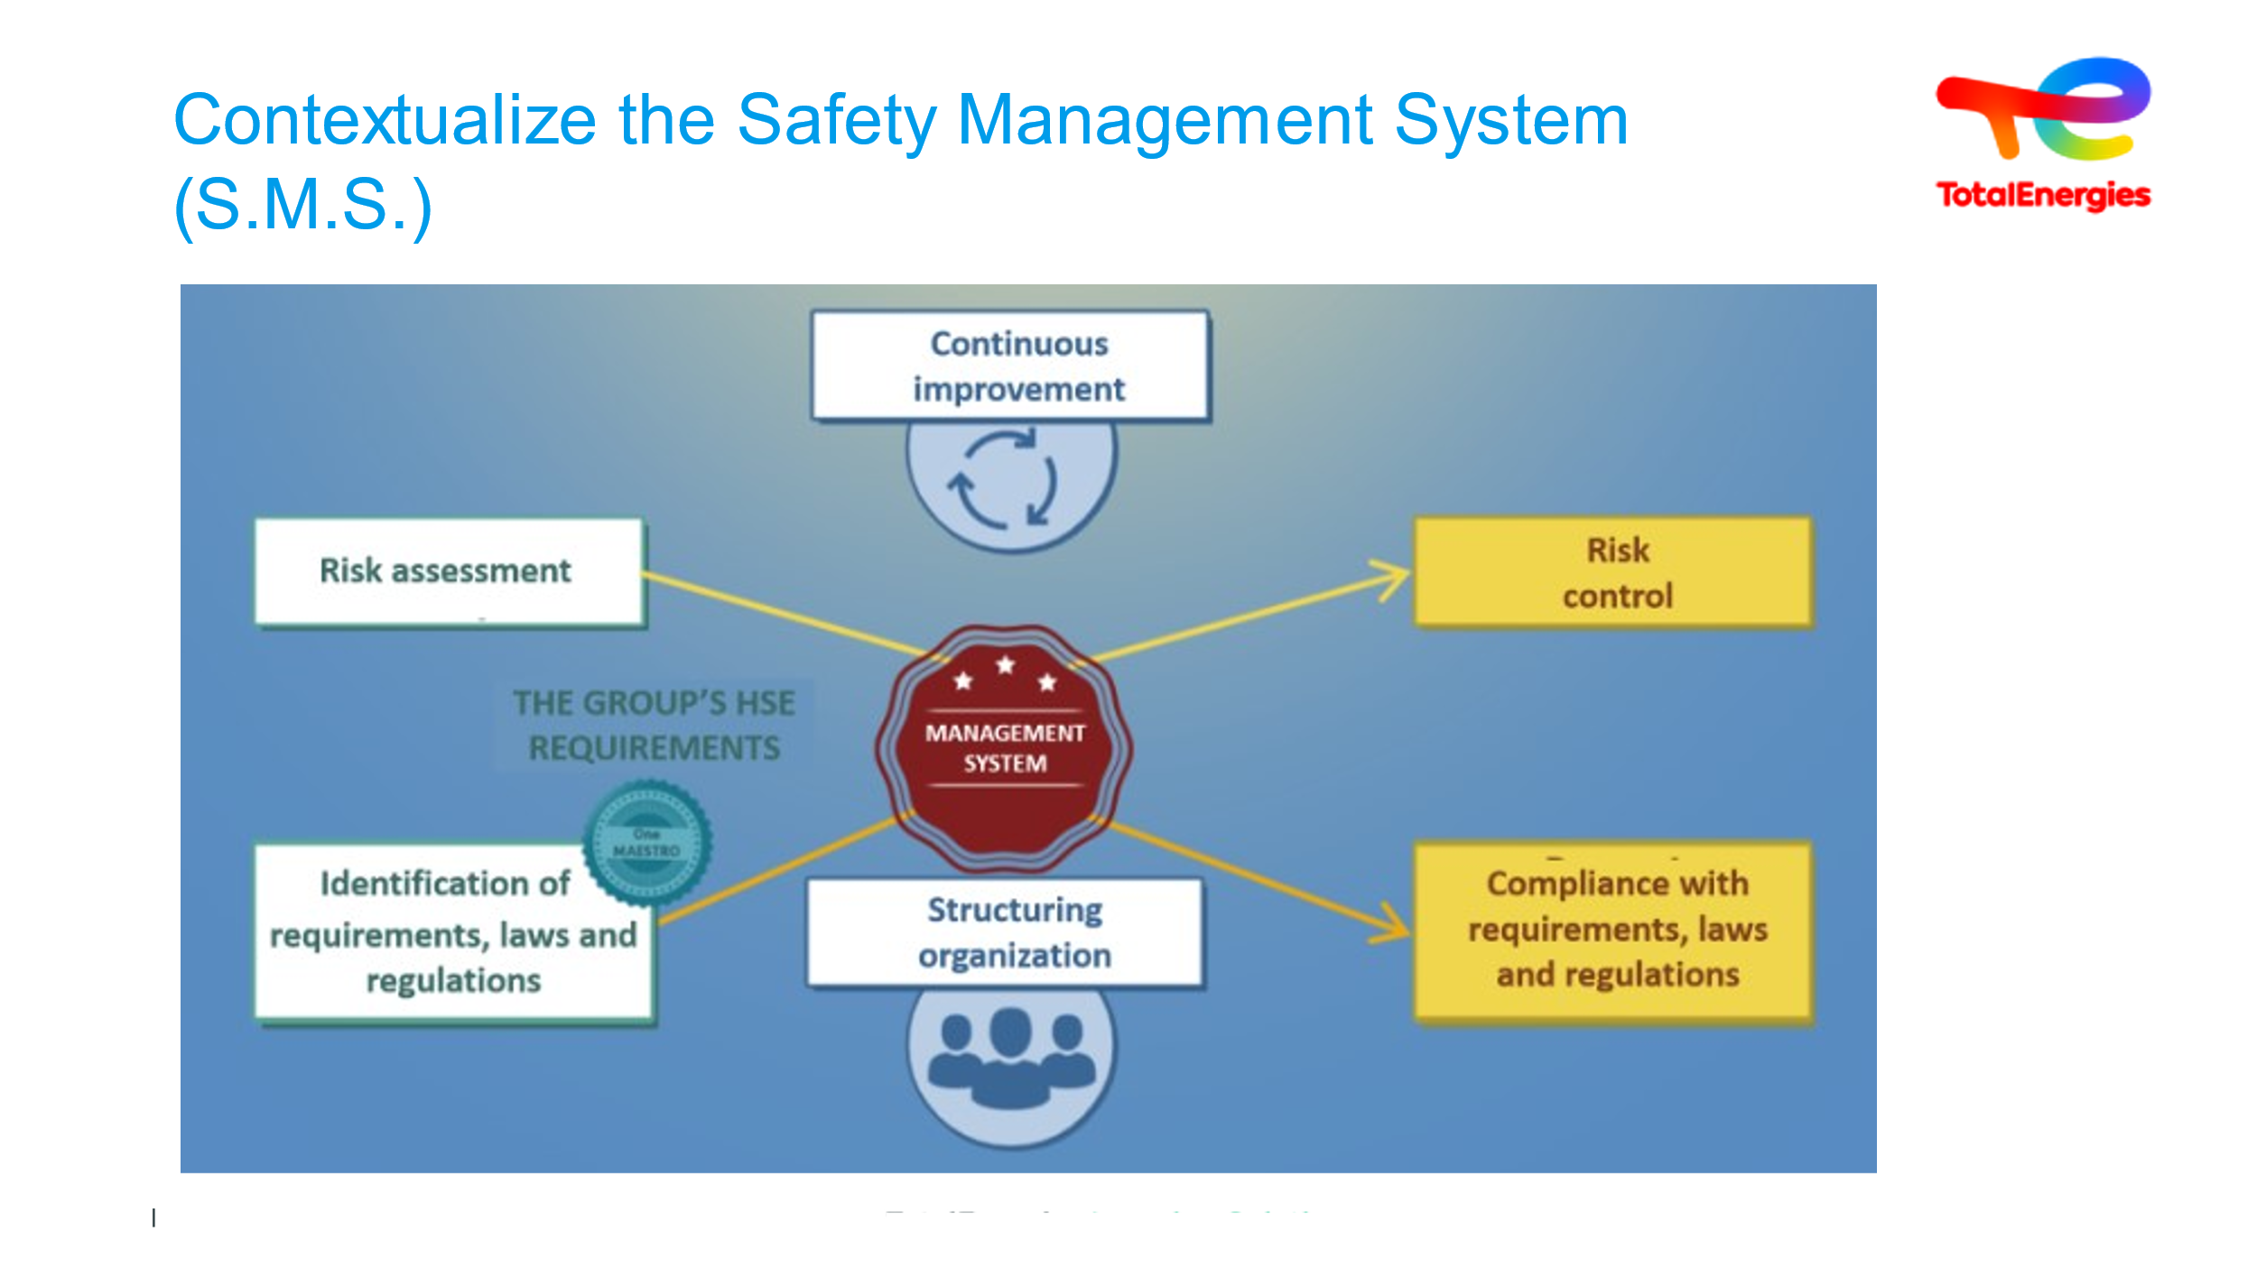  6 min | Understanding the SMS |  | SMS: safety management system.  This system makes it possible to better structure the organization of the entity subsidiary.  It is based on a continuous improvement approach.  It enables the subsidiary to control its risks and comply with requirements, laws and regulations.  The requirements to be taken into account include all of the group’s HSE requirements.  Everyone is involved in implementing the system.  You are all active parts of it. | Slide + Oral
 | 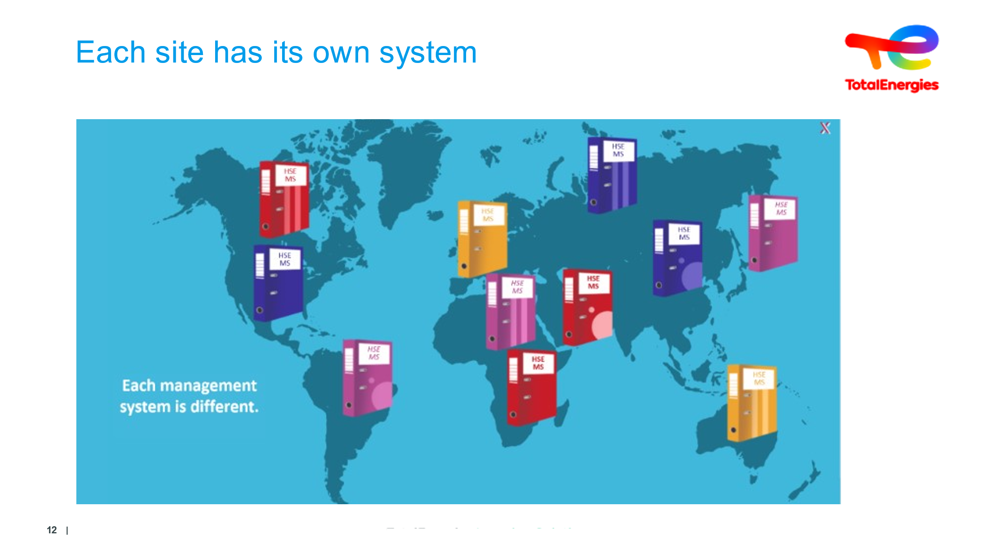  5 min | Each site has its own SMS or Health, Safety, Environment and Quality policy, tailored to its specific challenges and objectives |  | To control and manage HSE risks, each entity and subsidiary of TotalEnergies has its own management system in place.  These systems may vary from one to the next. They are tailored to the risks and specific challenges of the entity’s activities.  Simple system = Simple SMS | Slide + Oral
 | 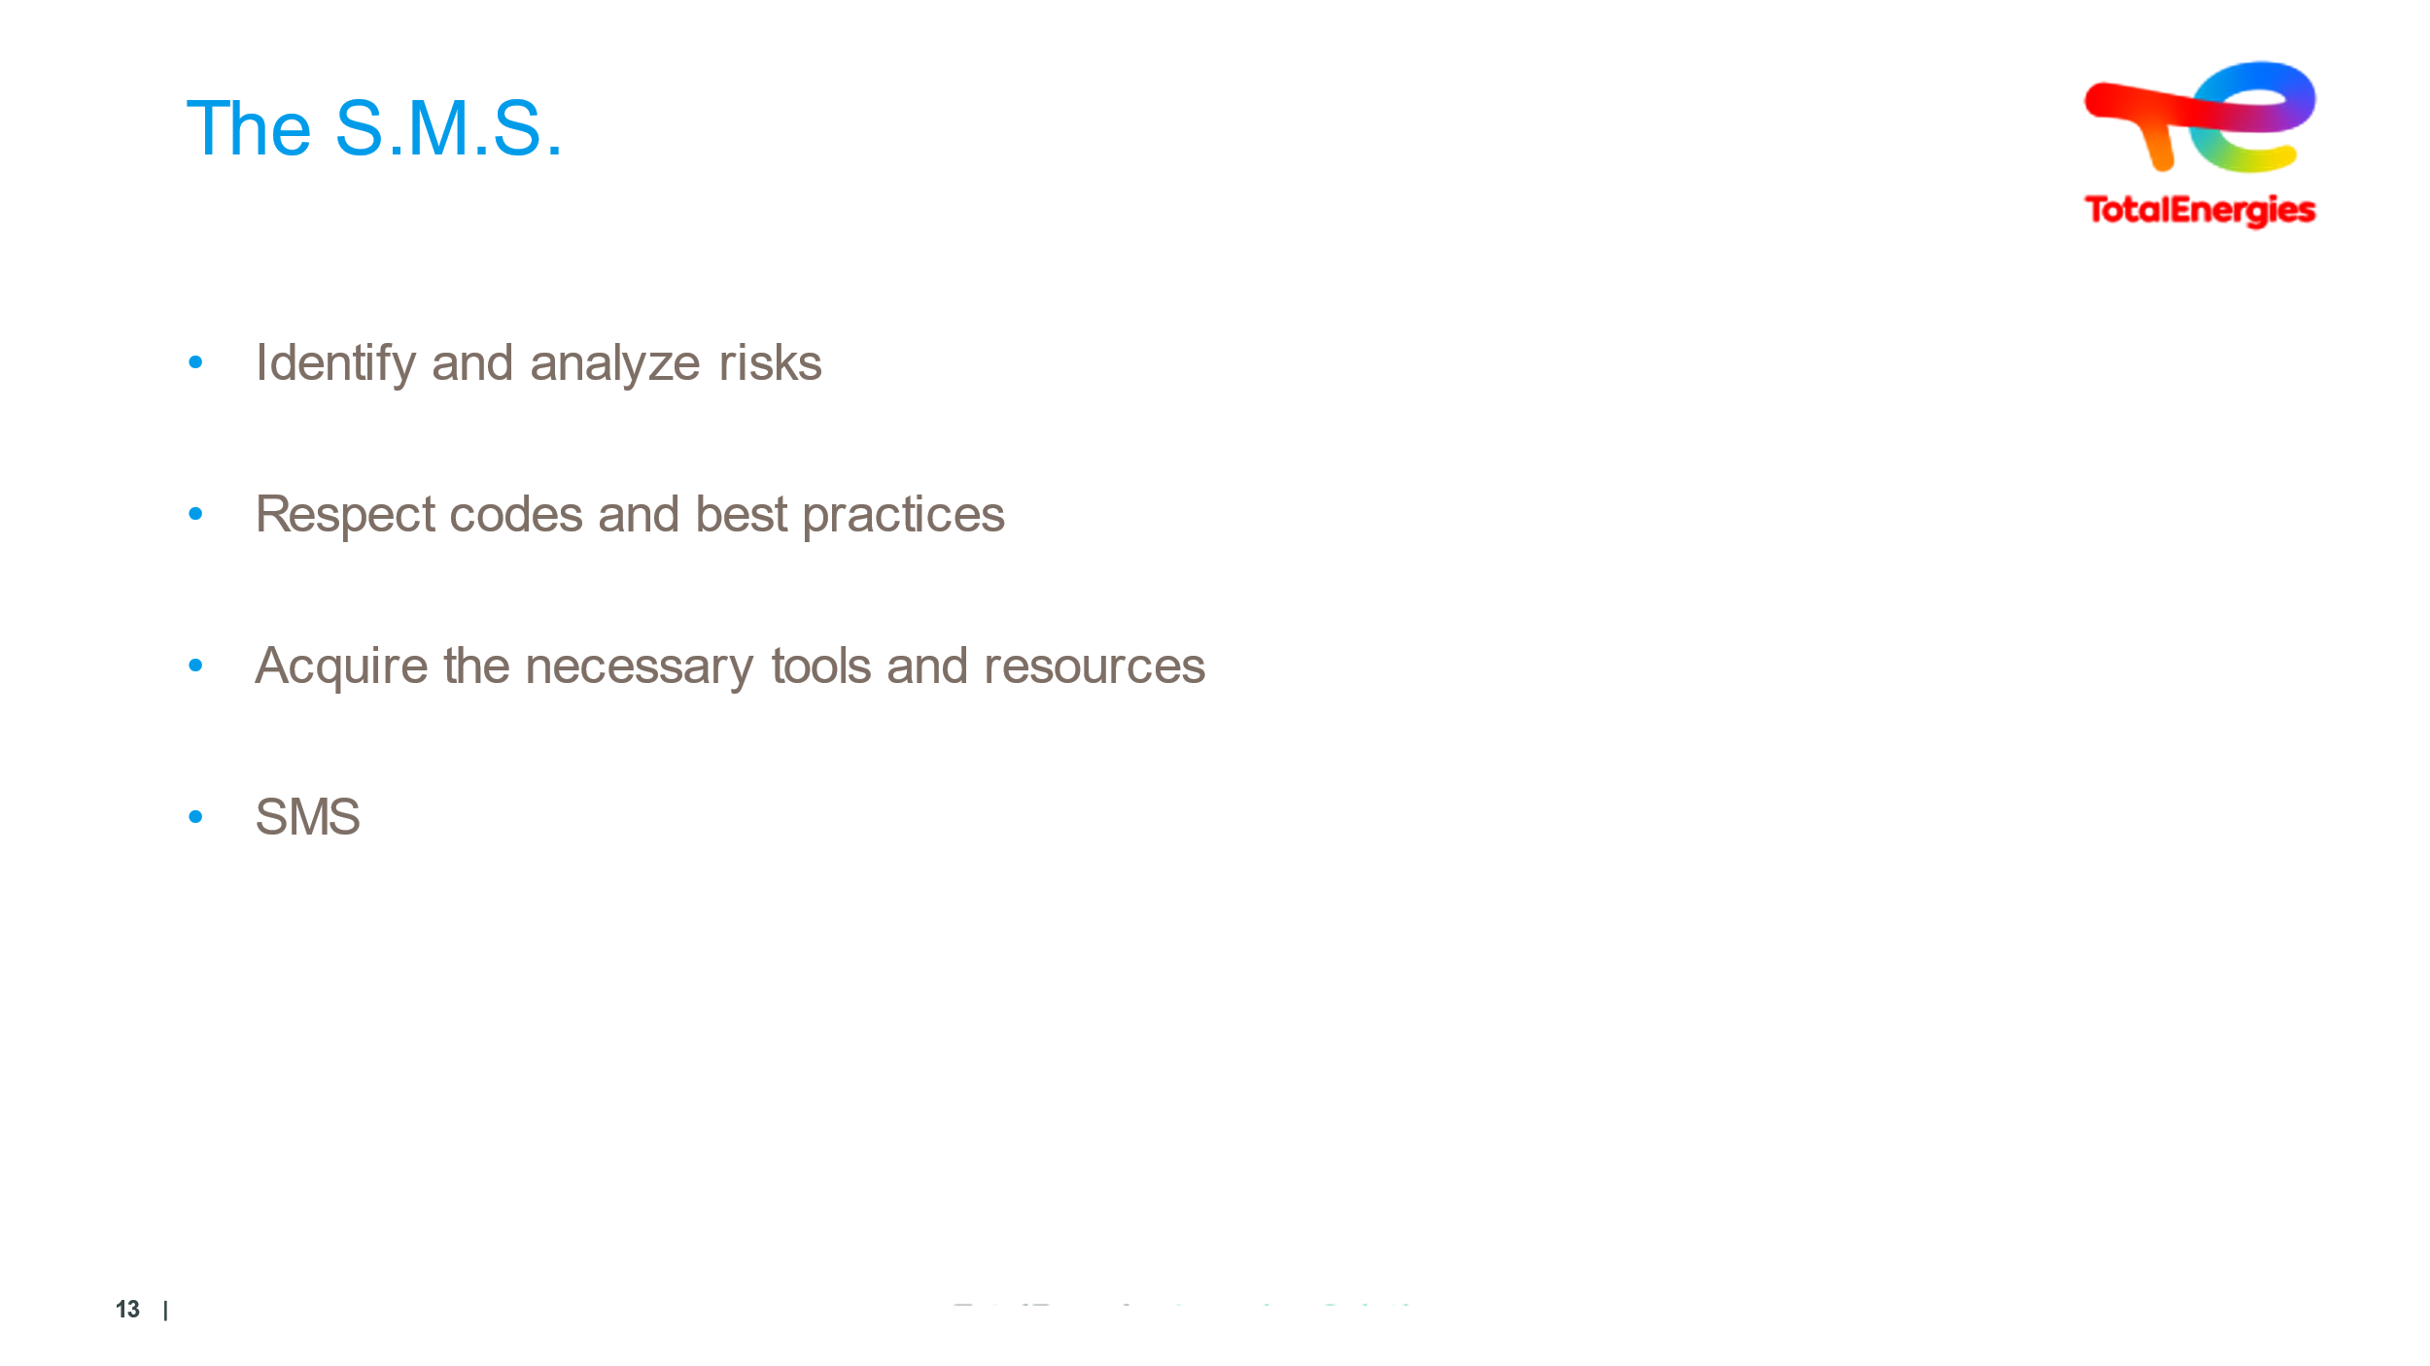  4 minutes | Module Conclusion |  | Message to get across :  “Safety is everyone business”  - Every safety initiative begins with hazard identification and risk analysis.  - In everyday life, you carry out risk analyses, comply with codes and best practices, and implement preventive, mitigating and emergency measures. Eventually, even without realizing it, you do it mechanically. But you need to know and understand why, so that you can explain it to your teams, your colleagues, your children.  - Once you've assessed the risks and devised preventive measures, you need to equip yourself with the tools and resources you need to control them: this is the safety management system.  - In concrete terms, an SMS brings together activities and procedures, all based on continuous improvement. The products we handle contain energy, and it's the release of this energy that we fear. | Slide + Oral

